The Wolves Theatre Company present
Marooned
Written by Michael Gray Griffith
PRODUCER Rohana Hayes

a powerful and revolutionary play about suicide

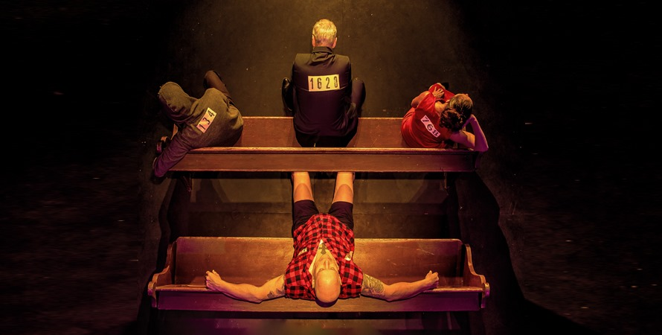

You are invited to a weekend of theatre, speakers and discussion. See the brilliant play Marooned, hear from mental health organisations and meet your rural community.

When: 12th Dec 2025 at 7.30pm
13th Dec 2025 at 11am

Where: Red Rock Regional Theatre and Gallery 520 Corangamite Lake Rd Cororooke. Bistro Open for food and refreshments

Tix https://www.trybooking.com/DGGXA

https://www.facebook.com/thewolvestheatre

click here for prospectus and history of the play Marooned

https://www.canva.com/design/DAD9PGJ0RiA/ayJto2rONd_FIVvFEH2OFQ/view

PERFORMANCE AND COMPANY INFORMATION

Running Time: 80 minutes
Interval: None
Warnings: the play contains themes of suicide, coarse language
Age Range 16 plus
Key themes: men’s health, suicide, life, youth suicide,

For info Contact Rohana on 0425854942 or thewolvestheatre@gmail.com

What may be surprising is the quietly increasing sense of hope that these four feel as they wait Marooned in an anonymous waiting room.

Synopsis
Four strangers are Marooned in a waiting room in the afterlife. The only thing it appears they have in common is that they have all attempted to take their own lives.
As time passes one by one, they start yearning to go home but declaring this want to go home to the “Gods”, doesn’t seem to be enough. Eventually, one of them believes that the only way out of this room is to talk, and to talk plainly and directly about what brought them here. He believes that they aren’t here to help themselves, but to work together to save each other.
Is he right? For the more they open-up, the more their truth comes out, the closer they grow and the closer they grow the more they find their second wind; the strength, through community, to face and deal with the issues that initially brought them to this room. We journey with them as they each come back from the edge. But are they going home?

Writer Michael Gray Griffith

Michael is a prolific writer with a unique voice. He has written several plays.
“You write without fear and yet with a keen sense of both heart and responsibility. You
have a good nose for story and a sharp sense of unrest and disquiet. There is enormous
truth at the core of your work and you are relentless in your pursuit of it.” ~ Chris Mead
Prior to the world stopping his play The Shadows and the Hues was set to be Directed by Bruce Bersford who said of his writing. "While I can see the influences of Pinter, this is not Pinter. This is an original voice."

"Michael Gray Griffith has an extraordinary gift as a writer, together with his (then) partner Rohana Hayes they are creating, producing, and directing some of the most poignant, exciting, funny scripts I have read in a long time" ~Amanda Muggleton
"Michael shits out plays like Richard Rodgers shat out tunes" John Wood
“Michael is an outstanding playwright. He has a great gift in creating uneasy ripples under everyday events and conversation, placing them with a strong ambience. His talent is matched only by his
compassion.” Aarne Neeme Director

Marooned was written after the suicide of an actor friend Guy May. This play is dedicated to Guy.

Producer Rohana Hayes
Rohana has been Producing plays with Michael Gray Griffith as The Wolves Theatre Company since 2015. Unfortunately, we had to put the Company on pause for a couple of years, due to Covid, but with the problems in society increasing and suicide especially since Covid I have decided to re-ignite what greatness we were doing.
With little funding and often challenging time frames and unexpected occurrences that can happen with independent theatre I am adamant that this play and also the film version that I am preparing to make, continues to get to the areas where it is needed and to as many people as possible.

History
The play was written after the suicide of an actor and initially it was only meant to be staged for the acting community as a form of healing, but from the first night it was clear that the play was special. We performed at the MTC Lawler and toured it to country towns where it was incredibly well received. In 2021 The Australian Army invited us to perform Marooned at the St Kilda Barracks in Melbourne and then in Canberra for the Chief of Army and a host of military VIPs. This was incredibly well received, and the Army Psychologist called it a revolution in suicide prevention

In the UK
Marooned is currently being used in the UK as a teaching tool for mental health nurses and psychiatrists, In 2022 the Institute of Psychoanalysis used a filmed reading of the play for their event, Psychoanalysis and Mental Health/Marooned in a collaboration with National Institute for Health Research (NIHR) Maudsley Biomedical Research Centre, the South London and Maudsley NHS Foundation Trust and Ten Windsor Walk. They now have funding to use this film as a teaching tool for their medical students.

To date we have had over 80 performances, and we are urged to take it everywhere as it resonates with so many people. After the play people hang around for ages wanting to talk and the discussions are healthy. This makes it the perfect tool for the regional areas. One young lieutenant who saw it at Victoria Barracks one weekend was so touched by it he, drove 400kms to see it again at Yarrawonga.

Marooned Quotes and Reviews
“Marooned is undoubtedly the finest piece of theatre I’ve seen in many years. It had me in tears and belly laughing. Beautifully written and expertly performed. Stunningly good.”~Megan Watts.
“Is it only last week Australian of the Year Grace Tame told us, “History, lived experience, the whole truth, unsanitised and unedited, is our greatest learning resource. It is what informs social and structural change”? Marooned is a play that fulfils this urgent purpose, using communal storytelling, aka theatre, to confront Australia’s epidemic of life-threatening despair, shame and grief. It does so with humour and compassion and honesty. It needs to be seen” Harriot Cunningham. The Sydney Morning Herald
Thank you for bringing Marooned to Castlemaine. My husband, daughter and I were in the audience last night and were emotionally touched by the performance, as were the people around us. We just wish our boy had had a chance to return but it was not to be. We are all involved in suicide prevention in our local community and wish to thank you for all the elements your play covered. It was very cleverly done and we sincerely hope more people get to see this play for the discussion it would spark around suicide prevention. An anonymous audience member
“Each of the characters’ stories represents a different group in our community, but all reveal how delicate is the human psyche, how fragile is our mental health and how tenuous our grip on this life.” ~Kate Herbert ★★★ The Herald Sun
“This is an important play,” ~Alan Hopgood. Playwright
“While I can see the influences of Harold Pinter, this is not Pinter. This is an original voice. And Marooned is a marvelous play. A clever and engaging work. Highly original & witty.” ~Bruce Beresford Director
“Marooned is a revolution in Suicide Prevention because it entertains and holds an audience’s attention, and while it powerfully conveys its message it manages to leave you feeling uplifted.” ~LTCOL Andy Cohn Army Psychologist
“I laughed, I cried, I felt. It’s raw and extremely real. The actors are beyond amazing, the writing is phenomenal. It was an occasional shifting of bodies that brought you back to the reality that reminded you that this was a play.” ~Natalie Powel
“I think it’s fair to say that any play that holds your attention for 90 minutes is something special. Having been in the audience, I can tell you this is that play. Miss it at your peril.” ~Simon Walters

