eNotice allows you to:
- Receive your Rates Notice/s by email
- View your current and previous Notices at any time
- Save or print the Notice
- Pay your rates

SIGN UP FOR ENOTICE

- Go to the enotice website at https://colacotway.enotices.com.au/ | 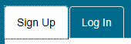
- Click on the Sign Up tab
Sign up via website
- Enter your email address | 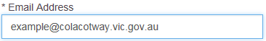
- Locate your enotice reference number on your rates notice
- Enter your enotice reference number  - All Notices with the same name and mailing address will be added once you add the first one | 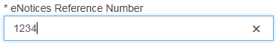
- Click on Sign Up button (an email will be sent to your email account for confirmation)
- Go to your email account
- Click on Start button in the email
Sign Up via facebook
- Click on Facebook button
- Enter your email address or phone number that you use when signing into facebook | 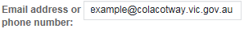
- Enter your facebook password
- Click on Log In button
- Click on Continue button
- Locate your enotice reference number on your rates notice
- Enter your enotice reference number
- Click on Continue button | 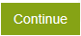
LOG INTO YOUR ENOTICE ACCOUNT

- Go to the enotice website at https://colacotway.enotices.com.au/ | 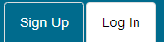
- Click on the Log In tab
- Enter your email address and password
- Click on Log In
- OR Log in via Facebook if you signed up using this method

DASHBOARD
From the Dashboard you can:
- Add a new Rates Assessment
- View your Rates Notices
- Update Contact Details
- Pay your Rates

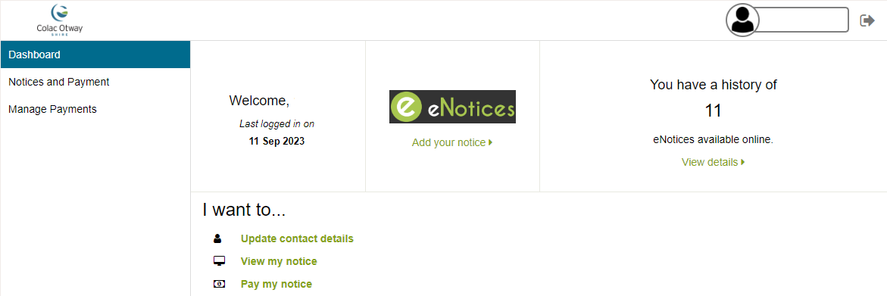

ADD A RATES NOTICE
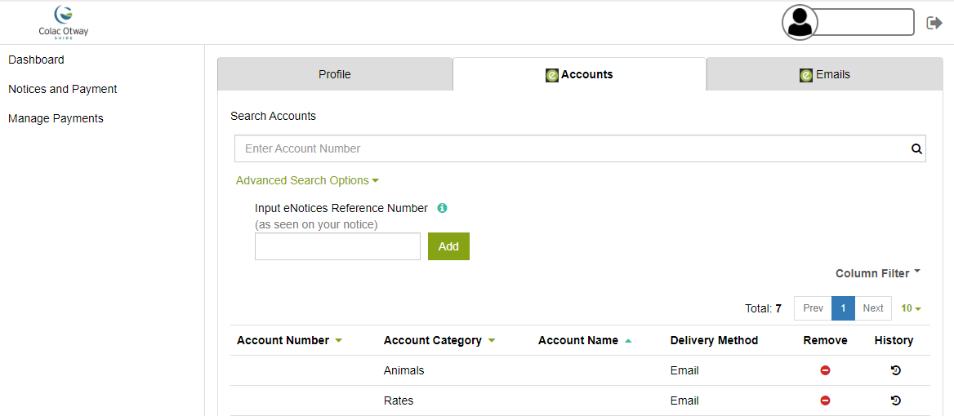

- On the Dashboard, click on ‘Add your Notice’ | 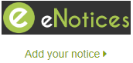
- Locate your enotice reference number on your rates notice
- Enter your enotice reference number | 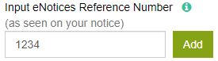
- Click on Add
- Assessment will now show in Account list | 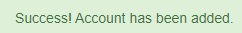

VIEW YOUR RATES NOTICE
You can view your current and past Rates Notices in eNotice. Please note the Bill Amount showing will be your original Instalment 1 amount and not the current balance if you have made payments

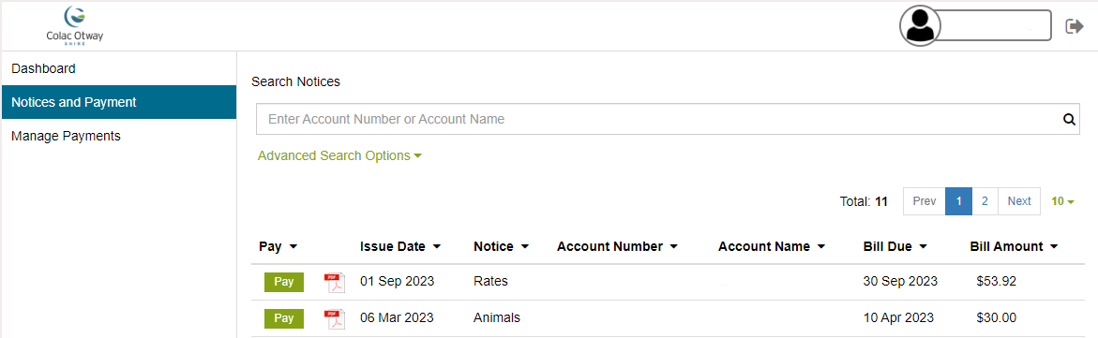

- On the Dashboard, click on ‘View Details’ OR ‘Notices and Payments’ |  | OR 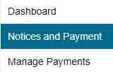
- Click on a Rates Notice to view the Rates Notice
- You can then save or print the Rates Notice | 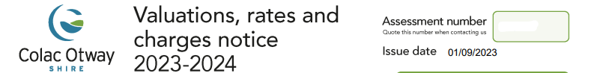

PAY YOUR RATES
You can pay your rates via BPAY (details on Rates Notice), Council (office, phone or website) or by eNotice

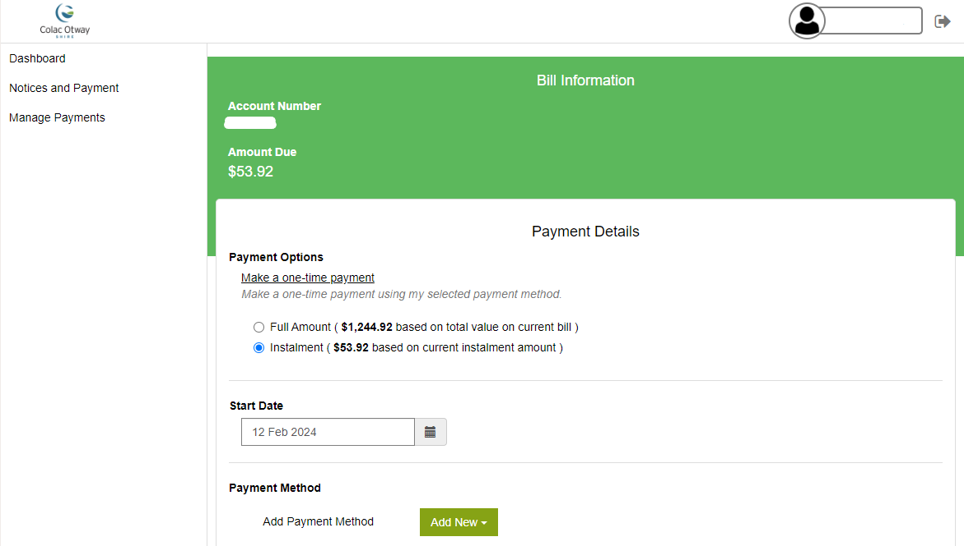

- Go to Notices and Payment
- Click on the ‘Pay’ button against the Rates Notice | 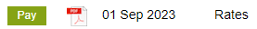
- Select the payment option  - Pay in Full (due 15 February)  - Instalment (due 30/09, 30/11, 28/02 & 31/05) | 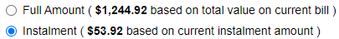
- Change payment date if you want to schedule the payment for a future date  - Leave date if you want to pay today | 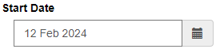
- Use the drop down arrow to select an existing account for payment
  - Click on ‘Pay’ button to make a payment
- OR click on ‘Add New’ button to create a new payment method
 | OR 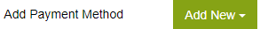
- Click on Make Payment button | 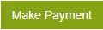
- Check payment details are correct
- Click on Back button to change details if required
- Tick the I’m not a Robot | 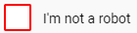
- Click on Confirm button to proceed | 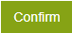
- The Pay button will no longer show if the rates have been paid

EDIT YOUR DETAILS

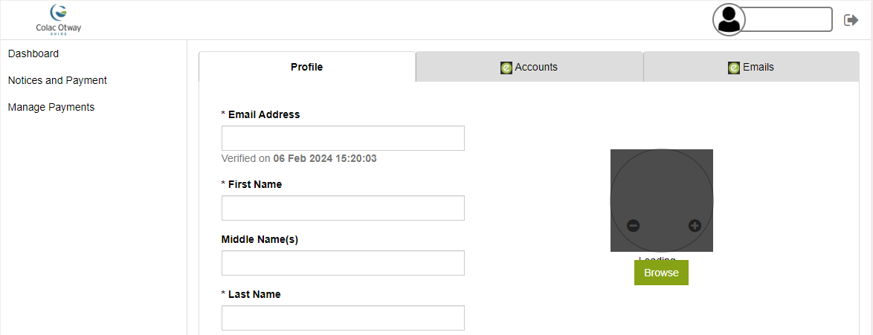

- Click on Update Contact Details or your name | or
- Profile Tab  - Change your email  - Change name or contact details  - Change password  - Add or remove a payment method | 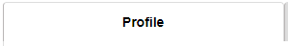
 | 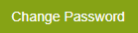
  - Accounts Tab
  - Add new accounts
  - Remove account
 | 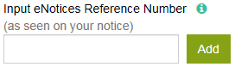
  - Emails Tab
  - Add additional emails to send notice/s to
 | 