Planning and Environment Act 1987

COLAC OTWAY PLANNING SCHEME
AMENDMENT C125cola

EXPLANATORY REPORT

Overview
The amendment removes the Development Plan Overlay Schedule 2 (DPO2) from the Colac West residential area and applies a new Development Plan Overlay Schedule 9 (DPO9). The amendment also amends Clause 17.03-1L (Industrial Development in Colac), Schedule 1 to the Design and Development Overlay (DDO1) and Schedule 7 to the Development Plan Overlay (J Barrys Road, Colac Industrial Area) (DPO7) to reduce the minimum lot size for industrial land in Colac.
The amendment seeks to strengthen the planning provisions for residential land in Colac West covered by the existing DPO2 (Future Residential Areas). It introduces a new DPO9 (Colac West) which contains additional design requirements for the preparation of a Development Plan for land in Colac West bounded by Murray Street to the south, Rifle Butts Road to the west, Lake Colac to the north, and existing residential development and the former Colac High School to the east. The amendment also includes a statutory provision to prepare a Shared Infrastructure Funding Plan in association with the Development Plan.
The amendment also seeks to promote a range of lot sizes, including large lot sizes on land covered by the existing DPO7 (J Barrys Road, Colac Industrial Area), and more generally provide greater flexibility in lot sizes in Colac’s industrial areas.
Where you may inspect this amendment
The amendment can be inspected, free of charge, at:
- Colac Otway Shire Council website at https://www.colacotway.vic.gov.au/Planning-building/Strategic-planning/Planning-scheme-amendments
- Colac Otway Shire Service Centre, 2-6 Rae Street, Colac (during office hours)
- Department of Transport and Planning website at http://www.planning.vic.gov.au/public-inspection or by contacting the office on 1800 789 386 to arrange a time to view the amendment documentation.
Submissions
Any person who may be affected by the amendment make a submission to the planning authority. Submissions about the amendment must be received by 16 November 2023.
A submission must be sent to: inq@colacotway.vic.gov.au
Panel hearing dates
In accordance with clause 4(2) of Ministerial Direction No.15 the following panel hearing dates have been set for this amendment:
- directions hearing: Week commencing 15 January 2024
- panel hearing: Week commencing 4 March 2024

Details of the amendment

Who is the planning authority?
This amendment has been prepared by the Colac Otway Shire, which is the planning authority for this amendment.

Land affected by the amendment
The amendment applies to land within the Colac West Residential Area covered by the Development Plan Overlay Schedule 2 (Future Residential Areas) and industrial land covered by the Design and Development Overlay Schedule 1 (Colac Industrial Areas) and Development Plan Overlay Schedule 7 (J Barrys Road, Colac Industrial Area) of the Colac Otway Shire Planning Scheme as shown on the maps below.
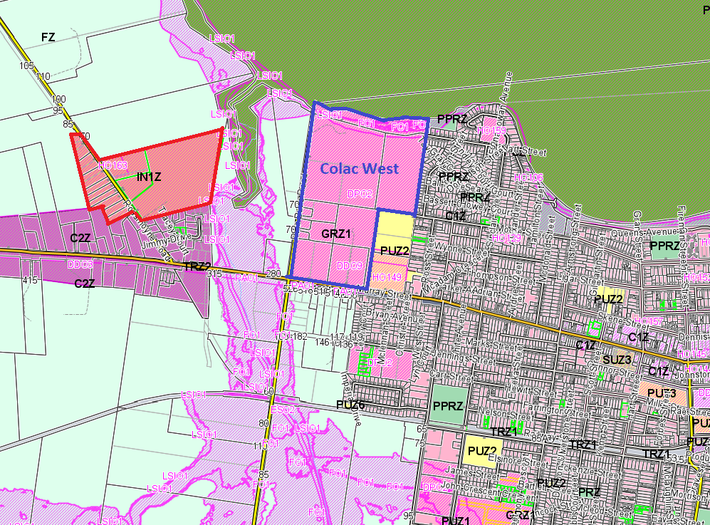
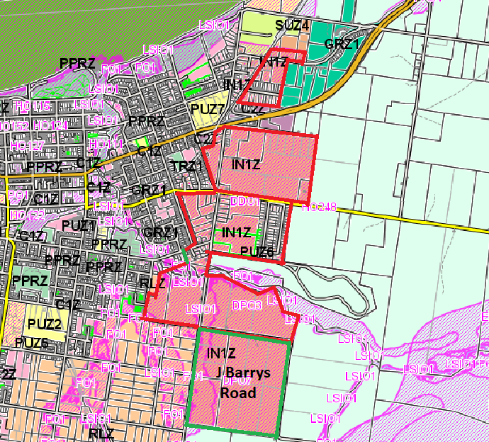

What the amendment does
The amendment removes the Development Plan Overlay Schedule 2 (DPO2) from the Colac West residential area and applies a new Development Plan Overlay Schedule 9 (DPO9). The amendment also amends Clause 17.03-1L, Schedule 1 to the Design and Development Overlay (DDO1) and Schedule 7 to the Development Plan Overlay (J Barrys Road, Colac Industrial Area) (DPO7) to reduce the minimum lot size for industrial land in Colac.
Specifically, the amendment:
- Amends Planning Scheme Map Nos. 5DPO and 11DPO to delete DPO2 from the West Colac residential area and apply DPO9 to the land.
- Amends Clause 17.03-1L (Industrial Development in Colac) to encourage a range of industrial lot sizes.
- Amends Schedule 1 to Clause 43.02 Design and Development Overlay to delete the minimum lot size for subdivision of industrial land.
- Amends Schedule 7 to Clause 43.04 Development Plan Overlay to reduce the minimum lot size for subdivision of land within the J Barrys Road, Colac Industrial Area.
- Inserts a new Schedule 9 to Clause 43.04 Development Plan Overlay to provide additional design requirements for the preparation of a Development Plan for residential land in Colac West.

Strategic assessment of the amendment

Why is the amendment required?
The planning scheme amendment is required to update planning controls affecting two parts of Colac.
1. Colac West Development Plan Area (land bounded by Murray Street to the south, Rifle Butts Road to the west, Lake Colac to the north, and existing residential development and the former Colac High School to the east)
The first part to the amendment is to introduce Development Plan Overlay Schedule 9 to land currently included in existing Development Plan Overlay Schedule 2 (Future Residential Areas) to provide a higher level of specific design detail applicable to land in the Colac West Development Plan Area as described above, and to include a specific requirement for a Shared Infrastructure Funding Plan for the land. These items include elements that reflect the current work occurring by Council in preparing a Development Plan for the land and to provide certainty that a Shared Infrastructure Funding Plan is a requirement of the Development Plan.
Council has been assisting landowners in Colac West to prepare a Development Plan over a number of years. While substantial progress has been made in the preparation of the plan, its finalisation is waiting on a final decision concerning the location of a key stormwater drainage facility. Alternative locations for this facility have been explored at the request of two key landowners. This work is ongoing.
There is currently no requirement in the Planning Scheme to prepare a Shared Infrastructure Funding Plan for the Colac West Development Plan Area. However, there are a number of assets within the Development Plan Area that are key shared infrastructure items that will need to be funded across the Development Plan Area. Council must ensure that a Shared Infrastructure Funding Plan forms part of the Development Plan Schedules to ensure key shared infrastructure is provided in an equitable manner and to collect contributions from those who benefit from the infrastructure and to reimburse those that are affected by the infrastructure or chose to build the infrastructure as works in kind. Without the Shared Infrastructure Funding Plan being an explicit requirement in the planning scheme, Council exposes itself to potential legal challenge and financial risk.
In addition to including the Shared Infrastructure Funding Plan in the new DPO9 Schedule for Colac West, it is proposed to strengthen the requirements of the Development Plan Overlay to include key design elements that are part of the draft development plan that has been prepared to date. These include:
- the north-south boulevard from Murray Street to the Lake Colac foreshore along the western boundary of the former high school land.
- the east-west extension of Moore Street across to Rifle Butts Road.
- a flood free shared pathway along the Lake Colac foreshore.
- a stormwater wetland detention basin to treat run-off from the land before it enters Lake Colac.
2. J Barrys Road, Colac Industrial Area (south east of the intersection of Forest Street, Hearn Street and J Barrys Road, Colac
The second part of the amendment is intended to change the existing Development Plan Overlay Schedule 7 for the J Barrys Road, Colac Industrial Area to provide flexibility in the minimum lot size requirement to align with market interest in industrial lots. This change would assist in the development of the land for industrial purposes while retaining a requirement for larger lot sizes.
Council has been preparing a Development Plan for the J Barrys Road Industrial Area utilising funding from the Victorian Planning Authority. Development Plan Overlay Schedule 7 states that the development plan must include the following requirements:
The general subdivision layout including location and distribution of lots showing a variety of lot sizes with a minimum size of five hectares. The layout is to maximise solar efficiency to as many lots as possible.
This reflects a minimum lot size of five hectares specified for all industrial areas in Colac, including this land, affected by the Design and Development Overlay (DDO1).
The original strategic planning intention for the J Barrys Road Industrial Area was for lots with a minimum size of five hectares to attract industrial development that required a larger footprint than the smaller scale industrial areas elsewhere in Colac, such as Rossmoyne Road and Hugh Murray Drive. It is still intended that the J Barrys Road Industrial Area cater for larger lot sizes. However, a minimum lot size of five hectares is not what the market has been seeking. Advice from Colliers International suggests that there is a competitive market for lots in the one to two hectare size range.
The planning scheme is to be amended to remove the mandatory five-hectare minimum requirement from both the DPO7 and DDO1 planning controls to ensure there is greater flexibility in development options moving forward. The Schedules will be amended to build in flexibility to meet market demand while catering for a mix of smaller lots in accordance with market recommendations, and to include an ability to retain lots over five-hectares to attract and cater for larger scale industries.
3. Industrial areas in Colac
A consequential amendment adjusts the wording of the Planning Policy Framework at Clause 17.03-1L (Industrial Development in Colac).
In addition, an anomaly in Schedule 7 to Clause 43.04 Development Plan Overlay (J Barrys Road, Colac Industrial Area) is to be corrected removing an incorrect reference to an incorporated plan and replacing with the correct reference to a development plan, at 2.0 Requirement before a permit is granted.

How does the amendment implement the objectives of planning in Victoria?
The amendment implements the objectives of planning in Victoria. It provides for the fair, orderly, economic and sustainable use and development of land and enables the orderly provision and co-ordination of public utilities and other facilities for the benefit of the community. The amendment also ensures a sufficient supply of industrial and residential land in Colac.
The amendment also results from the regular review of the Colac Otway Planning Scheme to ensure that it is maintained in a clear and useable form and that land can be used and developed in accordance with the Act.

How does the amendment address any environmental, social and economic effects?
The proposed amendment has positive environmental, social and economic benefits by co-ordinating development in Colac to facilitate the provision of more housing supply, protecting the environment and providing more flexibility in the provision of industrial lot sizes, while still catering for the needs of larger industries.
The amendment for the Colac West Development Plan Area also ensures that public infrastructure is provided through the development of land in a fair and equitable manner.

Does the amendment address relevant bushfire risk?
The proposed amendment does not impact on existing bushfire controls and will not result in any increase to the risk to life, property, community infrastructure and the natural environment from bushfire. Any future development will be considered under the Bushfire Area Mapping requirements as part of the Building Codes.

Does the amendment comply with the requirements of any Minister’s Direction applicable to the amendment?
The amendment is consistent with the Ministerial Direction on Form and Content of Planning Schemes under section 7(5) of the Act. Ministerial Direction No. 11 (Strategic Assessment of Planning Amendments) is addressed through this explanatory report.

How does the amendment support or implement the Planning Policy Framework and any adopted State policy?

The amendment supports relevant strategies at Clause 11.01-1S (Settlement) to:

Develop sustainable communities through a settlement pattern offering convenient access to jobs, services, infrastructure and community facilities.

Support sustainable development of regional centres such as Colac.
The amendment implements Clause 11.01-1R (Settlement – Geelong G21) by supporting the G21 Regional Growth Plan with Colac designated as a District town with a key existing / planned employment node.
The amendment implements Clause 11.01-1L (Colac urban growth) by supporting the growth of Colac consistent with its role as the major urban centre of the Shire.
The amendment is consistent with Clause 17.03-1S (Industrial land supply) by providing an adequate supply of industrial land in appropriate locations including sufficient stocks of large sites for strategic investment, and planning existing industrial areas to facilitate further industrial development.
The amendment also gives effect to Clause 17.03-1R (Industrial land supply – Geelong G21) by planning for the expansion of industrial employment areas at Colac.
Clause 17.03-1L (Industrial development in Colac) is amended to provide a range of industrial lot sizes, including larger lots, to encourage industrial development in Colac’s eastern industrial areas, including the J Barrys Road Industrial Area, for a diverse range of light to general industrial activities while ensuring a sufficient supply of land for large scale industrial development.
The amendment implements Clause 19.03-2S (Infrastructure design and provision) by ensuring the timely, efficient and cost-effective provision of development infrastructure that meets the needs of the community. The proposed DPO9 includes the requirement for a Shared Infrastructure Funding Plan.

How does the amendment support or implement the Municipal Planning Strategy?
The amendment supports the Municipal Planning Strategy by planning for growth in business and employment and managing infrastructure assets so they are sustainable in the long term.
The amendment also supports major industrial development, particularly in East Colac consistent with the strategic directions of the Colac Framework Plan at Clause 02.04.

Does the amendment make proper use of the Victoria Planning Provisions?
The proposed amendment does not introduce any new zone or overlay mechanisms, and improves the current performance of the existing Development Plan Overlays to support the proper use of the Victoria Planning Provisions.

How does the amendment address the views of any relevant agency?
Relevant authorities and Prescribed Ministers will be notified as part of the standard notice requirements during the exhibition period of this amendment.

Does the amendment address relevant requirements of the Transport Integration Act 2010?
The amendment will not have a significant impact on the Transport Integration Act 2010.

Resource and administrative costs

What impact will the new planning provisions have on the resource and administrative costs of the responsible authority?
The amendment will result in no negative impact on resource and administrative costs for the Responsible Authority as the proposed changes are minor in nature. Administration of the Colac Otway Planning Scheme will be more efficient as a result of the amendments.
The Colac West Development Plan Area amendment will provide a funding mechanism for Shared Infrastructure items that require funding through the development of the Development Plan Area.

