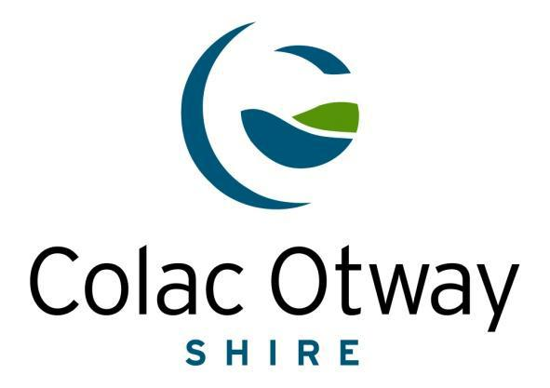

**ELECTRIC LINE CLEARANCE**

**MANAGEMENT PLAN**

**MARCH 2023**

**ELECTRIC LINE CLEARANCE**

**MANAGEMENT PLAN**

**MARCH 2023**

|  |  |
| --- | --- |
| **Document number:** | **ELCMP** |
| **TRIM File number:** | **D20/99176** |
| **Authorised by:** | **Anne Howard**  **Chief Executive Officer** |
| **Authorisation Date:** |  |
| **Electronic Signature:** |  |

**For - Energy Safe Victoria**

|  |  |  |
| --- | --- | --- |
| Revision No | Date | Details |
| 0 | 28/03/2020 | Draft Colac Otway Shire (COS) review |
| 1 | 14/04/2020 | COS internal review after feedback from ESV |
| 2 | 4/05/2020 | Completed review and ESV notified |

**Contents**

Definitions 5

Structure of Plan 6

ELECTRIC LINE CLEARANCE MANAGEMENT PLAN SUBMITTED BY: 6

9(2) Preparation of a Management Plan 6

9(3) Management Plan requirements 6

9(3)(a) Name, Address and Telephone Number of the Responsible Person: 6

9(4)(b) Name, Address and Telephone Number of the Person Who was responsible for the Preparation of the Plan: 7

9(4)(c) Name, position, address and telephone number of the persons who are responsible for carrying out the plan: 7

9(4)(d) The telephone number of a person who can be contacted in an emergency that requires clearance of an electric line that the responsible person is required to keep clear of vegetation. 7

9(4)(e) The objectives of the plan. 8

9(4)(f) The land the management plan applies. 8

9(4)(h) The location of areas that the responsible person knows contain a tree that the responsible person may need to cut or remove to ensure compliance with the Code and that is: 9

(i) Native 9

(ii) Listed in the Planning Scheme to be of ecological, historical, or aesthetically significant: 10

(iii) Trees of cultural or environmental significance: 10

9(4)(i) The means which the responsible person is required to use to identify a tree specified in (g): 10

9(4)(j) The management procedures which the responsible person is required to adopt to ensure compliance with the Code, which must: 12

9(4)(k) The procedures to be adopted if it is not practicable to comply with the requirements of AS 4373 while cutting a tree in accordance with the Code: 20

9(4)(l) A description of each alternative compliance mechanism in respect of which the responsible person has applied, or proposes to apply, for approval under clause 31 of the Code. 22

9(4)(n) A description of the measures to assess the performance of the responsible person under the management plan. 22

9(4)(o) Details of the audit processes that must be used to determine the responsible person’s compliance with the Code: 23

9(4)(p) The qualifications and experience that the responsible person must require of the persons who are to carry out the inspection, cutting or removal of trees in accordance with the code: 25

9(4)(q) Notification and consultation procedures:……………………………………………………………………………..………………25

9(4)(r) Dispute resolution procedures:………………………………………………………………………………………………………………26

4. A method for determining an additional distance that allows for cable sag and sway may provide for different additional distances to be determined for different parts of a span of an electric line:…………………………..…………..27

7a. A responsible person must ensure that a copy of the management plan is published on the responsible person's internet site:………………………………………………………………………………………………………………………………………….27

7b. A responsible person must ensure that a copy of the management plan is available for inspection at the responsible person's principal office in the State during normal business hours:……………………………………………….28

2a. A responsible person who receives an exemption must ensure that a copy of the exemption is published on the responsible person's Internet site:……………………………………………………………………………………………………………….28

2b. A responsible person who receives an exemption must ensure that a copy of the exemption is available for inspection at the responsible person's principal office in the State during normal business hours:…………………..28

4. Exception to minimum clearance space for structural branches around insulated low voltage electric lines only:……………………………………………………………………………………………………………………………………………………………….….29

5. Exception to minimum clearance space for small branches around insulated low voltage electric lines only:29

6. Exception to minimum clearance space for structural branches around uninsulated low voltage electric lines in low bushfire risk areas:……………………………………………………………………………….……………………………………………………..29

8. Responsible person may cut or remove hazard tree:……………………………………………………………………………………. 30.

10. Cutting or removal of:………………………………………………………………………………………………………………………………….30

16. Responsible person must publish notice before cutting or removing certain trees:…………………………………….30

20. Duty relating to the safety of cutting or removal of trees close to an electric line:………………………………………..30

APPENDIX 1- Map of Declared Area 33

Title : Map of Declared Area - Electric Line Clearance Management Plan 34

APPENDIX 2 - Areas of Vegetation Determined to be Historically or Culturally Important or of Outstanding Aesthetic Value ..…………………………………………………………………………………………………………………………………………….35

APPENDIX 3- Approval to Work Procedure 48

# Definitions

**Code –** Code of Practice for Electric Line Clearance as defined in the Schedule of the Electricity Safety (General) Regulations 2020.

**COS** – Colac Otway Shire Council

**Conductor –** Overhead powerline.

**CM**- Content Manager

**Declared Area** – The area of the municipality where vegetation management around powerlines is the responsibility of Colac Otway Shire Council.

**DELWP** - Department of Environment, Land, Water and Planning.

**ELCMP**- Electric Line Clearance Management Plan

**ESV** – Energy Safe Victoria.

**HV** – High voltage means a nominal voltage exceeding 1000 volts AC. or exceeding 1500 volts DC.

**LBRA –** Low Bushfire Risk Area - An area that a fire control authority has assigned a fire hazard rating of “low” under section 80 of the Act; or an urban area.

**LV** – Low Voltage means nominal voltage exceeding 50V AC or 120V DC but not exceeding 1000V AC or 1500V DC.

**Plan** –Colac Otway Shire Council Electric Line Clearance Management Plan.

**Regulations** - Electricity Safety (General) Regulations 2019.

**The Act** – Electricity Safety Act 1998.

## Structure of Plan

The Electric Line Clearance Management Plan has been structured to align with the relevant clauses of the Regulations. The corresponding section of the plan is numbered identically to the section of the Regulations to allow for cross referencing.

# ELECTRIC LINE CLEARANCE MANAGEMENT PLAN SUBMITTED BY:

**Name:** Heath Chasemore

General Manager Environment & Infrastructure

Colac Otway Shire Council

**Date:** March 2023

The following sections are in response to Regulation 9(2) – Preparation of a Management Plan, Part 2 of the Electricity Safety (General) Regulations 2019.

## 9(2) Preparation of a Management Plan

Colac Otway Shire, General Manager Environment & Infrastructure or delegated authority will review and amend the Plan annually. The amended document will be submitted to the General Manager Infrastructure & Leisure Services for review and authorisation prior to the 31st March each year.

Preparation of this document is scheduled in the Parks Services and Assets calendar for the first week in January every year. The preparation of this document will include a review of all processes and procedures and their effectiveness in meeting the plan objectives.

The new document will be submitted to the CE for authorisation prior to the 31st March each year. The superseded document will be removed from circulation on 30 June of each year and replaced with the new approved document.

Colac Otway Shire, Manager Services & Operations will submit the Plan within 14 days of a request.

The following sections are as per Regulation 9(3) of the Electricity Safety (General) Regulations 2019

## 9(3) Management Plan requirements

## 9(3)(a) Name, Address and Telephone Number of the Responsible Person:

|  |  |
| --- | --- |
| Name: | Colac Otway Shire Council |
| Business Address: | 2-6 Rae St, PO Box 283 |
|  | Colac VIC 3250 |
| Email: | inq@colacotway.vic.gov.au |
| Telephone No.: | (03) 5232 9400 |
| Facsimile No.: | (03) 5232 1046 |
| Name of Chief Executive Officer: | Anne Howard |

## 9(4)(b) Name, Address and Telephone Number of the Person Who was responsible for the Preparation of the Plan:

|  |  |  |
| --- | --- | --- |
| Name: | Heath Chasemore |  |
| Position: | General Manager Environment & Infrastructure |  |
|  | Colac Otway Shire Council |  |
| Address: | 2-6 Rae St |  |
|  | Colac VIC 3250 |  |
| Telephone No.: | (03) 5232 9482 |  |
| Facsimile No.: | (03) 5232 1046 |  |
| Email: | Heath.chasemore@colacotway.vic.gov.au |  |
|  |  |  |

## 9(4)(c) Name, position, address and telephone number of the persons who are responsible for carrying out the plan:

|  |  |  |
| --- | --- | --- |
| Name: | Cameron Duthie | |
| Position: | Manager Services & Operations | |
| Address: | 140 Pound Rd | |
|  | Elliminyt VIC 3250 | |
| Telephone No.: | (03) | 5232 9449 |
| Facsimile No.: | (03) | 5232 1046 |
| Email: | Cameron.duthie@colacotway.vic.gov.au | |

## 9(4)(d) The telephone number of a person who can be contacted in an emergency that requires clearance of an electric line that the responsible person is required to keep clear of vegetation.

|  |  |  |  |  |
| --- | --- | --- | --- | --- |
| Name: | Mark Robinson | |  | |
|  | Team Leader Parks & Gardens | |  | |
| Address: | 140 Pound Rd |  |  | |
|  | Elliminyt VIC 3250 |  |  | |
| Emergency Telephone No.: | 0428 523 433 & (03) 5232 9526 |  |  | |
|  | (After hours pager service operates) | |  | |
| Email: | Mark.Robinson@colacotway.vic.gov.au | |  | |
|  |  | |  |  |

## 9(4)(e) The objectives of the plan.

The following are identified as key objectives of this Plan in fulfilling Council’s obligations as being a responsible person for the purposes of the relevant provisions of the Electricity Safety Act 1998.

* To maintain public safety.
* To comply with the Regulations and Code, whilst protecting areas of important vegetation as identified in the Plan.
* To minimise fire starts that may occur due to contact between vegetation and the electricity network.
* To assist in the provision of reliable electrical supply.
* To support workplace safety.
* To manage vegetation in a manner that maximises the amenity and environmental benefits.
* To protect areas of important vegetation which may be deemed as such on the basis of those areas listed in a planning scheme to be of ecological, historical or aesthetic significance or trees of cultural or environmental significance.
* To maintain community satisfaction with the manner in which the necessary works are carried out.
* To continuously improve the Plan and its implementation through the use of measurable Key Performance Indicators as defined in clause 9(4)(n)

## 9(4)(f) The land the management plan applies.

**Declared Area Boundary**

Council’s declared areas are gazetted by State government as prescribed in the State Electricity Act 1998 and are based within the Colac city township as it was in 1986. For operational purposes, Council has replicated these maps which are based on the formal ESV database maps (<https://eservices.esv.vic.gov.au/LineClearance/> Detailed (scaled) maps are produced for contractors each year to use for ELC clearing purposes. Council GIS layers can be used to determine exact boundary locations.

Declared area(s) within the Colac Otway Shire are shown in **Appendix 1**.

**9(4)(g)**

**Hazardous Bushfire Risk Area (HBRA) and Low Bushfire Risk Areas (LBRA)**

The CFA produce Hazardous and Low Bushfire Risk maps as prescribed by Section 80 of the Electricity Safety Act 1998. COS declared areas are predominately LBRA. Small sections of HBRA exist in the Colac Township. Council requests the GIS layers from the CFA each year to confirm if any changes have been made to HBRA boundaries. Contractors are provided with a hard copy of these maps. Current HBRA mapping has been loaded onto the COS GIS system and available in high resolution maps supplied to ELC contractors. For further details on Hazardous Bushfire rating maps please refer to the Colac declared area map book in Appendix 1

## 9(4)(h) The location of areas that the responsible person knows contain a tree that the responsible person may need to cut or remove to ensure compliance with the Code and that is:

## (i) Indigenous to Victoria

The trees that require clearing from electric lines typically occur within nature strips, road reserves, recreation reserves and other areas of land within the Declared Areas managed by Council.

The street tree population of the City of Colac represents an established, healthy, significant tree resource of varying ages, sizes and types.

For the purposes of this ELCMP Definition of Indigenous to Victoria: means indigenous to the COS local government area. There are a variety of tree species throughout the Declared Areas, which are native to Australia, however some are not native to the area or region (indigenous) or affected by this ELCMP.

The Southern part of the declared area is predominantly vegetated with native trees. Whilst not individually mapped, such trees are recorded in Council’s tree database. The predominant categories of vegetation located on public open space and in urban streets are:

**North of Princess Highway (Murray Street)**

Predominantly exotic species being generally Fraxinus, Ulmus and Plane trees

**South of Princess Highway (Murray Street)**

Predominantly a mix of natives being generally Melaleucas and Eucalypts

To ensure the trees are identified correctly the COS utilises suitably qualified arborists for inspections who are able to identify the relevant species.

COS will ensure staff and contractors involved in works covered under this Plan are aware of the location of indigenous to Victoria vegetation.

Council will as far as practicable, restrict cutting or removal of trees indigenous to Victoria or trees of cultural or environmental significance to the minimum extent necessary to ensure compliance with the requirements of the code, the schedule to the code or to make an unsafe situation safe. The use of mechanical equipment may be deployed when it is unsafe to put in a standard crew. All pruning of Native/significant trees will be within the framework of AS4373.

**Habitat for Threatened Fauna**

If it is found that a tree contains occupied habitat the following process will be implemented to manage the tree/s;

* As soon as a tree is identified as the habitat of a possibly threatened species, the operator must stop work and inform their supervisor, or Council, and seek clarification of the threatened species and the breeding season of that species. Council or the contractor will consult the following;
* EPBC Act List of Threatened Flora or Fauna - <http://www.environment.gov.au/biodiversity/threatened>
* Threatened Flora List
* Threatened species advisory lists
* Works will be scheduled outside of breeding season where practicable
* Where it is not practicable to undertake cutting or removal of the tree outside of the breeding season for that species, translocation of the fauna will be undertaken wherever practicable.

Threatened Invertebrate Fauna List means the Advisory List of Threatened Fauna in Victoria published by the Department of sustainability and Environment as published or amended from time to time. Council will refer to <http://www.environment.gov.au/biodiversity/threatened>

## (ii) Listed in the Planning Scheme to be of ecological, historical, or aesthetically significant:

Colac Otway Planning Scheme identifies a number of places and precincts within Colac, where tree control is to apply. These are:

* HO127 Manifold St Culverts,
* HO114 Botanic Gardens Colac,
* HO307 Residential Colac Precinct and
* HO308 Memorial Square Precinct.

Information on areas within Colac of heritage significance are detailed in Appendix 2.

The Colac Otway Shire Heritage Overlay provides that a permit is not required to remove, destroy or lop a tree if it relates to any action which is necessary to keep the whole or any part of

a tree clear of an electric line provided the action is carried out in accordance with a Code of Practice prepared under Section 86 of the Electricity Safety Act 1998.

COS is continuing to develop a register of Significant trees as part of its asset management framework.

## (iii) Trees of cultural or environmental significance:

There are no known trees of ecological or habitat significance for rare or endangered species listed in Councils declared areas within the vicinity of powerlines that require pruning or clearing to ensure compliance with the Code of Practice.

Council’s Konnect database shows indigenous or significant trees. Printed maps to be given as part of contractor’s initial induction meeting prior to commencing works.

There are no known trees which are identified on the Victorian Aboriginal Heritage Register that are impacted on by Council’s vegetation management activities associated with powerline clearance.

## 9(4)(i) The means which the responsible person is required to use to identify a tree specified in (h):

Council does not have specific maps which address predominant vegetation types. Council has all street trees in the Colac area on the Konnect database.

There are no known trees of ecological significance listed in Councils declared areas. Where these are identified in the future, all maps and information available to Council will be used to monitor these areas to ensure that minimal impact is made in the event of works being required.

Where appropriate, Council will undertake minimal pruning of vegetation as part of the pruning program of street trees and trees located in Public Open Space in the vicinity of powerlines.

All pruning activities will comply with the standards and specifications as detailed in ***AS4373-2007 Pruning of Amenity Trees***. Pruning may be undertaken using elevated work platforms or other similar methods in an effort to minimise overall site damage.

The declared area managed by the Colac Otway Shire Council is predominantly a developed urban area and as such no habitat trees for rare or endangered species are known to exist.

The responsible person will consult the following resources at least annually to ensure the accuracy of Council’s knowledge on the location of such trees:

* Annual inspection and identification of Council trees by qualified arborist
* Threatened Flora List in accordance with section 10 of the Flora and Fauna Guarantee Act 1988 - Advisory List of rare or threatened plants in Victoria. (Endangered or Vulnerable)
* Flora or Fauna as listed as threatened with a status of ‘Vulnerable’ ‘Endangered ‘or critically endangered. <https://www.environment.vic.gov.au/conserving-threatened-species/flora-andfauna-guarantee-act-1988/protected-flora-controls>
* Threatened Vertebrate Fauna List <http://www.environment.gov.au/biodiversity/threatened> Threatened Invertebrate Fauna List – Advisory List threatened invertebrate Fauna in Victoria.<https://www.environment.vic.gov.au/conserving-threatened-species/threatened-speciesadvisory-lists>
* Council planning scheme overlay for historical, cultural, environmental or aesthetic significance
* Register of significant trees; • Heritage Register (http://vhd.heritagecouncil.vic.gov.au/) within the meaning of the Heritage Act 1995
* Council will be notified by Victorian Aboriginal Heritage Council of any changes to the Victorian Aboriginal Heritage Register. The Victorian Aboriginal Heritage Register is not a publicly accessible register because it contains culturally sensitive information. Applicants may apply online for access or advice using the Aboriginal Cultural Heritage Register and Information System (ACHRIS - <https://applications.vic.gov.au/apps/achris/public/request-for-access/enter>) established under section 144 of the Aboriginal Heritage Act 2006
* EPBC Act List of Threatened Flora or Fauna <http://www.environment.gov.au/cgibin/sprat/public/publicthreatenedlist.pl?wanted=flora>
* Council will determine location of important vegetation by consulting Environment protection and Biodiversity Conservation Act 1999 (EPBC), list of threatened flora, list of threatened ecological communities, list of threatened fauna and protected matter search tool <http://www.environment.gov.au/epbc/protected-matters-search-tool>

Council will undertake cutting or removal of the tree outside of the breeding season for that species. Where it is not practicable to undertake cutting or removal of the tree outside of the breeding season for that species, translocation of the fauna will be undertaken wherever practicable.

Should a tree be identified as either being of cultural significance or listed on the Victorian Aboriginal Heritage Register established under ***Aboriginal Heritage Act 2006***, Council will contact either the Registered Aboriginal Party for the area or Aboriginal Victoria to determine the need for obtaining a Cultural Heritage Permit or the preparation of a Cultural Heritage Management Plan. No further pruning or clearing work associated with the identified tree will occur until all statutory requirements are fulfilled or it has been determined that permits, etc. are not necessary for Council’s activities.

The Colac Botanic Gardens has been included in the Victorian Heritage Register in recognition of their cultural, historical, and botanic significance. This heritage listing applies to the entire

gardens precinct and includes certain exemptions for maintenance and management of the area. Trees in the vicinity of overhead electric lines within the Colac Botanic Gardens will be managed to comply with the clearance limits prescribed by the Code of Practice for Electric Line Clearance. The exemptions provided by the heritage listing and dependent on Council ensuring that all trees are managed and pruned in accordance with ***AS 4373-2007 Pruning of Amenity Trees*** (as amended) as a minimum standard.

Any associated records will be filed in Council’s document management system and retained in accordance with the Retention and Disposal Authority for Records of Local Government Functions to ensure compliance with the ***Public Records Act 1973***.

## 9(4)(j) The management procedures which the responsible person is required to adopt to ensure compliance with the Code, which must:

#### Include details of the methods proposed to be adopted for managing trees and maintaining a minimum clearance space as required by the Code.

**Inspection/pruning programs and schedules**

Council has determined that the electric line clearance inspection and pruning will be undertaken annually for maintaining the statutory clearance space between vegetation and powerlines. This period provides the greatest opportunity to maximise the amenity value of its street trees. A qualified inspector will conduct annual inspections and provide a report of findings to Councils Responsible Person. Identified works of any pruning required are to ensure the street trees remain clear of electrical lines. Each inspection shall be fully documented, and each street visited shall be identified.

The High voltage and High Bushfire Risk areas within the declared area may require an additional inspection by an qualified inspector before the Fire danger period is declared each year.Council’s Parks & Gardens Team Leader or nominated officer will focus primarily on the powerline clearance program for the duration of the annual program each year rather than their normal role.

Council’s ELCMP reflects our current Street Tree Policy which can be found on council’s website at <http://www.colacotway.vic.gov.au/Council-the-shire/Council-policies#section-11>

Council has a draft Urban Forestry Strategy which nominates unsuitable species and also gives suitable planting combinations to place in streetscapes containing overhead powerlines.

Council will base its program around prioritising the HBRA and ensure all clearing is completed prior to the Declared Fire Season of each year.

Council requests HBRA mapping from the CFA to determine the location of the HBRA affected spans, advising cutting contractors of these locations to enable them to apply correct clearance requirements.

The inspection of declared areas is conducted each year .The Cutting Crew is required to maintain the vegetation clear of the minimum clearance space plus an additional allowance for 12 months. Trees unable to achieve 12 mths clearance are reported to the Parks & Gardens Team Leader. The Council will utilise this information to evaluate the growth rates and size of all trees near powerlines and then take appropriate action to remove fast growing and tall trees and replace with appropriate species or replace powerlines with engineering solutions.

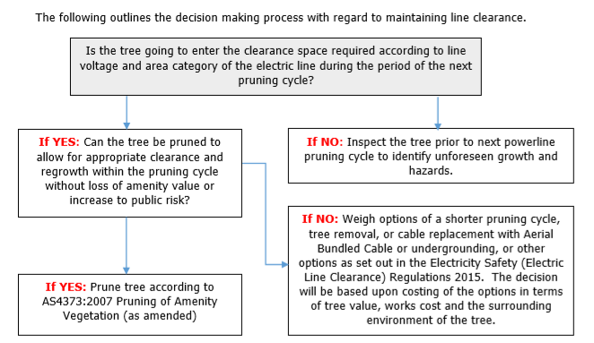

**IF NO: Weigh options of a shorter pruning cycle, tree removal, or cable replacement with Aerial Bundled Cable or undergrounding, or other options as set out in the Electricity Safety (General) Regulations 2019. The decision will be based upon costing of the options in terms of tree value, works cost and the surrounding environment of the tree.**

In the inspection, trees which are in breach of the Code will be identified. In addition, any trees which are determined to be likely to breach the Code in the next twelve months are also to be identified.

In making these evaluations and before deciding on the most appropriate method, due consideration is given to the site's specifics, including:

* the significance of the site as a natural habitat of endangered species of both flora and fauna
* relocation of the powerline from the vegetation evaluating the savings achieved by avoiding the recurrent costs of cutting and assessing the benefits of implementing available and practicable alternative construction methods
* the significance and public value of the site's aesthetics
* the impact on the tree's amenity and utility value if subjected to pruning versus removal
* the sites suitability to accept more appropriate species as replacements
* the environmental impact of proposed works
* determining the most appropriate method of actioning the offending vegetation concerned
* appropriate planning and scheduling
* identification and quantification of equipment and accredited personnel required
* any hazards outside the clearance and regrowth spaces that may require assessment or correction
* funding
* community and customer consultation
* Compiling a data base in conjunction with the Distribution Company that can be used in future years in determining costs associated with different clearance techniques.

All pruning works will be undertaken in accordance the Electricity Safety (General) Regulations 2019, AS4373:2007 Pruning of Amenity Trees and best practice methods.

**Emergency Cutting and Pruning**

Council will undertake emergency cutting and pruning activities in the following situations:

* Where a tree is identified as encroaching the clearance space due to unanticipated growth
* As a result of a tree falling or becoming damaged so that it requires cutting or removal to maintain the required clearance space; or
* Where a tree has been assessed by a suitably qualified arborist and confirmed to have an imminent likelihood of contacting the electric lines having regard to foreseeable local conditions.

As part of such works Council will record where and when the cutting or removal was undertaken, identify why the cutting/removal was required and record when the last inspection of the tree occurred.

Council will undertake its urgent works in accordance with the Regulations and not remove or cut any more than one metre from the minimum clearance space around the electric line. Ongoing monitoring by visual assessment of the regrowth rates of Council’s trees growing under powerlines will be undertaken to ensure continued compliance.

**Notified Work Required/Conducted**

Locations notified by the Distribution Company or any other interested party as requiring attention to maintain powerline clearance that are responsibility of the Municipality will be assessed by the Responsible Person as soon as practical following receipt of the notice.

The Responsible Person will convey to the contractor, the site of any pruning’s notified by the Distribution Company as being the result of emergency clearing. The work of removing the pruning’s will be programmed by the contractor.

**Hazard Trees**

A hazard tree is a tree that:

* a suitably qualified arborist has assessed the tree in regard to foreseeable conditions and advised the tree or part of the tree is likely to fail and will contact an electric line if this occurs.

All identified hazard trees are to be cleared to ensure compliance is maintained and in a time, that prevents the tree from entering the clearance space. Hazard trees are to be cleared only when it is safe to do so and if a Hazard tree cannot be removed in a timely manner, Powercor are to be contacted to discuss other means of removal or Powerline disconnection.

As part of the annual inspection Council will seek to identify vegetation infringing on clearance space within the declared area. The Inspection includes the Hazard Space outside the clearance and regrowth spaces. Trees in the Hazard space that are identified and require clearing will cleared without further assessment if the tree is urgent or contains significant faults that are deemed to be a risk to the public.

In a situation where Council identifies a tree that is likely to fall onto or otherwise come into contact with an electric line that is not urgent or a risk to the Public, Council will assess the tree using a suitably qualified arborist who holds the qualification of National Certificate III in Arboriculture, including the “Assess Trees” and “Identify Trees” modules, or an equivalent qualification and at least three years of field experience in assessing trees. Note: For the purpose of this Plan, a hazard tree is a tree that possesses hazardous faults which if not actioned, will negatively impact distribution assets. These trees may possess characteristics such large cavities, severe decay, major cracks etc.

In situations where the arborist's assessment confirms the likelihood of contact with the electric line having regard to foreseeable local conditions including weather and around instability, Council will remove or cut the hazard tree as per the Code. In the event of a hazard tree being identified as a culturally significant, environmentally significant or habitat tree, Council will where possible minimise

the impact on the tree or fauna as previously outlined, to ensure compliance with the requirements of the code, the schedule to the code or to make an unsafe situation safe.

Hazard trees that are found to NOT to be the responsibility of Council will be reported to Powercor by phone or email.

Trees reported by residents or other authorities will be recorded on Councils CRM customer management system. Trees reported that are Councils responsibility will be actioned as required by this plan. Trees that are not Councils responsibility will be recorded and forwarded to Powercor.

**Managing and Recording Growth**

Council will observe and record the rate of growth of species under the growing conditions, which prevail in the Municipality and apply these observations when determining the extent and frequency of pruning.

The following growth rates have been assumed by Council:

*Species Annual Estimated Growth Rate*

*Side* Annual Estimated Growth .2 m for Eucalypts and Exotics

*Under* Annual Estimated Growth Eucalypts .8m Exotics .6 m

The minimum clearance space required is detailed under Schedule 1 of the Electricity Safety (General) Regulations 2019 – Code of Practice for Electric Line Clearance and summarised in the following tables:

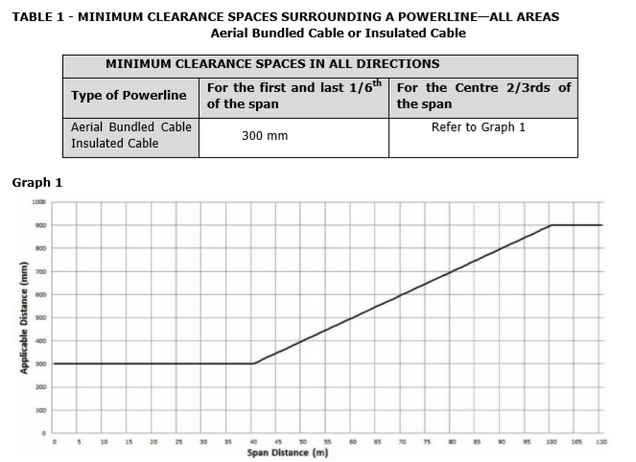

These clearances in this section allow for sag and sway of the conductors. Refer to Schedule 2 of the Code for further details

The Clearances in the above graph allow for sag and sway for spans up to 100m. For Spans greater than 100m an allowance for sag and sway is required. Very few spans if any are greater than 100m however Powercor will be consulted with if a span greater than 100m is identified to assist in determining the amount to allow for sag and sway.

The Clearances in the above graph allow for sag and sway for spans up to 100m. For Spans greater than 100m and allowance for sag and sway is required. Very few spans if any are greater than 100m however Powercor will be consulted with if a span greater than 100m is identified to assist in determining the amount to allow for sag and sway.

The Clearances in the above graph allow for sag and sway for spans up to 100m. For Spans greater than 100m and allowance for sag and sway is required. Very few spans if any are greater than 100m.

The Clearances in the above graph does not allow for sag and sway for spans. Very few spans are in the HBRA and Powercor will be consulted with to assist in determining the amount to allow for sag and sway.

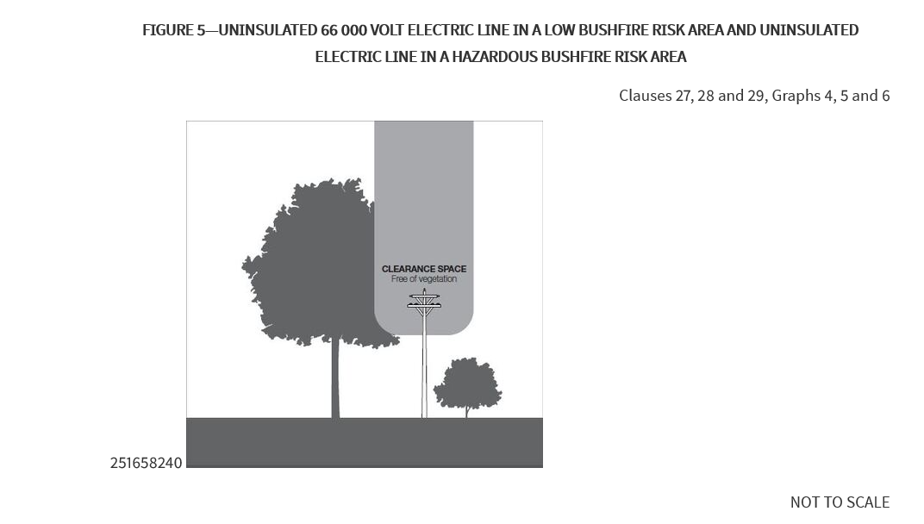

The Clearances in the above graph does not allow for sag and sway for spans. An allowance of for sag and sway is required for all spans. Refer to 3i(ii) to determine the distance required to allow for sag and sway.

Hazardous bush fire risk areas (HBRA) are inspected at the same time of the annual inspection, which is conducted during april to June of each year where every span on Powercors network in the Declared Area is assessed. All follow up works are carried out during the months of July to October. The contractor is required to prune the street trees so that the clearance space is in accordance with the Regulations. The contactor will report to Council the extent of regrowth observed from each species. The Council will utilise this information to evaluate the growth rates and size of all trees near powerlines and then take appropriate action to remove fast growing and tall trees and replace with appropriate species or replace powerlines with engineering solutions.

To ensure Council is made aware of any changes to the network within its Declared area, scheduled meetings will occur as a minimum annually between Council and Distribution Business’s to facilitate consultation and discussion of clearance issues such as:

* Programming and scheduled works
* Accessing live line clearing, suppression & shutdown coordination
* Performance
* Specific events
* General issues
* Network changes

During these meetings, any additional infrastructure that has been installed in Council’s declared area will be advised by the Distribution Business.

DB process for providing assistance:

1. **Determining an additional distance that allows for cable sag and sway**

The Clearance space to be maintained for the centre 2/3rds of spans is specified in Schedule 2 of the Regulations. A summary to be used for operational purposes is included in the charts above.

The spans in the LBRA are expected to be less than that which requires additional distances to be added to allow for sag and sway. Powercor will be consulted with where longer spans are identified, to determine the amount to allow for sag and sway of the conductors. Council will ensure extra clearance distances are achieved within spans that exceed the standard length.

Powercor will be consulted to assist in determining the amount to allow for sag and sway for spans known to be in the HBRA.

Employees and subcontractors employed in the process of Inspection are inducted into the ELCMP Reference Manual.

Council records of sag and sway calculations will be filed in the ELCMP Operations folder and archived and maintained for 5 years as per COS Archiving procedure.

Council will base its program around the timelines in the Works Schedule. The Schedule is designed to prioritise the HBRA and ensure all clearing is completed prior to the Declared Fire Danger Period.

**9(4)(k)The procedures to be adopted if it is not practicable to comply with the requirements of AS 4373 while cutting a tree in accordance with the Code**

The Municipal Association of Victoria advises Council to ensure the latest version of AS4373 is being referenced. Notifications of new or amended standards are forwarded to when they are released.

COS strives for its internal staff and contractors to meet the pruning standard set out in AS4373 as far a reasonably practicable while completing cutting activities to clear vegetation from electrical assets.

This definition of reasonably practicably is discussed at toolbox meeting before works carried out under the ELCMP are commenced. This includes toolbox meetings with contractors.

Reasonably practicably in relation to AS4373 means pruning crews will achieve clearance as a first priority and where possible apply principles of AS4373 for all pruning works, considering and weighing up all relevant matters including:

(a) The likelihood of the hazard or the risk concerned occurring – will the action create a defect, hazard, loss of tree health or aesthetic value in the present or future

(b) The degree of harm that might result from the hazard or the risk - what will the impact be on the tree or future safety of the public

(c) What the person concerned knows, or ought reasonably to know about:

(i) The hazard or the risk – must have adequate knowledge to determine the hazards risks

(ii) Ways of eliminating or minimising the risk – must have adequate knowledge in relation to alternative measures

(d) The availability and suitability of ways to eliminate or minimise the risk – are other resources or techniques available to complete works to the standard.

(e) After assessing the extent of the risk and the available ways of eliminating or minimising the risk, the cost associated with available ways of eliminating or minimising the risk, including whether the cost is grossly disproportionate to the risk – does the cost required to complete works to the standard grossly outweigh the value of the tree.

Under the current procurement, contractors completing pruning works are required to complete all works to AS4373 as far as reasonably practicable which includes not removing more than 30% of foliage, not removing large structural limbs, using top/bottom cut method to prune to eliminate bark tearing. Where this cannot be achieved the site or trees are to be referred to Councils Parks & Gardens Team Leader to make an assessment on whether it is reasonably practicable to deviate from AS4373.

Council conducts audits of completed works to ensure the application of the standard is being applied where possible. Weekly site meetings with the contractor are conducted whilst ELC pruning is occurring.

If Council identifies pruning that does not meet AS4373 during compliance audits. The contractor/crew will be sent back to the tree to remedy the situation. This may include targeting more appropriate final cuts or other works as necessary to address the no-compliance.

Ongoing systemic poor pruning techniques will result in the Council requesting the offending staff/contractors undergo further training to ensure AS4373 can be met when its reasonably practical to do so. If poor cutting continues contractor/crew will be removed from further works.

All vegetation workers must complete Certificate II in ESI Powerline Vegetation Control. This course provides competencies for planning and carrying out vegetation control at and above ground level near live electrical apparatus. For inspectors, this training must include the following modules; AHCPCM201A – Recognise plants and UETTDRVVC24A – Assess vegetation and recommend control measures in an ESI environment.

Induction training of all Council employees and contractors shall be undertaken prior to commencing or accessing the site. All employees and contractors must be inducted into the safety requirements for the contract and the site prior to being permitted to undertake works on the site. AS 4373 and the definition of “as far as practicable” will be outworked to personnel at the induction. Contractors shall provide Colac Otway Shire Council a Training Matrix for all tree cutting personnel showing all required training is up to date.

## 9(4)(l) A description of each alternative compliance mechanism in respect of which the responsible person has applied, or proposes to apply, for approval under clause 31 of the Code.

This clause is not applicable to Council at this time. If an alternative compliance mechanism is required in the future, this ELCMP will be updated to reflect proper process to be followed.

**9(4)(m) The details of each approval for an alternative compliance mechanism**

**i. that the responsible person holds**

This clause is not applicable to Council at this time. If an alternative compliance mechanism is required in the future, this ELCMP will be updated to reflect proper process to be followed.

**ii. that is in effect**

This clause is not applicable to Council at this time. If an alternative compliance mechanism is required in the future, this ELCMP will be updated to reflect proper process to be followed.

## 9(4)(n) A description of the measures to assess the performance of the responsible person under the management plan.

The Parks & Gardens team leader will conduct regular audits to ensure that inspection and cutting has been completed in accordance with industry standards, including Electricity Safety (General) Regulations 2019, AS4373:2007 Pruning of Amenity Trees and best practice methods and according to the schedule.

Continual monitoring of historical workload indicators will take place in respect to the number of:

* Identified vegetation clearance breaches to the code
* Emergency clearances
* Customer requests for line clearance
* Network operator requests for pruning
* Clearing not meeting quality requirements (AS4373 min.)

Non-compliance sites and outages data provided by Powercor are reviewed at the scheduled meetings. Utilising this historical data, a range of benchmarks for intervention of non-compliance has been established.

* For internal audits a 100% minimum compliance benchmark is in place. This audit covers both clearance and quality of works to AS4373. Scoring less than this threshold requires investigation the program will not be recorded complete until additional works are completed, and a new audit conducted. This process is performed by the Parks & Gardens Team Leader. A range of performance related penalties apply within our externally contracted service, while works by internal staff are subject to individual performance management. This allows mechanisms and incentives for improvement.
* Analysis of work types, job numbers and works priorities completed each year are also used to give insight into the number of trees reaching intervention levels between pruning cycles. Review of works completed over consecutive visits can show trends in the performance of the current ELCMP. An increase in high and urgent priority works of greater than 10% triggers an investigation by the Parks & Gardens Team Leader to investigate causes and implement improvement strategies where required.
* If supplied, compliance and outage results from Powercor are another useful tool to help monitor the performance of the plan. This will be measured on a number of events basis/month or year. Significant increases between periods would also warrant investigation.

The Team Leader Parks & Gardens will annually review the ELCMP to improve inadequate performance of the ELCMP against KPI’s.

Audit findings are sent to and discussed with the powerline clearance contractor representative and the audit process is discussed during induction. Any audit improvements will be rectified, and non-conformances shall be addressed within agreed timeframes and with agreed methods.

## 9(4)(o) Details of the audit processes that must be used to determine the responsible person’s compliance with the Code:

Council shall ensure that all vegetation is pruned to compliance with the Code plus an allowance for regrowth.

The General Manager Infrastructure & Services shall be responsible for overall management and audit procedures and the outcomes of such audits will be recorded and maintained in Council’s document management systems. Powercor also conducts audits and forwards the information to Council. This information is recorded and actioned according to the assessed priority.

Primary audits are conducted by personnel who have suitable audit training and background. External specialist resources, which are experienced and have appropriate expertise in the relevant field, may be engaged to assist. Where appropriate the Contractor and Council management are directly involved in these audits. Council Officers will attend Cert II Assessor stream training to update knowledge of the Code of Practice for Non Electrical personal on a regularly basis.

Any non-conformances or required improvement actions will be recorded on the audit and be rectified immediately and signed off when completed.

Any additional hazards/risks (or any risk controls that are not effective) identified by the audits must be recorded on the checklist, addressed immediately with appropriate risk control measures (agreed with the affected persons). All non-conformances shall be addressed within agreed timeframes and all non-conformances will be investigated further to determine their cause and any remedial actions will be implemented as soon as practicable or an agreed plan will be developed in order to address such issues.

All work activities relating to the extreme or high risks identified must cease until the risk has been effectively eliminated or controlled (if not possible to eliminate risk).

Council’s Parks & Gardens Team Leader or nominated officer will undertake an audit of powerline works on a daily basis during the pruning season. These audits are then recorded in Council’s document management database, any actions arising from the audits are communicated with the contractor in a timely manner. Post works site inspections will occur weekly to ensure all vegetation is trimmed and disposed of as required. This post works inspection may also identify vegetation needing remedial works that has grown within the clearance zone area since the original inspection was undertaken.

**Control of Non – Conformances**

All non-conformances identified by Council or Powercor will be addressed within the timeframes and with agreed methods dependant on the risk. The potential risk of a non-compliance can vary greatly and this will be evaluated, Parks & Gardens Team Leader will have responsibility for determining the rectification timeframes.

Council will conduct audits of the contractors against the ELCMP to establish if all aspects of the ELCMP are being met. All audit results will be discussed with the Contractor and results that appear to be systemic will be investigated internally and discussed in detail with the responsible contractor or works crew at contractual meetings.

If issues raised at contract meetings continue to occur, the non-conformances will be escalated to include management level within Council and the Contractor involved. This may result in standing the contractor/crew down until issues are resolved.

This ongoing review will assist in the selection of suitable contractors each year. Contractors who demonstrate systemic non-compliance will be excluded from tendering for ELC clearance works

**Annual Review and Continuous Improvement**

Regular meetings are carried out during the Electric Line Clearance Program. The results of the audits and other items that were noted as not going to plan will be reviewed. The purpose of the review is to identify strategies to prevent reoccurrence or identify if further issues are likely to arise.

Council and contractors shall conduct regular inspections of work sites to ensure that cutting or removal is done in accordance with industry standards, including AS4373 (Pruning of Amenity Trees) and that contractors continually demonstrate compliance with the prescribed safety and environmentally responsible aspects of the industry.

Council is responsible for comprehensive auditing of the vegetation management process including compliance to the requirements of this Plan.

Primary audits, such as OHS Systems, Environmental Management Systems, Quality Control, Traffic Management Procedures, etc., are targeted at the verification of systems of management and risk mitigation. These are further supported by field verification and compliance monitoring audits.

Primary audits are conducted by personnel who have suitable audit training and background. External specialist resources, which are experienced and have appropriate expertise in the relevant field, may be engaged to assist. Where appropriate, Council and contractors are to be directly involved in these audits.

The audit schedule is reviewed annually to address any changes in business requirements, concerns from previous years, and the contractor’s performance history. There are broadly four different types of audits within the schedule, relating to;

* Health and Safety – Safe work methods (e.g. General work methods, working near powerlines and tree clearing methods), equipment vehicles and plant, inductions, training and authorisation, traffic management.
* Compliance – General inspection and cutting compliance with programs, hazardous trees, stakeholder and defect management.
* Procedure/Work Instruction – Policies, work instructions, procedures, customer notification, data management and accuracy, reporting and documentation
* Environmental – Important or significant vegetation, chemicals, weeds, noise, pruning technique and quality.

The audit process considers actual performance and outputs and then compares them against planned performance and expected outputs. Where a variation occurs, the item is noted and followed through to ensure corrective actions are taken and improvement opportunities are factored into plans to enhance future performance.

Any non-conformances identified will be addressed within agreed timeframes and with agreed methods. If non-compliance is found to be a result of a Contractor not meeting its contractual obligations, the breach of compliance may be deemed by the Contract Coordinator as a breach of contract and may result in termination of the contract.

The annual review of the ELCMP will ensure that the latest version of AS4373 is being applied.

When vegetation pruning methods are unable to comply with the requirements of AS4373, the Parks and Gardens Team Leader at Colac Otway Shire is to be notified. AS 4373 and the definition of “as far as practicable” will be outworked to personnel at the induction. Every action will be taken to ensure that vegetation pruning methods taken minimise the extent of pruning and the effects of such pruning on vegetation. The process above is not required when a tree is being trimmed back to established practices for that tree.

## 9(4)(p) The qualifications and experience that the responsible person must require of the persons who are to carry out the inspection, cutting or removal of trees in accordance with the code:

When staff and contractors are undertaking electric line clearance works for the COS they are working as qualified persons as outlined in the Electricity Safety (General) Regulations 2019

The COS will ensure that all staff and contractors working as qualified persons will conform to:

* Electricity Safety (General) Regulations 2019 r. 616,
* Australian Standard AS4373-2007 – Pruning of Amenity Trees,
* The “Blue Book”, and
* Any organisational procedures, safe work method statements and Job Safety Assessments to ensure the work can be completed safely.
* The satisfactory completion of a Cert II in ESI power and vegetation control and ESV specified annual refresher as required by ESV qualification or equivalent.

The COS will ensure that all staff and contractors:

* are trained both initially and when refresher courses are required by a Registered Training Organisation (RTO)
* performing tree pruning and removal works around electric lines are suitably qualified and trained personnel who hold the following qualifications:
* Arborist / Grounds Person
  + Certificate II - ESI in Powerline Vegetation Control, and
  + Minimum Certificate III Horticulture / Arboriculture.
* Arboriculture Inspector
  + Minimum Certificate IV Horticulture / Arboriculture, including

the nationally accredited ‘Assess’ and ‘Identify’ modules,3 years industry experience

The Certificate III Horticulture/Arboriculture and Certificate II ESI cover many aspects of required training such as Chainsaw use, OH&S principles, First Aid, pruning techniques and High Risk licences. Additional staff may be required to hold training in;

* Traffic management,
* Chipper operation/induction,
* Chemical application (A.C.U.P or similar), or
* Tree Climbing

A register of employee training is maintained on personnel files by the COS to ensure all staff have appropriate and current qualifications.

Colac ELCMP Council, including its contractors must ensure that qualified persons, using an EWP/observing have completed Certificate II ESI – Powerline Vegetation Control including the following electives prior to commencement of work.

* UETTDRVC25A – Use elevated platform to cut vegetation above ground level near live electrical apparatus.
* UETTDRVC33A – Apply pruning techniques to vegetation control near live electrical apparatus.
* AHCARB205A* - Operate and maintain chainsaws (or equivalent) must have.
* TLILIC0005 * - Licence to operate a boom type elevating work platform (boom length 11m or more ) (or equivalent) must have.

Council including its contractors must have completed Certificate II ESI – Powerline Vegetation Control including the following electives if involved in assessing vegetation at and above ground level near live electrical apparatus prior to commencement of work.

* AHCPCM201 – Recognize plants.
* UETTDRVC24A – Assess vegetation and recommend control measures in an ESI environment.
* AHCARB205A* - Operate and maintain chainsaw (must have).

All contractors are required to provide evidence of appropriate qualifications and training prior to the commencement of work and report on updates to training via monthly and annual reports. All records are stored in the Colac Otway Shire document management system.

To ensure staff are aware of site and employee requirements new staff and contractors are subject to both internal & external induction processes and specific task related site safety assessments.

Any staff or contractor found on site without appropriate qualifications, training or experience to be excluded from the site immediately.

As part of the preparation for the Plan, COS will consult with all relevant bodies and standards to ensure all organisational procedures are current.

**9(4)(q) Notification and consultation procedures**

Council will ensure adequate notice is given to affected persons in regard to programmed line clearance works. Notification of Council’s program of works will be undertaken in accordance with the Electricity Safety (General) Regulation’s 2019. Where Council intends to cut or remove a tree that is on public land or within the boundary of a private property which the responsible person neither occupies nor owns or where the tree is of cultural or environmental significance Council as the responsible person will give notice of the intended cutting or removal to all affected persons in accordance with the regulations.

Prior to the commencement of programmed works, a notice will be published on Council’s website or a newspaper circulating generally in the locality of the land in which the tree is to be cut or removed at least 14 days and no more than 60 days before the intended works. Cutting shall not occur if the notification is less than 14 days and greater than 60 days. Evidence of notifications will be saved for audit purposes. Example of general notice is contained in Appendix 5

Where the tree intended for cutting or removal is a tree of cultural or environmental significance, notice will include the impact of the cutting or removal of the tree and the actions to be taken to minimise that impact. Decisions on removal or “clearing” of trees will be in accordance with Section 4j

By maintaining the annual inspection and cutting program and allowing for growth for individual species no urgent pruning or clearing should be required. In the case of urgent cutting or removal being required, Council will ensure that the process identified under “Emergency Cutting and Pruning” is followed, in accordance with the requirements of the Code.

**9(4)(r) Dispute resolution procedures**

If the vegetation is identified as being not compliant, the vegetation will be treated and cleared as per the urgent pruning process.

All enquiries should be managed to avoid disputes or complaints if reasonable to do so. Disputes should be resolved as per the following process.

All disputes between Council and affected parties, Stakeholders or the Distribution Business will be managed in line with the following process. If there is a conflict between this process and the Distribution Company or ESV formal process, the Responsible Person may decide to alter this process.

For the purposes of dispute resolution, the following Responsible Person may be contacted in conformance with the requirements set out in this section.

|  |  |  |
| --- | --- | --- |
| **Name:** | Mark Robinson | |
|  |  | |
|  | Team Leader Parks & Gardens | |
| **Address:** | 140 Pound Rd |  |
|  | Elliminyt VIC 3250 |  |
| **Emergency Telephone No.:** | 0428 523 433 & (03) 5232 9400 |  |
|  | (After hours pager service operates) | |
| **Email:** | Mark.Robinson@colacotway.vic.gov.au | |

The dispute resolution procedure is available for inspection at Council offices during normal business hours. The procedure is also published on Council’s website.

**Step 1 - First Level of Contact**

The Contractor Employee endeavours to resolve any disputes arising from the execution of their duties in a fair and reasonable manner. Disputes cost time and money and reflect poorly on Council and the contractor’s reputation. Disputes may be the result of a breakdown in communication prior to works or as a result of dissatisfaction with works.

Every attempt should be made to settle the dispute at the first point of contact to avoid unnecessarily escalating the incident. The contractor employee should explore all options within his authority in the consultation phase of the process in attempting to avoid disputes.

**Step 2 - Reference to the Council Manager**

Parks & Garden Team Leader- Where a dispute cannot be settled the contractor employee will notify the Manager and provide a detailed briefing. Any correspondence from the Affected Person will be logged in the contractor quality system for response tracking. The Manager will review the dispute and explore all practical options at his disposal. If under the circumstances the Manager is able to offer any further alternatives to what has been offered, these will be presented to the Affected Person by the contractor employee or the Manager if it is considered appropriate.

**Step 3 -Reference to the General Manager Infrastructure & Operations**

If the options identified by the Manager require higher management approval or if it is beyond the Manager’s delegated level of authority, a detailed proposal will be presented to the General Manager Infrastructure & Operations for approval. If all options offered are unacceptable to the Affected Person the Director, shall consider the risks associated with the outstanding vegetation clearance in determining the final resolution of issue.

**Step 4 -Reference to Arboreal Advisers**

While all contractor employees have had training in tree identification, pruning techniques and tree physiology some special situations may require greater expertise. Advice may be sought from an arborist where the dispute requires an expert third party opinion on a matter relating to the tree or trees in question. Requests for this advice should be passed to the Manager who can arrange advice or provide contact details. The advice may be based on photographs and description supported by specimen leaves and fruit of the tree or it may require a site visit by the expert arborist. Copies of reports should be forwarded to the Manager for compilation. The reports will be made available to the contractor employees and across Council for reference.

**Step 5 -Resolution**

If agreement is reached, then the agreed course of action shall be recorded in an agreement and signed by the Affected Person or Stakeholder. In order to avoid any future dispute where the agreed action is to take place over a period of time a notation referring to the agreement should be made in the Significant Tree register.

**Step 6 - No Resolution**

If no agreement is reached, the parties in dispute may choose to refer the case to Energy Safe Victoria (ESV) or The Energy and Water Ombudsman (EWOV), as appropriate, for a mechanism for resolution. If the non-completion of the disputed work presents a fire or safety risk the Operational Manager may be obliged by Code, to enter the property and complete the work.

Any customers who consider they have been poorly treated under this process are welcome to approach the EWOV for recourse. The EWOV is the last industry advocate available to settle tree related disputes. Further recourse may be available through the legal system.

**Obligations Relating to the Management of the Plan**

The following sections are as per Regulation 10 of the Electricity Safety (General) Regulations 2019:

**4. A method for determining an additional distance that allows for cable sag and sway may provide for different additional distances to be determined for different parts of a span of an electric line**

This is covered in Section 4j(ii)

**7a. A responsible person must ensure that a copy of the management plan is published on the responsible person’s Internet site**

The Electric Line Clearance Management Plan is published on Council’s website by the Manager Assets & Project Delivery. The Responsible Person will confirm with the IT department to ensure correct plan is available for the website.

The Electric Line Clearance Management Plan is published on Council’s website at the domain listed below.

The Team Leader Parks & Gardens will provide the COS IT department with any revisions and the updated version of the ELCMP prior to the commencement of the new financial year. The new plan will appear on the Councils website from the 1st of July each year.

The plan published on the COS website is to be used as the current version of the plan. The Team Leader Parks & Gardens shall ensure staff/contractors have access to the correct version. The final version each year will be saved in Councils record management data base. All superseded plans will be removed from circulation by email request to staff/contractors.

**7b. A copy of the management plan is available for inspection on the Council’s website**

The Plan is available at the address listed below.

Visit the Council’s website at [https://www.colacotway.vic.gov.au/Council-the-shire/Reports-strategies-plans/Strategies-plans%23section-10#section-10](https://www.colacotway.vic.gov.au/Council-the-shire/Reports-strategies-plans/Strategies-plans%23section-10%23section-10)

* Infrastructure Strategic and Public Documents
* Electric Line Clearance Management Plan – Revised March 2023

**Exemptions**

The following sections are as per Regulation 11 of the Electricity Safety (General) Regulations 2019

**2a. A responsible person who receives an exemption must ensure that a copy of the exemption is published on the responsible person’s Internet site**

This clause is not applicable to Council at this time. There are no exemptions in place. If an exemption is required in the future, this ELCMP will be updated to reflect proper process to be followed. The exemption will also be published on the Council website and a link provided.

**2b. A responsible person who receives an exemption must ensure that a copy of the exemption is available for inspection at the responsible person's principal office in the State during normal business hours**

This clause is not applicable to Council at this time. There are no exemptions in place. If an exemption is required in the future, this ELCMP will be updated to reflect proper process to be followed. The exemption will also be available at the principle Council office for inspection.

**Clearance Responsibilities**

**Exception to Minimum Clearances**

Council commits to achieve/maintain clearances prescribed within the Electricity Safety (General) regulations 2019. As a general rule all trees will be pruned to meet the code requirements.

Under this current ELCMP there are no trees within Colac declared areas that are currently being managed under exception rules 4, 5 & 6.

Inspectors and contractors are instructed to advise the Parks & Gardens Team Leader of any vegetation that is unable to be pruned to meet the prescribed clearances. Assessment will be conducted to determine if the nominated trees can meet all the criteria for the application of exception rules.

**4. Exception to minimum clearance space for structural branches around insulated low voltage electric lines only.**

Council does not currently have any trees managed under these exception criteria

Intent of this clause is to permit sizable structural branches of trees that are unlikely to move significantly in most wind conditions. This clause allows the structural branches of a tree to be within the minimum clearance space, provided that;

* The branch is > 130mm in diameter on entry to the clearance space, and the branch is >300mm away from the insulated low voltage line.
* Within the last 12 months a suitably qualified arborist (defined in the code):
  + has inspected the specific branch and tree
  + the qualified arborist has advised the relevant RP that the branch does not have any visible structural defects which could cause the branch to fail
  + The RP has assessed and effectively mitigated any identified risks posed by the branch.
  + The RP retains records of the inspections of the tree, advice and risk management measure for the tree for a period of 5 years

**5.** **Exception to minimum clearance space for small branches around insulated low voltage electric lines only.**

Council does not currently have any trees managed under these exception criteria.

The intent of this clause is to permit small, fine branches to be within the minimum clearance space around insulated low voltage electric lines, recognising that potential intermittent contact between fine vegetation and an electric line may occur provided that;

* The branch is <10mm wide at the point of entry to the clearance space, and the branch has been removed from within the minimum clearance space within the last 12 months.

In practice, this exception is intended to allow these types of branches to grow into the minimum clearance space provided they are removed from the clearance space at least once every 12mths. COS currently applies the prescribed clearances and clears to allow for a minimum of 12mths.

**6. Exception to minimum clearance space for structural branches around uninsulated low voltage electric lines in low bushfire risk areas**

Council does not currently have any trees managed under these exception criteria.

The intent of this clause is to permit sizable structural branches of trees that are unlikely to move significantly in most wind conditions to be permitted within the clearance space, but not to contact the lines, for uninsulated low voltage electric lines in low bushfire risk areas under certain conditions.

This clause allows the structural branches of a tree to be within the minimum clearance space provided that;

* The branch is >130mm in diameter on entry to the clearance space and the branch is no more than 500mm within the clearance space and located in a low bushfire risk area.
* If the branch comes within the minimum clearance space around the middle two thirds of the span, that span is fitted with one cable spreader if the span is <45m or is fitted with two cable spreaders if the span is>45m.

Within the last 12 months;

* a suitably qualified arborist (defined in the code) has inspected the specific branch and tree
* the suitably qualified arborist has advised the relevant RP that the branch does not have visible structural defects, which could cause the branch to fail
* the RP has assessed and effectively mitigated any identified risks posed by the branch
* the RP retains records of the inspections of the tree, the advice and risk management for the

tree for a period of 5 years.

**9. Responsible person may cut or remove hazard tree**

This requirement is covered in Section 4ji.

**10. Cutting or removal of:**

* indigenous trees
* trees listed in a planning scheme to be of ecological, historical or aesthetic significance
* trees of cultural or environmental significance
* must be minimised

All the above trees are to be inspected by a qualified arborist before any works are undertaken.

**17. Responsible person must publish notice before cutting or removing certain trees**

Council will advertise within the timeframe required. The contractor will only have authority to conduct works within the advertised period. If pruning is delayed or outside of the notification period, we will re-advertise to ensure compliance is achieved.

**20. Duty relating to the safety of cutting or removal of trees close to an electric line**

Powercor are the responsible Distribution Business and owner of assets located within the declared areas which Council is responsible for.

Where concerns are raised in relation to the safety of maintenance activities associated with maintaining vegetation clearances inside of the declared area, Council will make contact with Powercor to discuss concerns. Final recommendations will be provided by ORP Manager in an email to be recorded in Council’s electronic data capture system.

Council has no clearance responsibilities in relation to a span of an electric line that is part of a railway supply network or tramway supply network.

The Owner, operator or DB process for providing assistance:

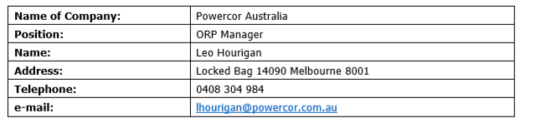

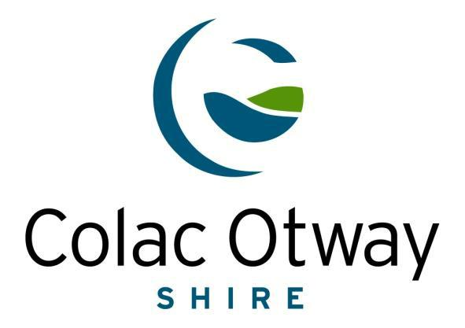

# APPENDIX 1- Map of Declared Area

|  |
| --- |
| Title : Map of Declared Area - Electric Line Clearance Management Plan |
|  |
|  |



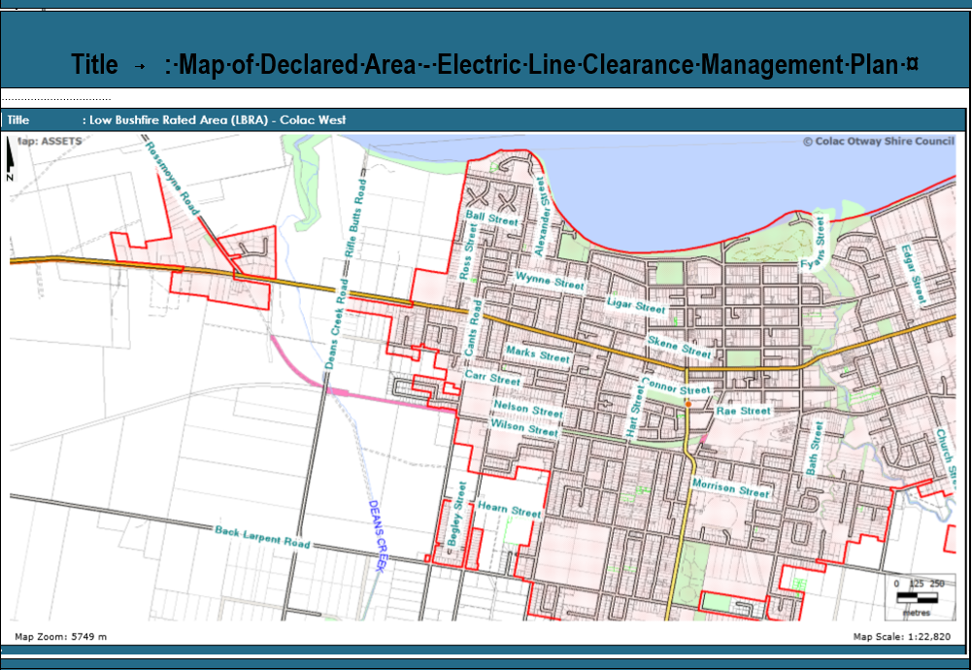

|  |
| --- |
| Title : Map of Declared Area - Electric Line Clearance Management Plan |
| LEGEND:  Declared Urban Area    LBRA  HBRA |
|  |



# APPENDIX 2

**Areas of Vegetation Determined to be Historically or Culturally Important or of Outstanding Aesthetic Value**

|  |  |  |  |  |  |
| --- | --- | --- | --- | --- | --- |
|  |  |  | **Colac Otway Heritage Study** | | |
|  |  |  |  | Volume II | |
|  | Name of Place : BOTANIC GARDENS | | | | |
|  |  |  |  | Ref. No. : 114 | |
|  | Location : | | 1 Fyans Street |  |  |
|  |  |  |  |  |  |

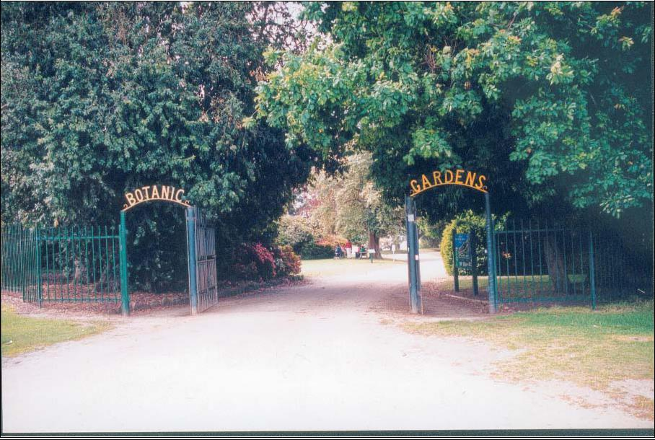SITE RECOMMENDED FOR PROTECTION IN 1997 LAND CONSERVATION COUNCIL REPORT LCC C 395

STATEMENT OF SIGNIFICANCE: (derived from Patrick & Wallace, 'Colac Botanic Gardens: A Conservation Study', 1993)

The Colac Botanic Gardens are located on the southern shore of Lake Colac, in Fyans Street. The land on which the Colac Botanic Gardens is located was gazetted in 1865 and in 1868 the then director of the Geelong Botanic Gardens, began the garden's plan. In 1910 William Guilfoyle contributed advice regarding the remodelling and development of the gardens. Colac Botanic Gardens are of historic, aesthetic, social and scientific importance to the State of Victoria. The Colac Botanic Gardens are of historic importance through demonstrating the nineteenth century remnant path lay -out which, though modified in parts, retains much of its earlier form. The Colac Botanic Gardens are of historic importance through association with two pioneers of garden design in Victoria, Daniel Bunce and William Guilfoyle. The Colac Botanic Gardens are of aesthetic importance through demonstrating a degree of intactness, which reveals a form very similar to that existing in the last century and documented in the plan prepared by William Guilfoyle (1910). The Colac Botanic Gardens are of social importance through the role of the gardens and recreation reserve as a site for past community activity. The Colac Botanic Gardens are of social importance in the on -going role of the gardens as a focus for activities by the Colac community. The Colac Botanic Gardens are of scientific importance through the high diversity of plant taxa, and most especially for the fine trees of gardenesque form. The Colac Botanic Gardens are of scientific importance through the presence of rare plant taxa in the gardens e.g. Cupressus forbesii and Aaonis marginata.

RECOMMENDED LISTING : State

Mary Sheehan & Assoc.

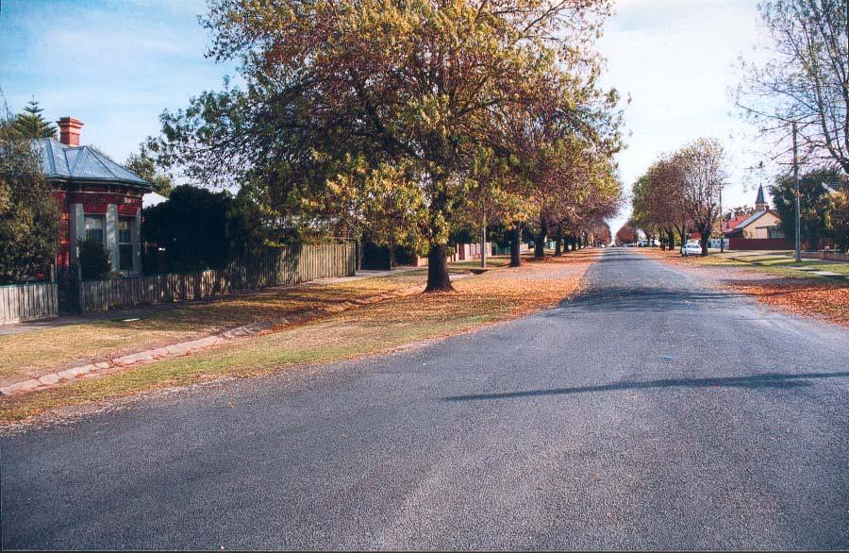

|  |  |  |  |  |  |  |
| --- | --- | --- | --- | --- | --- | --- |
|  |  |  |  | **Colac Otway Heritage Study** | | |
|  |  |  |  |  | Volume II | |
|  | Name of Place : MANIFOLD STREET CULVERTS | | | | | |
|  |  |  |  |  | Ref. No. : 127 | |
|  | Location : | | | Manifold Street |  |  |
|  |  |  |  | Colac | | |
|  |  |  |  |  |  |  |
|  |  |  |  |  |  |  |

STATEMENT OF SIGNIFICANCE:

The Road Culverts located in Manifold Street, Colac extend the length of the street from Queen Street to Grant Street. The Culverts on the south side of Manifold Street are formed from concrete, and those on the northern side are formed from bluestone. The Culverts were constructed by the Shire in two stages, in 1897 and 1901, the road was asphalted in 1903, following which the street plantings were established. The Manifold Street Road Culverts are historically and aesthetically important to the Shire of Colac Otway. The Manifold Street Road Culverts are historically important through association with the formation and development of local government in the area, whose main responsibility initially was the provision of services and infrastructure to ratepayers. The Manifold Street Road Culverts are aesthetically important through exhibiting a richness and diversity through the integration of features including the culverts, street plantings and absence of road curving, which all together demonstrate late nineteenth and early twentieth century residential road formation.

RECOMMENDATIONS: RECOMMENDED LISTING: Local

The site to be retained in the Colac Otway Shire Planning Scheme (Individual Listing)

THEMES: Formation of Local Government (8.1)

Mary Sheehan & Assoc.

HISTORY:

The Shire of Colac was formed in 1864 under the terms of the *Municipal Institutions Amendment Act* (1863). The first task was to establish a local council, then it was necessary to construct a Shire Hall that would suitably define and create a distinction for the newly -formed government. The prominent architects Alexander Davidson and E G Ovey were commissioned and Colac’s Shire Hall was completed and ceremoniously opened in 1878. With this task completed, the councillors could then look to developing the less-exciting aspects of the infrastructure necessary for a town.

Colac's streets were generally not formed until the 1870s, after the building of a meeting place for the council and suitable edifice, and the focus initially was on those areas, like Murray Street, that attracted the greater traffic. The construction of residential roads was delayed until funds became available, and it was not until the 1880s and 1890s that government grants were available for kerb and channel work.

Manifold Street was kerbed and channelled in three separate works programs in 1897, 1901 and 1903.

Contractor J Pell undertook the work. Asphalt was laid to the roadway in 1903 by Conway and Evans.

The street works provide evidence of the growth of local government and the projects undertaken in providing the infrastructure of towns in the Shire.

PHYSICAL DESCRIPTION:

The Manifold Street road culverts, formed of concrete, extend along the south side of the road from Queen Street to Grant Street. On the north side the culvert is formed from bluestone and extends the length of Manifold, from Queen Street to Grant Street. The planting of exotic trees and the absence of guttering along the road verges is contiguous with early nineteenth century road forms, and adds to the aesthetic importance of the site. In the mid-twentieth century ramps were formed across the verges at various intervals to enable vehicular access to residential properties.

|  |  |  |  |  |  |  |  |
| --- | --- | --- | --- | --- | --- | --- | --- |
| Condition : | | | Excellent | Good | Fair | Poor | Ruins |
| Integrity : | |  | Highly intact |  |  | Altered sympathetically | |
|  |  |  |  |  |  | Altered unsympathetically | |
|  |  |  | Damaged/disturbed |  |  |
|  |  |  |  |  |  |  |  |

**Shire of Colac Otway Heritage Study**

Volume II

Name of Place: RESIDENTIAL PRECINCT

Ref. No.: 307

Location: Fyans, Gellibrand, Manifold and Queen Streets

Colac

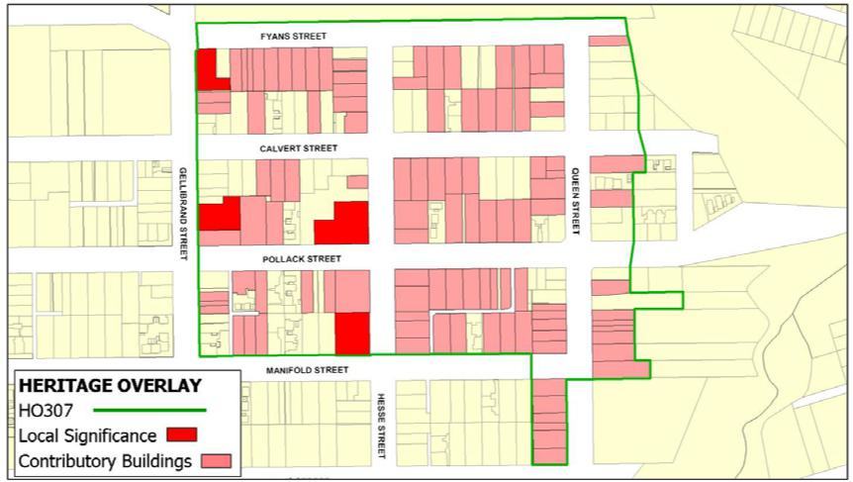

STATEMENT OF SIGNIFICANCE:

The Colac Residential Precinct is bounded to the north by Fyans Street; to the east by Queens Street; south by Manifold Street; and west by Gellibrand Street. The Colac Residential Precinct also extends south along Queen Street to Dennis Street and incorporates all those properties located on the east and west side of the street. The Precinct predominantly comprises single storey, exterior-painted weatherboard dwellings with corrugated iron clad roofs that were constructed in the late nineteenth and early twentieth centuries. The Precinct is distinguished by its street plantings, wide roads, grassy verges and deep culverts. The Colac Residential Precinct is of architectural, aesthetic and historic importance to the Shire of Colac Otway. The Colac Residential Precinct is of aesthetic importance in illustrating the principle characteristics of nineteenth century town planning in the grid format and wide road reserves. The Colac Residential Precinct is of architectural importance in demonstrating a continuum of residential styles incorporating modest Gothic; late Victorian Boom style; Federation and mid twentieth century brick dwellings that provide a 'map' in built form of Colac's residential development. The Colac Residential Precinct is of historic importance in demonstrating the evolution of Colac as an important regional centre, the residential development commencing initially in an area close to the churches, then later fanning out in a north east direction from an apex at Queen and Manifold Streets, adjacent to the original creek crossing and the civic precinct.

RECOMMENDATIONS: RECOMMENDED LISTING: Local

To be retained in the Colac Otway Shire Planning Scheme

THEMES: Building Towns (5.1)

**Shire of Colac Otway Heritage Study**

Mary Sheehan & Assoc. Recommendations - Places • 2

HISTORY:

Queen Street north was formed as a thoroughfare in 1885 and kerbed and channelled in 1897. These works made the street attractive and in the period from 1885 to 1900 nine residences were erected on the side between Dennis and Pollock Streets. Growth was halted by the onset of the economic depression in the early 1890s, when little building work was undertaken. However, at the close of the nineteenth century and early decades of the twentieth century, Colac experienced population serge. New residents were attracted to the town to take up residency by the expansion of the timber and dairying industry. So housing growth surged Houses fanned out along Queen Street, then Pollack and Calvert to Gellibrand Street until, in the first two decades of the twentieth century, timber dwellings began also to predominate along Fyans Street. A few of the dwellings constructed in the 1880s and early 1890s, were brick, but the majority in the precinct were timber with iron roofs, and most were modest is size.

The precinct continued to be fully occupied by the 1960s, although some places had been demolished and replaced by newer brick veneer or strata-title units. Garages and car port had also begun to intrude into some properties as owners attempted to accommodate this relatively new form of transport that had not been provided for when their houses had been constructed. The annual rates charged, on average, were lower - approximately £150 - £ 180 per annum - in comparison to the newer, more prestigious areas a few streets further west where rates, on average, were about £250 per annum. Rather than reflecting the standard of housing, the rate variation between this and other areas provides greater indication of popular trends ad fashion in housing by the mid-twentieth century, trend that have again altered to now embrace turn of the century dwellings that are now often marketed as 'period homes'.

PHYSICAL DESCRIPTION:

The Colac Residential Precinct is bounded to the north by Fyans Street; to the east by Queens Street; south by Manifold Street; and west by Gellibrand Street. The Colac Residential Precinct also extends south along Queen Street to Dennis Street which defines the southern limits of the precinct. The Colac Residential Precinct was initiated parallel to Barongarook Creek, which divided the old Colac settlement from the later nineteenth century town development. The houses offer a form of mapping and are consequently an important feature of the precinct. The housing stock seems generally to have fanned north and west from the Queen and Dennis Street apex, providing examples of domestic architecture commencing with the villas built in 1880s, the later Federation bungalow styled houses of the early decades of the twentieth century. An older section comprising a few timber houses also survive in Pollack Street, between Geillibrand and Hesse Streets, in the vicinity of the St John and St Andrew's churches, Although notable exceptions of mid-twentieth century brick houses are present, most offer good examples of late Victorian or early Federation villas. The majority of these homes are single-storey, timber framed structures with painted exterior weatherboard and grey corrugated iron clad roofs with typical decorative detailing. The houses opposite the Anglican church group are later in design. The dwellings, some of which are also modest in scale, are set in traditional styled gardens with front fences and uniform set backs. Although the precinct includes a number of infill developments commonly located at the corner intersections, these buildings, despite their very different architectural style, do not aversely diminish the quality of the historic streetscape vistas. The regular siting of these medium density projects, coupled with the consistently modest scale of development, along with the general lack of other competing modern infill projects, has to some degree, reduced the intrusive nature of these buildings in the streetscape. This type of development reflects attempts to increase the density of the historic residential area in line with state government housing policies of the late twentieth century and contrasts with their former policies, which led to the creation of low-cost public housing schemes of the mid twentieth century on the outskirts of Colac. Another notable feature of the precinct are the street trees planted on the edge of the roads, on the border of a deep grassy verges which drain towards central open channels or culverts. The integrity of the mature avenue of trees is considered relatively rare, as few similar streetscapes in rural Australia have survived. The position of planting has allowed the trees to spread their branches across the roads to meet in a grand arch, whilst leaving the front gardens of the residential properties on either sides of the street free of shade. In consequence there are a number of outstanding historic gardens in the precinct which contain mature ornamental trees and shrubbery.

Assessment Date: 2000

|  |  |  |  |  |  |
| --- | --- | --- | --- | --- | --- |
|  |  |  | **Colac Otway Heritage Study** | | |
|  |  |  |  | Volume II | |
|  | Name of Place : MEMORIAL SQUARE PRECINCT | | | | |
|  |  |  |  | Ref. No. : 308 | |
|  | Location : | | Murray Street |  |  |
|  |  |  | Colac | | |

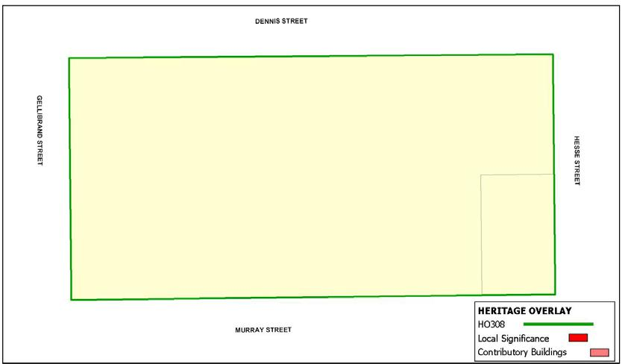

STATEMENT OF SIGNIFICANCE:

The Colac Memorial Square, bounded by Murray, Gellibrand, Dennis and Hesse Streets, is a World War 1 memorial reserve that evolved from the Market Reserve set aside when Colac was surveyed in 1864. Now known as Memorial Square, the areas incorporates a large walk-in war memorial (c1924) at its centre designed by Frederick Sales, and a generally symmetrical path system with extensive plantings of mature *Ulmus procera* (English Elm) framing the centrepiece. The Memorial Square also includes a number of memorials that commemorate members of the community, including those to Andrew Fisher, Fountain The St Johns Gymnastic Club, Rotary Club Clock, the Cliff Young Memorial Track and Plaque, the Lone Pine Plaque and the Jack Dillon Fountain and Plaque. The square is the focal point for community activities in the district, and is a popular recreational site providing respite for travellers passing through the Shire. The Memorial Square is of historical, architectural, aesthetic and social importance to the Shire of Colac Otway. The Memorial Square is historically important for its commemoration of the service and sacrifices of the Colac and district communities. The Memorial Square is architecturally important as one of the most impressive walk -in war memorials in regional Victoria. The Memorial Square is aesthetically and socially important as a public open space in continual use since the first settlement of Colac.

RECOMMENDATIONS: RECOMMENDED LISTING : Local

To be retained in the Colac Otway Shire Planning Scheme

THEMES : Memorials & Monuments (9.2)

Mary Sheehan & Assoc.

HISTORY:

The earliest town plans of Colac show an area set aside for a Market Reserve in Murray Street. The reserve was not ever developed and remained a dust bowl in summer and mud heap in winter where farmers parked wagons. In 1873 the Minister for Lands advised the Colac Shire Council that he would set aside the land for a public park. This was eventually agreed to and the block was enclosed with a picket fence in 1875 and some 140 trees planted. In 1879 Council proposed to subdivide the reserve to allow commercial development along Murray Street but a violent public reaction thwarted this move. Nevertheless, Council viewed the reserve as providing opportunities for various interest groups and allowed several structures to be built on it. In 1887 a fire station and tower was erected. In 1890 the Colac Bowling Club was permitted to build a club house and greens, and in 1901 a Library, masquerading as the South African War Memorial, was sited in the south east corner. The Library memorial plaque was later stolen and not replaced so the younger generation had no inkling of the Library’s true purpose after this. After the First World War the role of the reserve was critically looked at and a number of decisions made on its future. The Shire sponsored the War Memorial Movement and when sufficient funds were available, erected the memorial in the centre of the reserve. The fire station was removed as part of this renewal as well as general beautification works also being carried out. The reserve was then named The Memorial Square. The open space in the middle of town was still not immune from building over and in 1954 the Town Council proposed to construct a new Town Hall on the site. There was furious local opposition and the plan was dropped. However, the community would accept an extension to the war memorial and this was carried out in 1957. By now the Colac community fully accepted the role of the Square as open space that was not to be compromised. The Library building was removed in 1970 and the Bowling Club relocated in 1992 in order to provide a free expanse of parkland. The City Council rejuvenated the Square in 1993 with a Federal Grant and works included renewal of pathways, installation of a playground and construction of a Town Plaza and Pergola. The architects were Green & Dale. The Memorial Square houses a number of monuments and plaques that reflect the spirit of the community and its response to national and local events.

The centre piece of the Square is the First World War Memorial. A citizens committee devised the proposal to erect a Permanent Peace Memorial in the Market Square and, with Colac Shire Council approval and cooperation, undertook fund raising and a design competition for such a memorial. The chosen design was by Frederick Sales. The memorial is 50 feet high, 20 feet wide and 16 feet deep and is built on a base of heavy bluestone with a natural rock face. The front entrance comprises bluestone steps bordered by facing piers leading to the main entrance. A small panel carries the words “The Shire’s Tribute” and other panels bear the names of the many well- known battles during the conflict. The portals of the building are enclosed between two Corinthian columns 20 feet high supporting the pediment of the Corinthian order and carved leaves of the Acanthus decorate the tops of the columns. The chamber with a tiled floor, a lofty dome and panelled roof lists the names of 1546 servicemen who enlisted and 318 who died. All the stone in the structure, including the Corinthian columns, came from Waurn Ponds. A torch emblem tops the Memorial in a bowl 11 feet in diameter with the sculptured head of Mars, the God of War, facing the four points of the compass. The main superstructure above the base is Ballan yellow dressed stone with rich veins of colour markings. The official unveiling took place on 15 November 1924 and was performed by Sir Henry Chauvel. The memorial is the most magnificent anywhere in country Victoria and is only bettered by the larger walk -in structures at Geelong and Melbourne. The memorial to those who served in the Second World War and Korean War was constructed as a separate entity on the Murray Street side of the First World War memorial. In 1955 Architects Mason & Weinstock developed a contemporary design involving a low wall and two tall columns facing a pool of remembrance. The memorial was opened on 3 August 1957 by Lt. Governor Sir Edmund Herring. Since then there have been other plaques placed on the memorial complex recognising the conflicts in Malaya, Borneo, the Malayan Peninsula and Vietnam 1948 – 1972; Women who Served and the Garden of Peace (the latter two unveiled on 15 August 1995, being the 50th anniversary of the end of World War Two).

(History cont.)

Other memorials and plaques within the Square include the (1) Fisher Memorial. A plaque commemorates the utterance of Andrew Fisher, leader of the Federal Labor (Opposition) Party, who in Colac on 31 July,

1914 said that Australia would fight the Germans to the last man and the last shilling after details of German aggression against its neighbours were announced. (2) St John’s Fountain The St Johns Gymnastic Club donated a polished granite drinking fountain in 1923. (3) Rotary Clock The Rotary Club movement donated a clock on an elevated metal standard on the Murray Street frontage, 23 February 1980. (4) Cliff Young Track Local resident Cliff Young rose to national attention in 1982 when he won the Sydney to Melbourne ultra marathon foot race. A running track around the Square was installed for the purposes of endurance running. A plaque to this effect was unveiled in 1982. (5) Lone Pine Plaque - An Aleppo Pine tree generated by seed from the original lone pine at Gallipoli was planted on the north side of the mound in 1995. A plaque records this. (6) Dillon Fountain. In 1972 Cr. Jack Dillon suggested that the Square be made more attractive by an illuminated fountain and this was installed and opened in 1974. The fountain was modelled on the El Alemain Fountain at Kings Cross. In 1993 the centrepiece fountain was removed and the basin converted to a reflective pool.

PHYSICAL DESCRIPTION:

The Town Square precinct comprises the Memorial Square, the former market square, the avenue of mature trees and other plantings, layout paths and all the historic structures and Memorials contained within the square bound by Murray, Hesse, Gellibrand and Dennis Streets, it also includes all those properties which overlook the square. These consists of the group of remodelled 1950s shop fronts along Murray Street, the former SEC Commission office building, the Sewell Building, and a small group of Inter War shops on Gellibrand street, the Italianate 19th century building and its associated development on Hesse streets and the remaining group of 19th century Victorian villas along Dennis Street, all these buildings contribute to the character and narrative history of the development of the Square, providing physical evidence of the precarious evolution of the former market square from an area used by farmers to hitch their wagons while attending the sales yards and auctions opposite, to community use of the space and the beautification work associated with the War Memorial Movement and unveiling of the First World War Memorial in 1924. The Memorial dominates the square, entitled “ The Shire’s Tribute” and is one of the most impressive and aesthetically outstanding structure in Victoria, carved out of Ballan stone standing 50 feet high designed by Frederick Sales to commemorate the 1,546 local servicemen who enlisted and 318 who died during war. It is designed like a neo-Palladian sacrificial temple of remembrance, associated with the Inter War Stripped Classical architectural style. A series of steps leads up to a raised chamber on a platform with domed panelled roof, accessed through 20ft stylized Doric/Corinthian columns in antis, with surmounting Greek entablature and pediment topped by a giant Grecian urn and torch with sculptured heads of Mars, god of war, facing the four points of the compass. The shrine is placed within a wider landscaped setting designed in 1955 by architects, Mason & Weinstock, using contemporary sandstone paving, upright free standing columns, terraced walls and pool of remembrance since turned into a rose garden, other features include walkways, and extensive modern playground, 1900 Federation style Chinese influenced timber band rotunda, standing in the middle of a large paved area surrounded by timber park benches and low clipped green hedge and tall globe landscape lighting, pergola, miscellaneous collection of park bench seating, toilet block and barbeque. The square has also become a reciprocal for a number of memorial plaques mainly granite cairns with attached bronze plaques gathered in a random fashion in one location at the Hesse Murray street corner.

(Physical Description cont.)

Total number of trees: 54 Ages (est.): 100 (c1900) and 76 (pl. 1924)

Height: 20m (average) Canopy: 20m (average)

Trunk Circumference: not measured (3.1m in 1986)

Memorial Square is a World War 1 Memorial reserve developed from earlier parkland and bounded by Murray, Hesse, Dennis and Gellibrand Streets in central Colac. A park precinct, it is level in topography and its major elements comprising a c1924 [confirm] war memorial at its centre, and a geometric path system with extensive plantings of mature *Ulmus procera* (English Elm)framing this centrepoint. 54 trees assessed by NT in 1986 are a group planting which provides the context for the central memorial. Many perimeter trees precede the erection of the monument and appear to have been planted near or before the turn of the century (c1900), while trees closer to the memorial, especially those around the central circular path, date from the erection of the memorial (c1924), as confirmed by photographs of the time.

Further investigation should confirm any changes to the path layout and alterations to other fabric, as well as the exact extent of plantings predating the war memorial.



**Victorian Heritage Database place details - 20/9/2011**

**COLAC BOTANIC GARDENS**

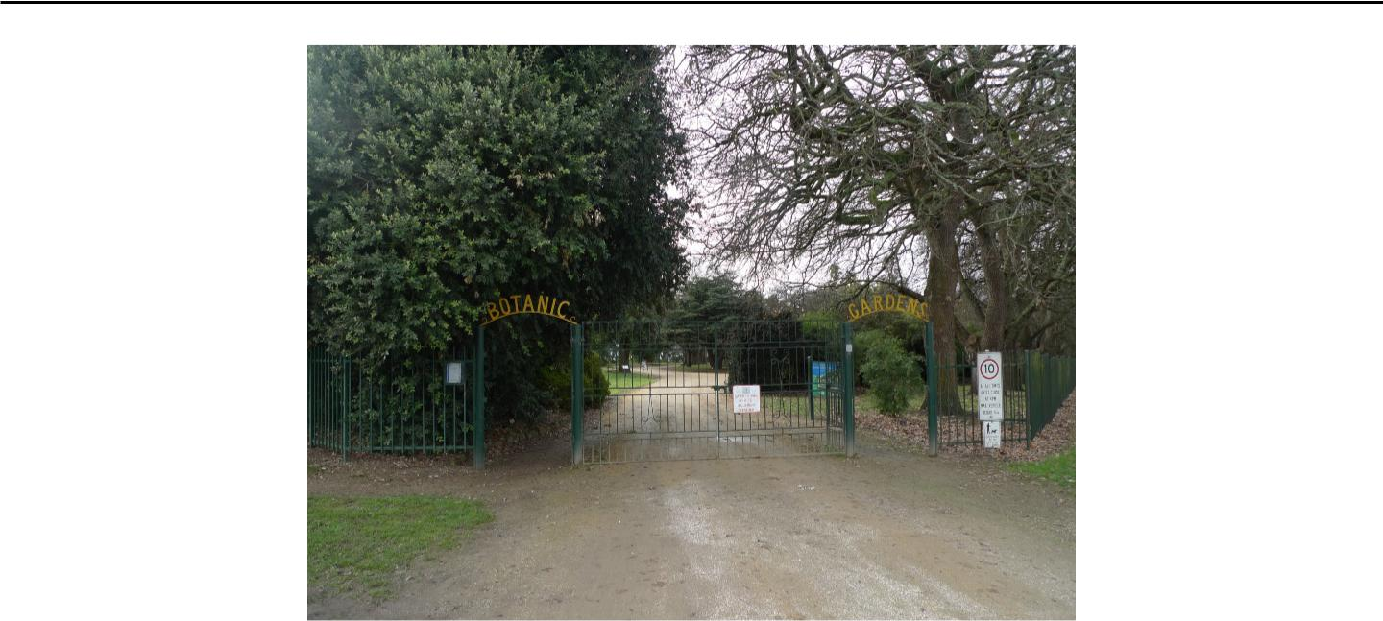

**Location:**

1-5 FYANS STREET COLAC, COLAC OTWAY SHIRE

**Victorian Heritage Register (VHR) Number:** H2259

**Listing Authority:** VHR

**Extent of Registration:**

1. All the buildings marked as follows on Diagram 2259 held by the Executive Director. B1 Former curator's residence (now café) B2 Old brick toilet block
2. All the features marked as follows on Diagram 2259 held by the Executive Director. F1 Bilson gates at Gellibrand Street entrance

F2 Terraces

F3 Lily pond

F4 Cannon

1. The circular driveway and paths marked P1 on Diagram 2259 held by the Executive Director.
2. All of the land marked L1 on Diagram 2259 held by the Executive Director being parts of Crown Allotment 25B and 25C, Township of Colac, and part of Crown Allotment 62A, Parish of Colac.

**Statement of Significance:**

The Colac Botanic Gardens occupy an elevated site of approximately 16 hectares north-east of the town centre bounded by the southern shores of Lake Colac, Gellibrand Street, Fyans Street and Barongarook Creek. The main entrance to the Colac Botanic Garden is through the south-west entrance Bilson gates (1962) on the corner of Fyans Street and Gellibrand Street where a carriage drive, lined with predominantly Quercus robur (English Oak) and few Quercus cerris (Turkey Oak), forms a row around the perimeter of the Gardens and is open to vehicle access. The area enclosed by the drive has a network of winding paths and is mainly open lawn with specimen trees, shrubberies, some bedding plants together with a palm bed, rose garden, rose arbour, pond and fountain, and cannon (acquired 1904) near the south eastern gate. The curator's cottage (c.1924, now a café) is located at the western end of the gardens with playground equipment, picnic facilities and car parking at the eastern end. A caravan park occupies the north-east corner along Barongarook Creek adjacent to the lake shore.

A steep escarpment planted with Pinus radiata (Monterey Pines) and specimen trees runs between the botanic gardens and the flat area around the shore of Lake Colac which contains remnant terracing, an old brick toilet block with castellated roof (c1930s), a walking track, a fire brigade asphalt training track and shed, rotunda (1999), car parks, a rowing club, angling club, public toilets, boat ramp (1968) and jetty (1971). The escarpment provides separation between the two areas and provides extensive views from the Botanic Gardens over Lake Colac.

The site was temporarily reserved in 1865 for botanical and recreational purposes after a request from local residents. Little progress was made until 1868 when Daniel Bunce, Director of the Geelong Botanic Gardens, was approached to lay out a plan for the garden. Implementation of the plan was slow with the construction of a carriageway and planting of trees the only known details.

Between c1875 -80, curators Reeves and McDonald made changes to the carriageway and introduced garden beds, curved paths, lawns and shady arbours. In the 1890s structures added to the gardens included a pavilion overlooking the lake a conservatory in the south-eastern corner and a permanent rowing clubhouse on the edge of the lake joining the existing structures of piers, baths and a boat shed. Most of these structures have been removed.

In 1910 William Guilfoyle, Director of the Melbourne Botanic Gardens, prepared a plan and a 'Report on the remodelling and development of the Colac Botanic Gardens', which are extant, suggesting some improvements and remodelling to take advantage of the slope and vistas across over the lake which he considered had been ignored. This included simplifying the existing path system within the circular drive, and removal of borders and crowded areas in favour of larger trees and clumps of shrubs and a palm and cordyline bed all of which were implemented. Curators Archibald Campbell (1911-40) and Dugald Leitch (1940-55) were responsible for implementation of part of the Guilfoyle plan and maintaining the maturing Gardens but, with Guilfoyle's death in 1912, any further influence ended. The last resident curator Donald Greenwood (1955-65) was responsible for the addition of many native plants and in more recent times the gardens have more simplified planting and a park-like character.

The Colac Botanic Gardens contains many rare plant species only found in historic gardens and several significant and uncommon trees including four Cupressus forbesii (Tecate Cypress), a very large Sophora japonica (Pagoda Tree), a Pittosporum tenuifolium 'Eila Keightley' (Kohuhu), a large Araucaria bidwillii (Bunya Pine) and an outstanding Ulmus x hollandica 'Vegeta' (Huntington Elm). In March 1996, James Guilfoyle, grandson of William Guilfoyle, planted an Arbutus caneriensis (Canary Island Strawberry Tree). In 2004 the Australian Plant Society planted an Otway Flora Bed on the eastern side of the Gardens. This site is on the land of the traditional owners.

Colac Botanic Gardens are of historical, aesthetic, and scientific (botanical) significance to the State of Victoria.

Colac Botanic Gardens are of historical significance as an important example of a regional botanical garden, established in the nineteenth century in response to the increased wealth of Victoria with the discovery of gold and the desire to provide a place for recreation and education in keeping with European trends.

The Colac Botanic Gardens are of historical importance through the association with Daniel Bunce and William Guilfoyle, two pioneers of botanic gardens and garden design in Victoria

The Colac Botanic Gardens are of aesthetic significance due to their park - like character and elevated location immediately above the southern shore of Lake Colac, providing vistas across the lake. The gardens are of aesthetic significance for the sub-tropical plant groups supported by Guilfoyle together with his gardenesque style. They are of aesthetic significance for the contrasting form and variety of trees and plants which includes

conifers, evergreen and deciduous plantings, together with the leaf shapes, colours and flowers, also contribute to the Garden's aesthetic quality and appeal

The Colac Botanic Gardens are of scientific (botanical) significance for a number of rare plants and trees including four Cupressus forbesii (Tecate Cypress), the only known examples in Victoria, a large Sophora japonica (Pagoda Tree), Pittosporum tenuifolium 'Eila Keightley' (Kohuhu), and large Araucaria bidwillii (Bunya Pine) and an outstanding Ulmus x hollandica 'Vegeta' (Huntington Elm).

|  |  |
| --- | --- |
| **Heritage Study** |  |
|  |  |
| **Year Construction Started** |  |
|  |  |
| **Architect / Designer** |  |
|  |  |
| **Architectural Style** |  |
|  |  |
| **Heritage Act Categories** | Heritage place |
|  |  |
| **Municipality** | COLAC OTWAY SHIRE |
|  |  |
| **Other names** | BOTANICAL GARDENS |
|  |  |
| **History** |  |
|  |  |

# APPENDIX 3- Approval to Work Procedure

**Purpose**

Colac Otway Shire staff may not have the knowledge or expertise to identify and understand all the risks associated with works being undertaken by contractors. This approval to work process is not to control or direct contractors in utilise their expertise in making decisions and developing work flows. This Approval to Work procedure is to ensure that:

* High Risk Work identified on the Contractor Job Sheet is highlighted;
* that extra licencing and training requirements are met;
* to ensure proper consideration is given to the risks of a particular task.
* To monitor the expected timeframes and record that contractors safely access, perform their work and then egress the site, and
* where their safety is in doubt that processes have been agreed minimise the risk of injury.

The “Approval to Work” is a separate formal written approval given to appropriately trained contractors to carry out work in areas where particular hazards or adverse conditions may be present. In particular those hazards and risks that are classified as High Risk in the *OHS Regulations (Construction) 2017*.

**Scope**

This Approval to Work procedure is required for all works where high risk work as described in the definitions or in the OHS Regulations 2017, will be undertaken and for any other work that is deemed to be a high safety risk.

This procedure applies to all contractors engaged directly by Colac Otway Shire to perform works at any worksite controlled or managed by Colac Otway Shire.

It is not intended for:

* Professional staff engaged through Human Resources on a work contract.
* For the Management of project work. Although the procedures and documents may be used for this purpose, they have not been designed with regard to contractual agreements that may overlap responsibilities.
* For the use of Principal Contractors engaged to undertake projects on behalf of COS.

Reference should be made to the OHS Regulations 2017 for further mandatory requirements.

**Definitions in this procedure**

|  |  |
| --- | --- |
| **Issuing Officer** | An Qualified Colac Otway Shire officer who has received training to issue an “Approval to work” and has the knowledge to identify in consultation with the Approval applicant the specific precautionary measures that may be required. |
| **Approval to Work** | An Approval to work authorises persons to undertake specified work in a designated area as described in the Approval following controls agreed in the approval and described in the Safe Work Method Statement. |
| **Competent person** | Person who has acquired through training, qualification or experience, or a combination of these, the knowledge and skills to carry out a specified function. |
| **Risk assessment** | A process that analyses conditions and circumstances to evaluate the likelihood and consequence of loss occurring for people, property and the environment.  Then to research, identify and implement measures to reduce the risk of exposure. |
| **Construction Induction Card** | The OHS regulations (Construction) 2017 require a person performing construction work must hold a construction induction card. This must be issued by an approved RTO and is colloquially known as “white card”. |
| **Safe Work Method Statement**  **(SWMS)** | **OHS Regulations (Construction ) 2017 S 324**  a ***safe work method statement*** means a document that—   1. identifies work that is high risk construction work; and 2. states the hazards and risks of that work; and 3. sufficiently describes measures to control those risks; and 4. describes how the risk control measures are to be implemented; and 5. is set out and expressed in a way that is readily accessible and comprehensible to the persons who use it.   **327 Safe work method statement required for high risk construction work**   1. a safe work method statement is prepared for the work before the work commences; and 2. the work is performed in accordance with the statement.   If there is non-compliance with a safe work method statement,   1. stop that work immediately or as soon as it is safe to do so; and 2. not resume the work until the statement is complied with or reviewed.   **328 Safe work method statement to be reviewed and revised**  must review and, if necessary, revise the safe work method statement—   1. whenever the high risk construction work changes; or 2. if there is an indication that risk control measures are not controlling the risks adequately, including after any incident that occurs during high risk construction work. |
| **High risk Construction work (HRCW)** | Ref OHS regulations 2017 S)322  Means any of the following work:   1. Where there is a risk of a person falling more than 2 metres; 2. on telecommunications towers; 3. involving demolition; 4. involving the removal or likely disturbance of asbestos; 5. involving structural alterations that require temporary support to prevent collapse; 6. involving a confined space; 7. involving a trench or shaft if the excavated depth is more than 1·5 metres; 8. involving a tunnel; 9. involving the use of explosives; 10. on or near pressurised gas distribution mains or piping; 11. on or near chemical, fuel or refrigerant lines; 12. on or near energised electrical installations or services; 13. in an area that may have a contaminated or flammable atmosphere; 14. Involving tilt-up or precast concrete; 15. on or adjacent to roadways or railways used by road or rail traffic; 16. at workplaces where there is any movement of powered mobile plant; 17. in an area where there are artificial extremes of temperature; 18. in, over or adjacent to water or other liquids where there is a risk of drowning; 19. involving diving. |
| **High Risk work - other** | High Risk Work may also include other circumstances and conditions, or combination of circumstance and conditions that increase the risks to contractors or staff and members of the public who are in the vicinity of works. Examples may include:   * After hours work or Working beyond a normal “shift” of 9 hours. * Working in the dark. * Working where there is no communication signal. * Working in extreme weather conditions. * Emergency response. |
| **Working at Heights** | Working at heights refers to any work related activity being undertaken in an elevated position where there is the potential to fall.  Falls from heights can also include working in pits, trenches, excavation and cliffs.  All works undertaken where a person may fall 2 metres or more requires an Approval to work. |
| **Overhead Power lines** | Planned work near (within 3 metres) of overhead power lines. If the plant or equipment required for the job will encroach within 3 metres of overhead power lines, an Approval to Work must be completed. |
| **Hot Works** | All hot work activities must be assessed for risk and an Approval considered. Activities such as welding, thermal or oxygen cutting, heating, including fire-producing or spark-producing operations that may increase the risk of fire or explosion is identified as being undertaken in, or on, a council owned building or a confined space.  All hot works conducted on a fire ban day, where those works cannot be postponed, must have an Approval to work issued.  A permit from the CFA may also be required |
| **Electrical Isolation** | Isolating functional sections of **electrical** systems to prevent current flow.  Electrical isolation requires as Approval to work.  The isolation must LOCK out the electrical system (engineering control/isolation) and not rely on tags (administrative control only) |
| **Confined Space** | Confined space OHS Regulations (Confined space) 2017.  Any duct, flue, oven, chimney, silo, reaction vessel, container, receptacle, underground sewer or well, or any shaft, trench or tunnel or other similar enclosed or partially enclosed structure, if the space—   1. is, or is intended to be, or is likely to be, entered by any person; and 2. has a limited or restricted means for entry or exit that makes it physically difficult for a person to enter or exit the space; and 3. is, or is intended to be, at normal atmospheric pressure while any person is in the space; and 4. contains, or is intended to contain, or is likely to contain— 5. an atmosphere that has a harmful level of any contaminant; or 6. an atmosphere that does not have a safe oxygen level; or 7. any stored substance, except liquids, that could cause engulfment. |
| **High Risk Space** | Although not a Regulated confined space, any other area where a worker may be trapped, have limited movement, or a small space with additional risks, and may be working alone may also be considered high risk and require an Approval to Work |
| **Chemical** | Any works undertaken where Hazardous or dangerous chemicals are to be introduced onto a Colac Otway Shire worksite and **handled in conducting work**.  This is not intended to include fuels for plant and equipment where those fuels are contained within the plant, equipment or vehicle. |
| **Biological** | Any works that require a person to work in close proximity to a biological agent that has the capacity to cause serious illness or fatality. |
| **Plant and traffic management** | Any works to be conducted where there is large plant operating in the vicinity, or  It is likely that the worker/s may need to share workspace with any plant or vehicle. |

**Responsibilities**

The responsibilities of both parties need to be clear prior to commencement of work. This will reduce the risk of errors and omissions in maintaining safety.

Failure to do so may leave Colac Otway Shire at risk in the event of a dispute.

**Colac Otway Shire Council**

* + Colac Otway Shire may be held accountable for injuries of contractors where not enough care has been taken to select an appropriately trained and qualified contractor to perform the work; this includes Contractors having “safe systems of work”.
  + Officers of Colac Otway Shire must take care not to direct the work of the contractor, where this can be seen as taking control of the work [away from the contractor]. This does not include discussions held and arrangements made prior to works commencing.

**Colac Otway Shire Officer – Low to Medium Risk works**

Colac Otway Shire Officer must undertake training in completing a “Contractor Job Sheet” to enable them to fulfil this role effectively. Requests for training and refreshers are to be made directly to the Risk & OHS Coordinator, we are happy to update your knowledge and skills.

* + Officers are responsible for:
    - managing the engagement of contractors
    - monitoring contractors conducting low to medium risk work
    - Monitoring the contractors safety periodically while work is being undertaken
    - evaluating the work when completed
    - completing the Job Sheet and ensuring work is signed off
    - They are also responsible for identifying High risk work and ensuring that an Approval to Work is issued by an Officer trained to issue the approval

**Colac Otway Shire building Maintenance Officer**

The Colac Otway Shire building maintenance officer is responsible for:

* + - Ensuring that a Job Sheet precedes the contractor where contract works have been arranged on behalf of other departments.
    - The Approval to work is to be issued by whoever of the Building Officer or that departments Issuing Officer will be responsible for monitoring contractor works and safety

**Issuing Officer – High Risk Work Approval to Work. (ATW)**

This Issuing Officer (ATW) has received additional training in issuing an Approval to Work on behalf of Colac Otway Shire and is responsible for:

* + - Prior to commencing work, gaining agreement on how the work is to be undertaken (e.g. procedures, precautions, equipment, location, start time, duration) - verbally and where necessary in writing.
    - Gaining additional information from a contractor to ensure they are competent to perform the High Risk work as directed.
    - Ensuring hazards associated with the proposed High Risk work have been identified, assessed and a method of control has been identified and the information provided to the Issuing Officer in a SWMS.
    - Ensuring that the area and equipment have been made as safe as reasonably practicable before **handing the work area over** to the contractor.
    - Ensuring the Approval contents are agreed and signed before work commences.
    - Monitoring the safety of the contractor while completing the High Risk Work,
    - Where the officer cannot be available for the whole of the works, they are responsible for signing the Approval to another Officer competent to monitor the works safety.
    - Closing off the Approval including Signing off the Approval to work by all parties.
    - Following up with contractors who do not adhere to the specifics of the Approval, this may include comments being entered in the supplier listing.
    - Ensuring appropriate persons are informed if a job is suspended and the Approval is cancelled.

**Contractor undertaking the work (Approval holder)**

Contractors have the same safety responsibilities for their business as does Colac Otway Shire.

* + The contractor or person qualified to make decisions about the works on behalf of the contractor company is responsible for:
    - Working safely according to their legislated responsibilities.
    - Ensuring the job is performed in a safe manner by identifying hazards and having the necessary controls in place; these are to be identified on the SWMS provided before an Approval will be issued.
    - Consulting and agreeing on the work requirements to be controlled by the Approval to work; this is acknowledged by their signature in the section marked “Start of Approval”.
    - Are skilled, qualified trained and competent to perform the work, including the use of any personnel protective equipment or rescue equipment.
    - Adhere to the Approval to Work requirements.
    - Making the work area safe, including equipment and seek immediate advice if in doubt or if circumstances or conditions change.
    - Closing out Approval with issuer prior to leaving the work site.
    - Leaving the work site in a safe and tidy manner.

**Identifying hazards and controlling risk**

Hazards must be identified, but there is no legislative demand to eliminate or control those hazards Legislative responsibility for safety requires that the responsible employer Control the risk.

Hazards that exist on site must be identified and made known to the contractor prior to work being undertaken, these are recorded on the ***Contractor Job Sheet***.

Risk Control is addressed according to a hierarchy of controls and where possible controls should be put in place to reduce the risk at the source.

The SWMS prepared by the contractor must include how they will manage and control safety risks relating to the works they will be undertaking, this includes how they will control their exposure to any site hazards that have been made known to them. This does not remove the responsibility of Colac Otway Shire to provide a Safe workplace; where possible effort must be made to reduce or isolate existing site risks on Colac Otway Shire controlled worksites prior to the commencement of contractor’s works.

This Authority to work procedure is implemented as an administrative control to address residual high risk to worker safety.

**Hierarchy of controls**

* Elimination
* Substitution
* Engineer / isolate
* Administration
* Personal Protective equipment

**SWMS (Safe work Method Statement)**

**Legal requirements**

A SWMS is a regulated required by the OHS Construction Regulations since 2017. The format of the SWMS must be according to the template and guidance material provided by Worksafe VIC. All SWMS submitted should be on the Victorian Worksafe Template to remove and confusion. It is the party completing the SWMS who holds responsibility for using the correct template

SWMS are used where jobs and tasks vary day to day, the SWMS is completed as a job specific risk assessment and is intended to be valid for that specific job and location. Where the job and circumstances remain substantially the same, a SWMS may be used more than once, however it should be resigned each day to ensure that workers are aware of the risks and controls.

If the work is **not** High Risk Construction work as defined in the OHS regulations 2017 and is undertaken in the same way and at the same place, a risk assessment and supporting procedures may be used in place of a daily SWMS.

**Completing a SWMS**

Worksafe Victoria requires a specific format for SWMS and has provided guidance on completing a SWMS. This can be found on the Worksafe website: <https://www.worksafe.vic.gov.au/resources/safe-work-method-statements-swms> , the Colac Otway Shire OHS Intranet <http://cosweb/Page/page.asp?Page_Id=556&h=0> and in also in Trim Document ID: D18/73728 Worksafe - SWMS template & guidance 2017.

**Emergency procedures**

Contractor Emergency procedures are notes in Section 4 of the Approval.

The purpose of the approval is to ensure all parties remain safe and injury free, several section of the Contractor management processes that have been implemented are for the purpose of monitoring the safety of the contractor.

Contractors should have emergency procedures in place that suit their business, these must be noted on the Approval. If a Contractor is working alone, especially offsite works, and they do not have emergency procedures in place – a process MUST be agreed prior to work commencing to ensure they complete their work and leave the site safely.

* + Contractors emergency procedures should be noted on the Approval when issued
  + The Colac Otway Shire officer should make enquiries and follow up where:
    - A contractor cannot be contacted and could be expected to be contactable.
    - A contractor does not contact the issuer of a permit at or before the end time of the permit.
    - When the issuer has any doubt, including “gut instinct” that the contractor may be at risk.
  + Emergency follow up must occur when all attempts to check contractor safety have failed.
    - Travel to the worksite and check contractor.
    - Implement the contractor’s emergency procedures if details have been provided.
    - Contact 000

**Contractor review**

Where check ins have been ignored by the contractor, or they have failed to follow the conditions of any Job Sheet, SWMS or Approval to work, the permit issuer or manager of that area must counsel the contractor regarding the importance of compliance and a note should be entered against their contractor records.

Repeated noncompliance may impact on the contractor’s status on the preferred supplier listing.

**Display of Approvals**

Approvals to work are to be onsite and available for inspection whilst work is being undertaken. This may include hard copies; electronic versions may be used and digitally signed where it is not reasonably practicable for a Contractor to complete forms and sign at Rae Street, Colac.

The available copy **must** be completed including period of validity and signatures.

**Signing on and Off**

It is very important to obtain signatures at the correct time, before the works commence for signing on, and after the works have been completed and the site is safe for signing off.

* + - The contractor - The work are theirs and as such they should be the one that signs off to say that all was done and completed according to the agreed safety and work standards.
    - Signing off by all parties effectively closes and ends the permit. Once closed, a new permit must be issued for additional work at the same job or for new work.
    - Signing off must be done at the close of the permit as it verifies that the contractor, and all those responsible, for have safely completed the work and left the worksite.

**Record Maintenance**

Once works are completed and both the “Approval to work” and the “Contractor Job Sheet“ have been closed and signed off by all parties, all documents as listed below must be scanned and saved into Trim, the Councils document management system.

* + - High risk work will result in at least three documents being generated.
      * Contractor Job sheet
      * Approval to work
      * SWMS
    - If a contractor is not in the supplier listing, there may also be:
      * Contractor information sheet. This is an Appendix in the Contractor Job Sheet
      * Contractor induction checklist for the site where work is being conducted.
    - If a **new** supplier is likely to be used again,
      * the contractor information sheet must be sent to the Procurement Officer to be entered in the Contract Management System.
    - All records must be scanned and saved together in:
      * Trim Folder F20/5830 - Contractor Job Sheets 2022 – 23.

**Procedure**

**A *COS Contractor Job Sheet* must initiate contractor management for works to be undertaken. The job sheet must be provided to the Issuing Officer and be attached together with the Approval to work.**

The following steps will guide the issue of an Approval to Work. Please refer to the “Contractor Approval to work” Template at the end of this document.

* 1. **Contractor**

Information will be available on the Contractor Job Sheet. Note that All High Risk works may only be undertaken by:

* + 1. A current member of the Colac Otway Shire supplier panel, or
    2. Contractors who have completed the Contractors details sheet at the back of the Job sheet and satisfied all requirements before commencing work.
  1. **Description of works to be approved**
     1. This is **NOT** a one-word label of the type of High Risk Work; the High Risk works requiring approval must be **described**. The description must be clear and give full details of the works and the scope of the works approval required.
  2. **Attached documents**
     1. Contractor Job Sheet - an Approval to Work is only required for High Risk Work, the balance of works can be managed using the Contractor Job Sheet. The Contractor Job Sheet identifies the types of High Risk Work to be undertaken; it is also used to record monitoring processes undertaken for contractor safety. Both documents must be closed down at the completion of the works.
     2. If the Contractor is not a current member of the approved Colac Otway Shire suppliers, this means there are no details of safety or insurance recorded in the Contractor Management Systems. In the works cannot be delayed until proper process is undertaken, the full Contractor details at the end of the Job sheet must be completed prior to works commencing.
     3. SWMS – an Approval must not be issued without a SWMS. The SWMS must include known site hazards, hazards/risks for the works and appropriate safety controls. Safe Work Method Statement must include assessment and controls for the high risk work that is subject of the Approval. SWMS are to be reviewed with the Contractor to ensure controls are included. A copy of the SWMS must be attached to the Approval.
        + Note: it is the responsibility of the contractor to complete the SWMS and ensure that they have a safe system of work.
  3. **Approval Specifics.**

Column 1 in this section is labels only – no data is required to be entered.

* + 1. In column 2, check the box against the high risk work to which the Approval applies. The most common high Risk Work at Colac Otway Shire has been listed.
    2. In column 3, where indicated by a checkbox, collect evidence of contractor’s competency to perform the high risk work.
    3. In column 4, where indicated by a checkbox, contractors performing these works **MUST** have a licence or certification to perform the High risk Work, license numbers must be recorded in the space provided; if possible a copy should be taken and attached to the Approval to Work.
    4. In column 5, For the High Risk work selected, Check the SWMS to ensure that all selected works High Risks have been addressed. An approval cannot be issued without all selected high risks works addressed on the SWMS.
    5. In column 6 - Note any specific controls that must be put in place for this work and note the person responsible for implementing these controls.
    6. General Controls, select the checkbox for common controls required/agreed for this work, these should also be included in the SWMS, and It must be clear who is responsible for implementing these controls – the contractor or Colac Otway Shire.
    7. When monitoring safety, check the box under “present” to verify required general controls are in place.
    8. Emergency Procedures, this must be completed – refer to part 10 of this document for further information.
    9. Housekeeping is to be verified when monitoring for safety for Colac Otway Shire Staff.
    10. Any additional controls agreed must be included in the box “Other Controls”.
  1. **Approval Authority:** 
     1. **Approval Validity period**. The period over which the Approval is valid. This must include date and time.
        + An Approval to work can be used over a series of dates and times providing the Approval is for the same location and work activity.
        + A maximum period of one day applies to Hot Work and also where fire alarms are to be isolated in occupied buildings.
        + All valid dates and times of work must be listed on the Approval to work issued, an approval is not valid until it is signed by both the relevant Issuing officer and the Approval Holder (Contractor).
        + Works cannot be undertaken outside this time unless a request is made to the Issuing Officer prior to the expiry of the Approval. An extension of time can be recorded in the “extensions by agreement” section and initialled by the Issuing Officer.
     2. **Issuing office.** This person is responsible for the Approval details and tracking.
     3. **Approval Holder.** This is the natural person responsible for the work being done.
     4. **Contractor and subcontractor staff included in the Approval.** All persons who will be conducting works on behalf of the contractor under this approval must sign to acknowledge the requirements. Only those people named are permitted to conduct High Risk work.
        + **It must be noted that Under 18 and staff who are not fully qualified and competent must be supervised at all times while conducting high risk work under the Approval.**
  2. **Start of Approval**
     1. Both the COS Issuing Officer and the Contractor are to sign to commence the approval period ensuring both date and time are entered accurately.
     2. Colac Otway Shire Officer – approval authority handover. If the issuing officer will not be available for the whole period of the Approval, the authority and responsibility for monitoring may be handed over to another Colac Otway Shire Officer competent to monitor safety and close down the permit. This hand over must be noted on the Approval in this section and the new officer must sign to accept responsibility.
     3. Safety Monitoring must be entered on Approval or the original Contractor job Sheet.
  3. **Section 5. Close out of Approval**
     1. Both the COS Issuing Officer and the Contractor are to sign to close out the approval period ensuring both date and time are entered accurately.
     2. The works must be evaluated and any notes regarding the safety compliance of the Contractor made in the Contractor Management System. This will assist in providing appropriate information for Colac Otway Shire officers selecting Contractors in the future. Be mindful to include factual information only.
     3. All documents are to be saved into the trim Folder F20/5831 Contractor Management 2022 – 2023.

**REFERENCES AND ASSOCIATED DOCUMENTS**

**COS Contractor Management Procedure**

**Trim D18/73366 - COS Contractor Management Procedure**

**COS Contractor Job Sheet**

**Trim D18/73367 - COS Contractor Job Sheet**

**Permit to Work Procedure**

**D18/87052 - Approval to Work Procedure**

**Approval to Work template**

**D20/269440 - Approval to Work template**

**Worksafe - SWMS template**

Trim D18/73728 - Worksafe - SWMS template & guidance 2017.

Colac Otway Shire OHS Intranet [COS SWMS template and guidance](http://cosweb/Page/page.asp?Page_Id=556&h=0)

Victorian Worksafe Website [Worksafe Victoria SWMS template](https://prod.wsvdigital.com.au/sites/default/files/2018-06/ISBN-Sample-swms-template-for-high-risk-construction-work-2017-06.pdf)

Legislation

Occupational Health and Safety Act 2004 [OHS Act 2004 - legislation.vic.gov.au](http://www.legislation.vic.gov.au/Domino/Web_Notes/LDMS/PubStatbook.nsf/f932b66241ecf1b7ca256e92000e23be/750E0D9E0B2B387FCA256F71001FA7BE/$FILE/04-107A.pdf)

Occupational Health and Safety Regulations 2017 [OHS regulations 2017- legislation.vic.gov.au](http://www.legislation.vic.gov.au/Domino/Web_Notes/LDMS/PubStatbook.nsf/93eb987ebadd283dca256e92000e4069/05C39981B52D9E0FCA25810E0021D052/%24FILE/17-022sra%20authorised.pdf)

|  |  |  |  |  |  |  |  |  |  |  |  |
| --- | --- | --- | --- | --- | --- | --- | --- | --- | --- | --- | --- |
| **[http://profile.id.com.au/Assets/profile/colac-otway/images/242-logo.png](http://www.google.com.au/url?sa=i&rct=j&q=&esrc=s&source=images&cd=&cad=rja&uact=8&ved=0ahUKEwihwZvBmczOAhXJLpQKHbmICBQQjRwIBw&url=http://profile.id.com.au/colac-otway&psig=AFQjCNGSDAgH1aTr-6SA8e4pIIWJpfPIpA&ust=1471652117524937)High Risk Work**  **Contractor Approval To Work**  ***Only Staff trained to do so can issue an Approval to Work*** | | | | | | | | | | | |
| 1. **Contractor:** | | | | | | | | | | | |
| Supplier ID: | | | | | | | | | | | |
| Contractor Business Name: | | | | | | | | | | | |
| 1. **Description of high risk work requiring approval:** (Only the part of the job that is High Risk) | | | | | | | | | | | |
|  | | | | | | | | | | | |
| 1. **Attached documents:** | | | | | | | | | | | |
| Contractor Job Sheet: | | | | | | | | | |  | |
| If No Supplier ID, *Appendix 1 and 2 of the Job Sheet completed* and attached: | | | | | | | | | |  | |
| SWMS:  ***Approval must not be issued without a SWMS (Safe Work method statement)*** | | | | | | | | | |  | |
| 1. **Approval specifics** | | | | | | | | |  | | |
| **Works requiring Approval** | | **Approval includes this work** | **Competency** | | **Certified (required)** | **Controls included in SWMS** | | | **Other requirements** | | |
| Plant EWP | |  |  | |  |  | | |  | | |
| Electrical isolation | |  |  | |  |  | | |  | | |
| Falls Risk / heights (above 2M) | |  |  | |  |  | | |  | | |
| Scaffold required | |  |  | |  |  | | |  | | |
| Confined Space | |  |  | |  |  | | |  | | |
| Hot Work | |  |  | |  |  | | |  | | |
| Fire restrictions checked | |  |  | |  |  | | |  | | |
| Traffic Management required | |  |  | |  |  | | |  | | |
| Working near mobile plant in use | |  |  | |  |  | | |  | | |
| Fire Alarm Isolation | |  |  | |  |  | | |  | | |
| Excavation / Trenching | |  |  | |  |  | | |  | | |
| High Risk Chemicals | |  |  | |  |  | | |  | | |
| Working near powerlines | |  |  | |  |  | | |  | |  |
| **Powerline Clearance Controls & Checks:** | | **Required** | **Present** | | **Responsibility:** | | | | | | |
| Safety Barrier & Signs | |  |  | |  | | | | | | |
| Earth Chain being used | |  |  | |  | | | | | | |
| Cert II ESI | |  |  | |  | | | | | | |
| Housekeeping | |  |  | |  | | | | | | |
|  | |  |  | |  | | | | | | |
| **Other controls:** | | | | | | | | | | |  |
| 1. **Approval Authority** | | | | | | | | | | | |
| **Approval Validity Period:**  *1 day maximum for fire Alarm Isolation and hot work* | **Start**  **Time: Date: / /20** | | | | | | | **Finish**  **Time: __ Date: / /20**  **Extensions by agreement**  **Time: Initials:** | | | |
| **Issuing Officer:** | | | | | | | | | | | |
| Name: Signature: Date: | | | | | | | | | | | |
| **Approval Holder:** | | | | | | | | | | | |
| Name: Signature: Date: | | | | | | | | | | | |
| **Contractor and subcontractor Staff included in this Approval:** | | | | | | | | | | | |
| **Name:** | | | | | | | **Signature:** | | | | |
|  | | | | | | |  | | | | |
|  | | | | | | |  | | | | |
|  | | | | | | |  | | | | |
| **Note: Staff who are not fully qualified and competent must be supervised at all times** | | | | | | | | | | | |
| 1. **Start of Approval:** | | | | | | | | | | | |
| **COS OFFICER:**  **Name: ________________________________**  **Signature: ______________________________**  **Date: ___ /___ /20**  **Time: ___________**  I endorse the issue of this Approval | | | | **APPROVAL HOLDER:**  **Name: _____________________________________**  **Signature: ___________________________________**  **Date: ___ /___ /20**  **Time: ___________**  I have inspected the worksite, and will ensure that all persons under my control work safely | | | | | | | |
| **COS OFFICER – Approval Authority handover:**  **Name: ________________________________ Signature: ______________________________**  **Date: ___ /___ /20 Time: ___________** | | | | | | | | | | | |
| 1. **Close Out Approval:** | | | | | | | | | | | |
| **COS OFFICER:**  **Name: __________________________________**  **Signature: _______________________________**  **Date: ___ /___ /20**  **Time: ____________**  I endorse the closing of this Approval | | | | **APPROVAL HOLDER:**  **Name: _______________________________________**  **Signature: ____________________________________**  **Date: ___ /___ /20**  **Time: ____________**  Work is complete and I have left the site in a safe condition | | | | | | | |

**Powerline Vegetation Clearing Contractor Job Sheet**

|  |  |  |  |  |  |  |  |
| --- | --- | --- | --- | --- | --- | --- | --- |
| 1. **Contractor and Job details**   Con  **Supplier ID Number:**  **Only “one-off”, “Low Risk” jobs can be completed without an ID.** | | | | | | | |
| **Contractor (Business Name):** | | |  | | | | |
| **Contractor (Responsible person) :**  **Phone No** | | |  | | | | |
| **Contact for this job:**  **Phone No:** | | |  | | | | |
| **Contractor Emergency contact:**  **Phone No** | | |  | | | | |
| **Responsible Council Officer:**  **Phone no** | | |  | | | | |
| **Job details** | | | | | | | |
| **Site/location of works:** | | |  | | | | |
| **Job Date:** | | | **Expected Time Start:** | **Expected Time Complete:** | | | |
| **Works to be completed:**  *(Low risk work in staffed space, no known hazards, no High Risk Work).* | | | | | | | |
| 1. **Known Site hazards – Provide information to Contractor.**   Contractors required to **work around** known hazards **MUST:**   1. Have a Supplier Number (Contact “Administration Contracts” extension 487 if unsure) **OR** Complete the Contractor details information sheet at Appendix 2, **AND** 2. Provide details of how they will maintain their safety on site, taking into account the hazards present. | | | | | | | |
| Operating plant |  | Excavation/trenching | | |  | **Other** |  |
| Vehicle traffic |  | Asbestos | | |  |  |  |
| Chemicals / fumes |  | Noise / Vibration | | |  |  |  |
| Electrical Installations |  | Biological | | |  |  |  |
| Overhead Services |  | Large bodies of water | | |  |  |  |
| Unsound structures |  | Public in the area at time of work | | |  |  |  |
| Poor Lighting |  | Vegetation | | |  |  |  |
| Hazardous Animals/insects |  | Powerlines | | |  |  |  |
|  |  |  | | |  |  |  |

**POWERLINE CLEARING CONTRACTOR**

**JOBSITE INSPECTION**

|  |  |  |  |
| --- | --- | --- | --- |
| Company Name: **______________________**Jobsite Address:________________ ________________  Activity:______________________________  Jobsite supervisor:_______________________ Date & Time: _____________________  Inspector(s):___________________________  Signed:__________ | | | |
| Yes | No | NA | Area Inspected |
|  |  |  | 1. Has a traffic control plan been selected or provided and on site? |
|  |  |  | 1. Is the plan relevant for the work? |
|  |  |  | 1. Road signs/safety cones present |
|  |  |  | 1. Road signs/safety cones condition |
|  |  |  | 1. Vehicle pre start checks/plant log sheets |
|  |  |  | 1. Vehicles registered and plant accreditation up to date |
|  |  |  | 1. Contact number correct |
|  |  |  | 1. Hours of Work 7am – 4.00pm |
|  |  |  | 1. High visibility clothing present and good condition |
|  |  |  | 1. Red Card/Licences to operate EWP, Cert II ESI Powerline Vegetation Control |
|  |  |  | 1. Safety gear used of and good condition |
|  |  |  | 1. Is the Earth Chain being used? |
|  |  |  | 1. Is the Vehicle Electrical Tested? Is it within date? |
|  |  |  | 1. Auto Reclose suppression on HV |
|  |  |  | 1. First Aid Kit onsite |
|  |  |  | 1. Safe work method statements for activity on site and signed |
|  |  |  | 1. Fire extinguisher in vehicles |
|  |  |  | 1. First Aid Officers present |
|  |  |  | 1. List on site detailing works required/works completed. |
|  |  |  | 1. Correct Tree Trimming distances achieved |
|  |  |  | 1. Induction records keep for contractors? |
|  |  |  | 1. Clean up of pruning works left neat and tidy. |
|  |  |  | 1. Has veg been stacked off road & footpath? |
| Note on Audit: | | | |

# APPENDIX 5- Visit the Council’s website at:

[https://www.colacotway.vic.gov.au/Council-the-shire/Reports-strategies-plans/Strategies-plans%23section-10#section-10](https://www.colacotway.vic.gov.au/Council-the-shire/Reports-strategies-plans/Strategies-plans%23section-10%23section-10)

* Infrastructure Strategic and Public Documents
* Electric Line Clearance Management Plan – Revised March 2023