# Guidance plan to accompany THE development plan for COLAC WEST

## 1. introduction

This Guidance Plan has been prepared to satisfy the requirements of the Development Plan Overlay Schedule 2 (DPO2) of the Colac Otway Shire planning Scheme. DPO2 requires the approval of a Development Plan prior to the issue of any planning permits for the subdivision and development of land at Colac West. This Guidance Plan, along with the accompanying plans and technical reports, comprises the Development Plan required by DPO2 for the development of the site.

## 2. site description

The site is located in Colac and is generally bounded by the Princes Highway, Rifle Butts Road, Lake Colac and the former High School Site and housing lots that front onto Bilson Street, Colac (‘the Development Plan Area’).

**Figure 1: Development Plan Area**

The Development Plan Area consists of ten lots as follows:

|  |  |  |
| --- | --- | --- |
| **Lot description** | **Address** | **Area** |
| Lot 62D | Deans Creek Road | 4.19 hectares |
| Lot 1 TP600612 | 1-59 Rifle Butts Road | 25.58 hectares |
| Lot 2 PS804989 | 67-71 Rifle Butts Road | 2780m2 |
| Lot 3 PS804989 | 73 Rifle Butts Road | 1.747 hectares |
| Lot 1 PS610416 | 75 Rifle Butts Road | 3129m2 |
| Lot 2 PS644906 | 87 Rifle Butts Road | 1.47 hectares |
| Lot 1 PS644906 | 89 Rifle Butts Road | 2405m2 |
| Lot 1 TP140171 | 461-479 Murray Street | 4.04 hectares |
| Lot 1 TP140169 | 441-459 Murray Street | 4.04 hectares |
| Lot CP171401 | 439 Murray Street | 4.89 hectares |
| **TOTAL** | | **46.78 hectares** |

## 3. colac otway Planning scheme

**3.1 Zone**

All of the Development Plan Area is included within the General Residential Zone. Part of the purpose of the General Residential Zone is to encourage a diversity of housing types and housing growth particularly in locations offering good access to services and transport.

**3.2 Overlays**

The Development Plan Area is subject to the following overlays:

* Development Plan Overlay 2 (DPO2)
* Design and Development Overlay 9 (DDO9)
* Land Subject to Inundation Overlay (LSIO)
* Environmental Significance Overlay 2 (ESO2)

*3.2.1 Development Plan Overlay 2 (DPO2)*

The Development Plan Area is covered by Development Plan Overlay Schedule 2 (DPO2). DPO2 requires a Development Plan to be prepared prior to any subdivision or development occurring on the site. Schedule 2 to the Development Plan Overlay for DPO2 states that the Development Plan must address the following matters:

* Internal road network.
* Public open space.
* Connectivity to other residential land and public open space.
* Diversity of lot sizes and proposed lot density.
* Provision of community facilities
* Impact of development on flora, fauna and cultural heritage.

The Development Plan that has been developed for Colac West (Attached). This report is the Guidance Plan to accompany the Development Plan for Colac West.

*3.2.2 Design and Development Overlay 9 (DDO9)*

Design and Development Overlay Schedule 9 (DDO9) covers part of the Development Plan Area fronting the Princes Highway. The design objectives of DDO9 are:

* To enhance the arrival experience into Central Colac from the west.
* To ensure that the development of residential land and the former school site contributes to an improved landscape experience as part of the western entrance to Colac.
* To minimise visual clutter caused by signs, powerlines and other structures along the entrance to the corridor.

The Development Plan proposes a new service road parallel to the Princes Highway. This new service road will be provided with boulevard street planting along the edge of the Princes Highway that will enhance the arrival experience into Central Colac from the west. The new service road will also allow houses to front and address the new service road further enhancing the appearance of the western entry into Central Colac.

**Figure 2: DDO9 extent**

*3.2.3 Land Subject to Inundation Overlay (LSIO) and Environmental Significance Overlay (ESO2)*

Part of the Development Plan Area towards the northern boundary adjacent to Lake Colac is covered by the Land Subject to Inundation Overlay (LSIO) and the Environmental Significance Overlay (ESO2) as shown in Figure 2. Residential lots have been setback to the south of that part of the land affected by the LSIO/ESO2 land and above the high bank that runs east-west close to Stodart Street.

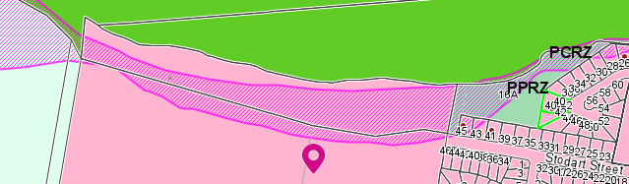

**Figure 3: LSIO & ESO2 extent**

**3.3 Cultural Heritage**

The Development Plan Area identified as being of Cultural Heritage Sensitivity is shown in Figure 3 in yellow hatching.

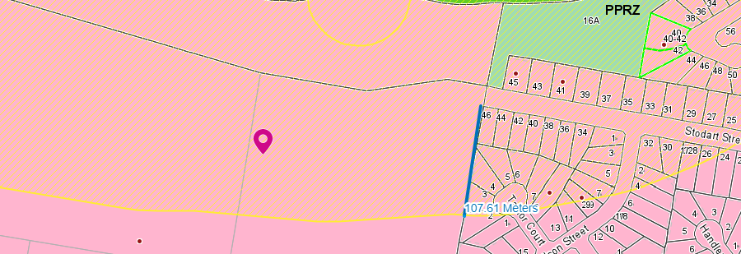

**Figure 4: Area subject to Cultural Heritage Sensitivity**

Council engaged Ecological Australia to prepare an Aboriginal Cultural Heritage Assessment of the Development Plan Area, including the land adjacent to Lake Colac in 2020. The findings and recommendations are summarised in section 4.6.2 of this report. The subdivision of a lot which is covered all or in part, or the creation of a road within land identified as being of cultural heritage significance would require an approved Cultural Heritage Management Plan (CHMP) to be submitted to Council prior to the determination of any planning application.

## 4. DEVELOPMENT Plan DETAILS

**4.1 Internal road network**

The Development Plan Area consists of land (the ‘land) bounded by the Princes Highway to the south and Rifle Butts Road to the west. The land also has road connections to Moore Street and Stodart Street to the east.

A new road connection will be provided to Princes Highway at the western boundary of the former Colac High School. This road connection will provide access to a 25m wide road that will extend directly north along the western boundary of the former High School site (outside the land) to a new 20m wide Esplanade Road that will run along the edge of the open space along Lake Colac. The new 25m wide road will provide good access to the former High School site, which will be used partly as a Specialist School, and partly as Open Space (an outdoor sporting facility) in the future, as well as the balance residential development of the Development Plan Area.

Moore Street will extend westwards within a 24m wide road along the northern boundary of the Open Space across to Rifle Butts Road. Rifle Butts Road will be sealed and will connect back to an intersection on the Princes Highway.

The pattern of development is a continuation of the road layout established immediately to the east of the Development Plan Area, which generally consists of east-west and north-south road alignments, which in addition to the Moore Street connection will also provide road access via Stodart Street and via new road connection to Ball Street.

However, it should be noted that the Stodart Street connection is subject to further cultural heritage investigation. If further investigation reveals items of significance in the vicinity, this link may not be able to be achieved. However, Council’s aim is to maximise road frontage to open space wherever possible, and the Stodart Street connection will achieve this.

Furthermore, the road connection to Ball Street relies on the demolition of a dwelling on the land outside the Development Plan Area. Land to the east is an older established estate dating back to the 1950/60s and is predominantly social housing. This land to the east is also identified as a Future Masterplan Area in the Colac Framework Plan in Clause 2.04 of the Colac Otway Planning Scheme. There is a potential to replan and replace some of the older housing stock as part of this Future Masterplan Area and reconfigure the road pattern to make better connections and improve access to open space. A link from this estate into the Development Plan area is seen as highly desirable for improved vehicular, pedestrian and social connectivity between the older and the new estate. Further negotiations with the Department of Health and Human Services will be required to achieve the Ball Street link as part of any future planning in accordance with the Colac Framework Plan.

The Development Plan provides an internal road network that provides for a high level of connectivity between each lot within the Development Plan area and is based on modified grid pattern layout.

Due to some lot excisions along Rifle Butts Road and the small size of lots, the extent of road construction has the potential to make development of part of the land financially unfeasible. The plan shows a court bowl and a road design that reflects an earlier version of a development plan (not previously endorsed by Council). For this reason, the general grid pattern layout has not been fully adhered to in this location to reflect the local circumstances on this side of the Development Plan Area. If a court bowl is provided, a pedestrian laneway will need to be considered for connectivity.

Unless otherwise marked on the plan all other roads are to be contained within a 16m wide road reserves. Some parts of the land may be suitable for rear laneway access for small lots to encourage housing diversity particularly where a higher level of amenity can be achieved (i.e. potential outlook to the Esplanade open space adjacent to Lake Colac.)

Furthermore, DDO9 requires that an improved landscape experience as part of the western entrance to Colac. It is proposed to provide a New Service Road parallel to the Princes Highway to enable housing on lots fronting the highway to provide an attractive front façade to the New Service Road. The New Service Road will also be provided with Boulevard entry tree planting to enhance the appearance of the western entrance to town.

**4.2 Public open space and connectivity to other open space**

The Public Open Space Strategy advocates for the provision of a network of well-distributed public open space that include local parks within 400m safe walking distance of at least 95% of all dwellings. Local parks should generally be 1 hectare in area and be suitably dimensioned and designed for their intended use and to allow for easy adaption in response to changing community preferences.

While it is not proposed to establish any local parks within the Development Plan area, it should be noted that the northern portion of the former high school land immediately to the west is to be utilised for sporting grounds (soccer pitches x2). Subject to land availability, a baseball diamond may also be included. While this particular open space is not within the Development Plan area, it is shown on the plan as Open Space for context. The land-owners immediately to the north of the proposed sporting grounds have offered to supplement this Open Space with Moore Street deviated slightly to the north, and additional open space added to the Open Space on the Moore Street extension’s southern side.

The Development Plan Area is also adjacent to the foreshore area adjacent to Lake Colac which will provide a continuous open space along the edge of the lake from Rifle Butts Road through to the Stodart Street Park, which has local play-set facilities. A continuation of the foreshore shared path from Stodart Street to Rifle Butts Road is a requirement of this Development Plan.

**4.3 Connectivity to other residential land**

The proposed development is be connected to Moore Street, which is a major east-west collector road in this part of Colac. This road will be the primary connection into the established residential area to the east. In addition, access will be provided to Stodart Street subject to the findings of a Cultural Heritage Management Plan giving clearance for the connection to go ahead (see further comment in section 4.6. Such connectivity is clearly desirable from an urban design perspective if it can be achieved.

In addition, a potential connection has been shown indicatively to Bilson Street. The location of this connection relies on a reorganisation of housing stock in the estate immediately to the east and would be subject to further discussion with the Department of Families, Fairness and Housing and is a long -term prospect. This will need to be discussed further at the time of subdivision of the adjacent land.

The plan is bounded by Rifle Butts Road to the east which runs the full length of the Development Plan Area. As such, good connections can be achieved to future residential areas to the west as they develop in the future as part of the broader Deans Creek Residential Growth corridor.

**4.4 Diversity of lot sizes and proposed density**

The Development Plan does not show individual lots. However, the roads have been arranged to permit a variety of lot sizes to be configured. The density of development will be generally consistent with the surrounding pattern of development.

Depending on a potential relocation of the location of the wetland / detention basin (see section 5.2 for more detail) to the west of Rifle Butts Road, the Development Plan Area will cater for approximately 480 residential lots. A relocated wetland / detention basin could add about 50 / 60 lots.

**4.5 Provision of community facilities**

It is not proposed that any other community facilities be provide as part of the Development Plan. However, part of the former High School site is to be repurposed into a Specialist School.

The land is close to a small general store at Moore Street/Donaldson Street and the development of the land for housing will help support the on-going viability of this facility.

**4.6 Impact of development on flora and fauna and cultural heritage**

*4.6.1 Flora and Fauna*

The proposed development will have no undue impact on significant flora or fauna. The Development Plan Area was cleared for farming purposes many years ago. Many of the property boundaries are defined by trees that were planted originally for windbreaks. However, these trees will ultimately be harvested for timber. The trees in the north-western corner of the Development Plan Area form part of a super-lot that will be available for further development in the future. These trees were also planted by the land-owners. The wetland vegetation in the north-east will be outside land that will developed for infrastructure or lots. Elsewhere, other vegetation mainly consists of ornamental planting around existing dwellings.

*4.6.2 Cultural heritage values*

Ecological Australia undertook an Aboriginal Cultural Heritage Assessment of the Development Plan Area and the land adjacent to Lake Colac in 2020. The results of the assessment indicate that the entirety of the study area has the potential for Aboriginal archaeological material to be present. Ecological Australia notes that the study area:

* Contains a registered Aboriginal cultural heritage place located on the foreshore of Lake Colac (VAHR 7621-0030).
* Intersects with an area of cultural heritage sensitivity, based on proximity to a registered cultural heritage place (reg 25) and a waterway (reg 26).
* Contains unregistered Aboriginal cultural heritage places, in the form of subsurface stone artefacts identified within 19 test pits.
* Is highly likely to contain further unregistered Aboriginal cultural heritage material.
* Presents areas of greatest archaeological sensitivity across the lake foreshore and lake terrace landforms.

The Area of Archaeological Sensitivity is marked in Figure 5.

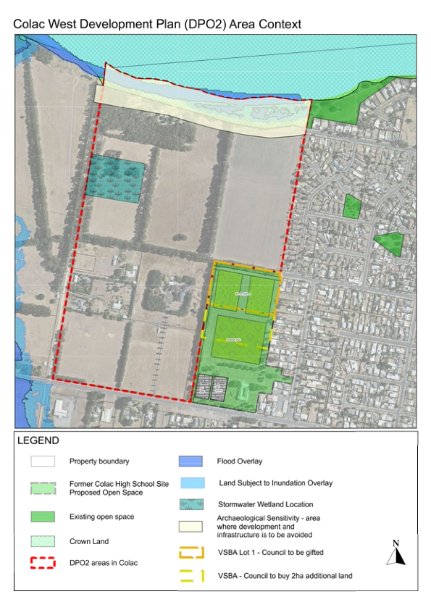 **Figure 5: Area of Archaeological Sensitivity**

As a result of the Aboriginal cultural heritage assessment, the following recommendations are made:

* Ensure that a CHMP be prepared for the future subdivision of the study area as per the requirements of the Aboriginal Heritage Act 2006 (Vic) (the ‘Act’).
* In the event that the study area is developed as separate property parcels and a CHMP is not required as per the strict interpretation of the Act, it is recommended that a voluntary CHMP be prepared.
* Avoid or minimise disturbance to ground surfaces known to be sensitive for Aboriginal cultural heritage material: the lake foreshore and lake terrace landforms.
* Communicate the discovery of Aboriginal cultural material to the Secretary, Aboriginal Victoria, as per the requirements of Section 24 of the Act.
* Communicate the existence of Aboriginal cultural heritage material to the land-owner, along with their responsibilities under the Act.
* Ensure further investigation into the nature and extent of the identified Aboriginal cultural heritage material occurs, including formal registration of the Aboriginal cultural heritage place with Aboriginal Victoria. This could occur during the preparation of a future CHMP. A landform-based registration covering the lake terrace may be appropriate.

It should be noted that the preliminary assessment undertaken by Ecological Australia does not constitute a CHMP as defined in Division 1 of the Act. Any further measures to ensure compliance with the blanket protection provisions of the Act are at the discretion of the proponent of any future development of the land.

For the purposes of preparing the Development Plan, roads and residential development have been mostly setback outside the Area of Archaeological Sensitivity shown in Figure 5. However, Stodart Street is shown extending into the Development Plan Area in the north-eastern corner of the Development Plan Area. This road extension is over the Area of Archaeological Sensitivity shown in Figure 5 as the connection is considered desirable from a traffic management and urban design perspective. The Development Plan notes that this road extension requires further Cultural Heritage Investigation and if it is confirmed that Aboriginal cultural heritage material is present, the Development Plan is to be adjusted to exclude this road connection

**4.7 Other important matters**

**4.7.1 Rifle Range**

A rifle range is located immediately to the west of the Development Plan Area. It is understood that the rifle range is currently only used on a limited basis (Saturday only).

The Environmental Protection Agency has raised concerns in relation to potential contamination from the use of the rifle range potentially spreading beyond the range’s boundaries and onto the Development Plan Area. A Site Contamination Assessment was prepared for the Rifle Range in 1995.

This report was referred to the Environmental Protection Agency for review in 2020. The Environmental Protection Agency’s advice was that further assessment be undertaken as:

* The standards of assessment have improved since the 1995 assessment was done.
* The 1995 assessment notes exceedances and the use has continued over 25 years. Despite only operating once per week, taken over 25 years, is considered a significant time period.
* The 1995 assessment did not consider potential off-site contamination.

It is a requirement of this Development Plan that each land-owner undertake the required Site Contamination assessment before they receive a planning permit, and where applicable a condition of the permit will specify what works need to occur prior to commencement of works.

**4.7.2 Private Property (Future Development)**

Land in the north-western corner of the Development Plan Area marked as Private Property (Future Development) is part of the General Residential Zone. The land contains vegetation that has been planted by the property owners over a number of years. Part of this land is likely to be suitable for some form of development in the future. Road connections have been provided to enable further development when it occurs.

## 5. implementation

**5.1 Future subdivision within the Development Plan area**

Any future subdivision proposal within the Development Plan area must be generally in accordance with the Development Plan to allow for orderly development of the land in the future. The Development Plan does not in any way require development to occur. Any decision to subdivide land remains the absolute choice of the affected property owners. Until that decision is made by the property owner(s), their property will remain in its current configuration.

While subdivision layouts must generally accord with the approved layout on a Development Plan, there is scope for minor variations provided they do not alter the principal intention of the layout. Minor variations can be considered on a permit-by-permit basis. If a significant change to the Development Plan is proposed at any time, Council would be able to consider adopting a revised Development Plan layout if it is established that it would have equivalent or improved benefits to the community and did not adversely affect the outcome being sought by the Development Plan.

**5.2 Stormwater management**

A Stormwater Management Strategy has been prepared by Engeny Water Management Consultants. The recommendations of the Stormwater Management Strategy must be generally complied with to allow subdivision and development within the Development Plan Area. The strategy includes hydraulic modelling and stormwater quality modelling.

From the modelling undertaken, the following summary of findings is provided:

* Two drainage options are available as part of the Stormwater Management Strategy. The proposed drainage system consists of property connections into the kerb and channel. This contrasts with the alternative drainage system option which would consist of property connections into the underground drainage system. The key difference is that the proposed drainage system limits the pipe lengths and as such the cost of construction. However, this option relies on the conveyance of overland flows with in the road network.
* As part of the area’s development, the proposed road alignments will need to ensure a minimum longitudinal grade of 1 in 300 or 1 in 400 as the absolute minimum for short sections. This will particularly be required along Rifle Butts Road towards Lake Colac and the Moore Street extension, west toward the proposed wetland asset. These road grading works will also require localised fill for the proposed residential lots to ensure suitable freeboard from the major overland flow paths.
* The Best Practice Environmental Management Guidelines targets are met through the implementation of a wetland asset, gross pollutant traps units and rainwater tanks. The proposed Open Space and Specialist School area lies outside the Colac DPO2 boundary, and as such treatment of this additional run off assists in achieving the total Best Practice Environmental Management Guidelines pollutant load removal targets for the DPO.

Some of the land owners within the Development Plan Area are currently investigating the option of relocating the wetland / detention basin to a more suitable location to the west of Rifle Butts Road, closer to Deans Creek. Further discussion is needed with the Catchment Authority and Cultural Heritage Management issues will need to be addressed in association with any planning permits required to relocate the basin on the western side of Rifle Butts Road. The Development Plan is annotated to show that subject to a section 173 agreement being in place, there is the option to relocate the basin to the western side of Rifle Butts Road and therefore allow more space within the Development Plan Area for additional housing lots.

Note: While the final Development Plan will provide Council’s position with respect to stormwater management, it will not resolve civil matters between land-owners, particularly with respect to obtaining stormwater discharge approvals to allow individual subdivision proposals to lawfully proceed.

**5.3 Water and sewer reticulation network**

A Water and Sewer Network Guidance Technical Memo (technical memo) has been prepared by Barwon Water for the Development Plan Area and for further land to the west that is identified under Colac 2050 Growth Plan as future residential / existing industrial development. The recommendations of the technical memo must generally be complied with to allow subdivision and development within the Development Plan Area.

Having regard to the Colac West Development Plan, the technical memo advises as follows:

The proposed layout is acceptable from a servicing perspective. Further conceptual work is currently underway to understand:

1. The amount of land which can be commanded by the existing sewers to the east. It is not yet confirmed whether land fronting the Princes Highway adjacent the school can be commanded by sewers to the east.
2. The final pump station location to appropriately service both the Development Plan land as well as Area 10, and potentially industrial land further west. Conceptually, this would be sited towards the low point likely between Moore Street and the wetland. A suitable site will need to be found. Typically, pump stations of this size would be on Barwon Water owned land and be approximately 1000m2.

Work on that is ongoing. However, Barwon Water provides the following conceptual layout for this area below. Note this layout may be subject to change.

Colac West SPS (BW Funded)

Area indicatively commanded by the sewers to the east

Reticulation interceptor sewer (Developer funded)

Area 10 Serviced by Colac West SPS

Figure 6: Colac West DPO Sewer Servicing Concept

**5.4 Transport, traffic and movement**

Wood and Grieve (WGE) were commissioned to prepare a Transport, Movement & Associated Infrastructure Assessment for Colac West, including taking into consideration the future use of the former Colac High School site (shown on the plan but not part of the Development Plan Area).

The original plan examined by WGE has since been amended and Wallbridge Gilbert Aztec (WGA) were commissioned to review the analysis undertaken by WGE. WGA conclude that the traffic impacts are not anticipated to change significantly as a result of the amendments to the Development Plan. All intersections are still anticipated to operate with an excellent level of service with acceptable queues and delays on all approaches.

Based on the discussions and analysis outlined in the assessment, the following key recommendations are derived:

**5.4.1 Traffic capacity**

* All assessed intersections are anticipated to operate within acceptable limits following full development of the site (all lots and the sporting precinct).
* Traffic volumes on the Princes Highway, east of Sinclair Street, are anticipated to exceed the theoretical mid-block capacity of a single lane road, following full development of the site.
* Assuming that all vehicle access is provided to the subject area to the Princes Highway and following full development of the subject area, it is anticipated that in the order of 210 additional lots could be provided south of the Princes Highway (in the vicinity of Deans Creek Road) prior to additional mitigating intersection works being required at the Rifle Butts Road / Princes Highway intersection.
* Subject to provision of mitigating road works nominated within this report, all intersections and roads are anticipated to function and operate within their theoretical capacities.

**5.4.2 Road Connections**

* The provision, or otherwise, of the Ball Street and/or former High School east-west road connections, does not impact on the mitigating road works or the internal road hierarchy and design.
* The provision of the Ball Street and/or former Colac High School east-west road design connections would assist with pedestrian movements and achieving street blocks which are generally in accordance with Standard C20 of Clause 56.06 of the Colac Otway Planning Scheme.
* It is considered that there are four potential access options to the Princes Highway as follows:
  + Access to the site via a service road
  + Access to the site via a single road
  + Access to the site via multiple roads
  + No access to the site
* There is a trade-off in each of the four Princes Highway access options between improved traffic amenity and rationalising access to the arterial road network (rationalising/removing access to the Princes Highway). The design and level of access provided to the Princes Highway will be subject to Department of Transport comments.

**5.4.3 Mitigating Road Works**

Mid-block

* Duplication of the Princes Highway is required between Ross Street through to the Colac township, ultimately linking through to the Princes Highway duplication between Colac and Winchelsea.
* The development of subject area presents an opportunity to improve pedestrian safety on the site frontage to the Princes Highway which is currently considered to be relatively poor.

**5.4.4 Intersections**

* Pavement improvement works to the bicycle lane, for at least 50 metres on the Princes Highway approach (both sides) to the Rifles Butts Road / Deans Creek Road intersection.
* A channelised right turn (CHR) treatment to be provided at the Princes Highway intersection with Rifle Butts Road, Ross Street and any future site access roads.
* Should no vehicle access be provided from the subject area to the Princes Highway, it is likely that parking would need to be restricted in the vicinity of the Princes Highway on Ross Street in order to provide a separate left and right-turn exit lane from Ross Street to the Princes Highway.
* Additional mitigating works at the Princes Highway / Rifle Butts Road / Deans Creek Road intersection, following full development of the subject area as well as the provision of 210 additional lots to the south of the Princes Highway. A summary of the mitigating roadworks options are below:
  + No works (only if Princes Highway traffic volumes are lower than anticipated – e.g. provision of a Colac by-pass)
  + Roundabout treatment
  + Provision of a wide central median
  + Traffic signals
  + Signalised pedestrian crossing with side road activation

**5.4.5 Road Design**

* Moore Street is proposed to be a Connector Street – Level 1.
* Rifle Butts Road is proposed to be an Access Street - Level 2.
* The new internal road located to the west of the proposed specialist school is anticipated to be an Access Street - Level 2 up until it reaches Moore Street.
* The balance of the internal road network is to be designed as a combination of Access Street – Level 1 and Access Lane road cross sections.
* The proposed road hierarchy and design accords with emergency and service vehicle requirements.

**5.4.6 Sustainable Transport**

* The following cycling infrastructure is proposed:
  + On-road bicycle lanes and a shared path within the Moore Street extension.
  + A shared path to be provided on the eastern side of Rifle Butts Road.
  + The Colac Lake shared path to be extended to Rifle Butts Road.
* Moore Street and Rifle Butts Road are considered to represent bus capable roads due to their cross-sections. Any potential future bus route would likely traverse these two roads as well as the Princes Highway in order to create a loop.
* The implementation of bus services is a matter for the public transport operators and Public Transport Victoria (PTV). Dependent on future bus stop locations, it is expected that the majority of dwellings will be located within a 400m walk of a bus stop.

**5.5 Shared Infrastructure Funding Plan**

A Shared Infrastructure Funding Plan (SIFP) has been prepared to guide the delivery of shared infrastructure in the Development Plan Area by:

* Identifying the land parcels which are to be developed and quantifying the area and likely development yield of each parcel.
* Identifying shared infrastructure required to support development.
* Identifying the specifications, costs and justification for each item.
* Apportioning costs to each land parcel in the Development Plan Area and calculating levies payable to ensure delivery of shared infrastructure.
* Identifying any additional infrastructure items that are to be provided by specific land-owners.
* Describing mechanisms by which the SIFP will be implemented, including the collection of levies, delivery of infrastructure, responsibilities for works in-kind and administration of the document (such as indexation).

The SIFP will be used to inform a Section 173 Agreement which will formalise arrangements for infrastructure delivery between Council and each land-owner in the Development Plan Area.

__________________________________________________________________________________________