Frequently Asked Questions & Answers

Where is the development plan proposed?
Colac West
Draft Development Plan
The development plan is to apply to ten land holdings generally bounded by Lake Colac, Rifle Butts Road, Murray Street and the former High School site in Colac West. An aerial image of the affected land is shown below:

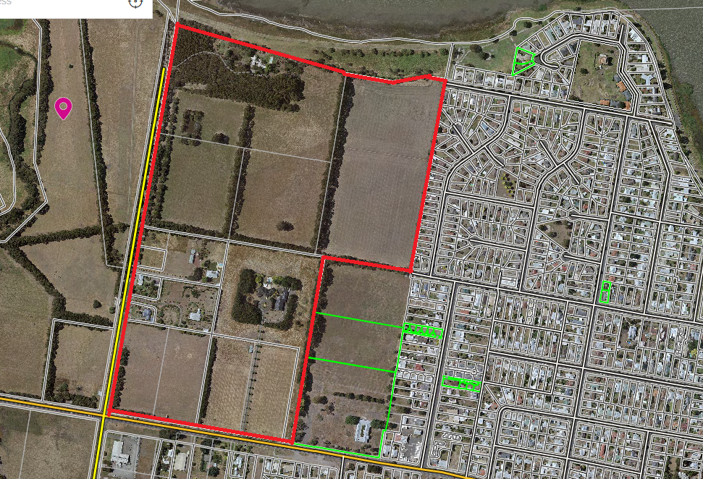

Details of each property are as follows:

Lot description | Address | Area
Lot 62D | Deans Creek Road | 4.19 hectares
Lot 1 TP600612 | 1-59 Rifle Butts Road | 25.58 hectares
Lot 2 PS804989 | 67-71 Rifle Butts Road | 2780m²
Lot 3 PS804989 | 73 Rifle Butts Road | 1.747 hectares
Lot 1 PS610416 | 75 Rifle Butts Road | 3129m²
Lot 2 PS644906 | 87 Rifle Butts Road | 1.47 hectares
Lot 1 PS644906 | 89 Rifle Butts Road | 2405m²
Lot 1 TP140171 | 461-479 Murray Street | 4.04 hectares
Lot 1 TP140169 | 441-459 Murray Street | 4.04 hectares
Lot CP171401 | 439 Murray Street | 4.89 hectares
TOTAL |  | 46.78 hectares

What is a development plan?
A Development Plan is essentially a blue print applying to land to provide a guide for the design of future subdivisions. Any future subdivision proposal must be prepared generally in accordance with the Development Plan to allow for orderly development of the land. The Development Plan is also accompanied by a Guidance Document that provides more information on the plan, including implementation.

What is the purpose of a development plan?
The purpose of a development plan is to ensure that any future subdivision of land is well-planned and makes provision for well-connected road and pedestrian access, public open space, drainage and other community infrastructure. In this instance, the development plan seeks to ensure that fragmented lots are not subdivided and developed independently of each other, and are designed to be well-integrated.

Why is a development plan being prepared for this area?
The development plan is a requirement of the Development Plan Overlay (DPO2) that applies to the land. Prior to any proposal to develop or use land affected by a Development Plan Overlay, it is a requirement that a development plan be prepared and approved by Council. Currently, there is no development plan to guide subdivision over the land affected by this particular Development Plan Overlay.

What are they key features of the plan?
The key features of the plan consist of a westward extension of Moore Street across to Rifle Butts Road, a new north – south road adjacent to the former High School Site running up to a Lakeside Esplanade Road, a connection to Stodart Street (subject to cultural heritage clearance). Other 16m wide roads will generally be based on a grid pattern with some flexibility to suit individual subdivision proposals as they are developed in more detail.

A shared pathway along Lake Colac from the Stodart Street Park to Rifle Butts is a condition attaching to the Guidance Document that accompanies the Plan.

Although outside the Development Plan Area, the former High School Site is to be developed into a Specialist School. Surplus land to the north will be open space and developed for sporting grounds.

The land is in the General Residential Zone which caters for a mix of residential lot sizes.

My property is adjacent to the area identified on the draft development plan. What does this mean for me?
It means that when the landowners in the DPO2 area decide to subdivide their land and the new lots are developed and dwellings are built, the layout of the subdivision will be required to be consistent with the development plan approved for that area. Essentially the development plan is a layout showing where future streets, pedestrian linkages, open space and new housing could be located. While there is no statutory requirement to exhibit the Development Plan, it has been Council’s past practice to informally exhibit such plans to nearby residents to keep the local community informed of future plans in their locality.

My property is within the area identified on the draft development plan. What does this mean for me?
If you decide to subdivide your land then a future subdivision application is required to be consistent with the development plan approved for your area. While subdivision layouts must generally accord with the approved layout on a Development Plan, there is scope for minor variations provided they do not alter the principal intention of the layout. These minor variations can be considered on a permit by permit basis. If a significant change to the Development Plan is proposed at any time, Council would be able to consider adopting a revised Development Plan layout if it is established that it would have wider benefits to the community and did not adversely affect the outcome being sought.

What if I have no plans to develop my property, will I be affected once the development plan is in place?
Any decision to subdivide land remains the absolute choice of the property owner. Until that decision is made by the property owner, their property will remain in its current configuration.

What is the purpose of the Wetland/Detention Basin shown on the development plan?
An area of land on the north-western side of the Development Plan is shown as a Wetland/Detention Basin. The purpose of the Wetland/Detention Basin is to mitigate stormwater flow from the land development and to treat stormwater quality.

Some of the land-owners within the Development Plan Area are currently investigating the option of relocating the wetland / detention basin to a more suitable location to the west of Rifle Butts Road, closer to Deans Creek. Further discussion is needed with the Corangamite Catchment Management Authority and cultural heritage management issues will need to be addressed in association with any planning permits required to relocate the basin on the western side of Rifle Butts Road. The Development Plan is annotated to show that subject to a section 173 agreement being in place, there is the option to relocate the basin to the western side of Rifle Butts Road and therefore allow more space within the Development Plan Area for additional housing lots. This modification could result in approximately 60 additional lots, bringing the total number of lots up to approximately 480 lots in total.

What happens after the consultation period?
Comments and informal submissions received will be considered by Council through an officer report before the draft development plans are finalised. All submitters will be notified of when Council is scheduled to consider the final plans.

Will this project change any planning controls affecting the project area?
No, the development plans are a requirement of the existing DPO2 when submitting a subdivision application to Council. This project will improve the subdivision application process under the DPO2.

Where can I get more info?
Further information on requirements relating to the project can be obtained from the Council’s website at www.colacotway.vic.gov.au, or by contacting Council’s Strategic Planning Department via email at inq@colacotway.vic.gov.au or by telephone 5232 9400.

