eNotices – Get your Rates Notice emailed to you

- Go to the enotice website at https://colacotway.enotices.com.au/  - Click on the Sign Up tab | 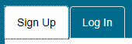
Sign up via website
- Enter your email address | 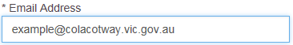
- Locate your enotice reference number on the bottom of your rates notice
- Enter your enotice reference number | 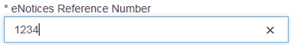
- Click on Sign Up button (an email will be sent to your email account for confirmation)
- Go to your email account
- Click on Start button in the email
Sign Up via facebook
- Click on Facebook button
- Enter your email address or phone number that you use when signing into facebook | 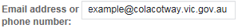
- Enter your facebook password
- Click on Log In button
- Click on Continue button
- Locate your enotice reference number on the bottom of your rates notice
- Enter your enotice reference number
- Click on Continue button | 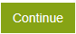

Edit your Details
- Log in to your eNotice account
- Click on Update Contact Details or your name | or
  - Profile Tab
  - Change name or contact details
  - Change password
- Accounts Tab  - Add new accounts  - Change delivery method (email or post)  - Remove account | 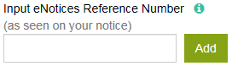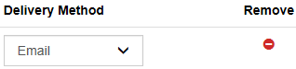
- Emails Tab  - Add additional emails to send notice/s to | 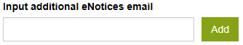

BPay View – Your bank will notify you when your Rates Notice is available to view

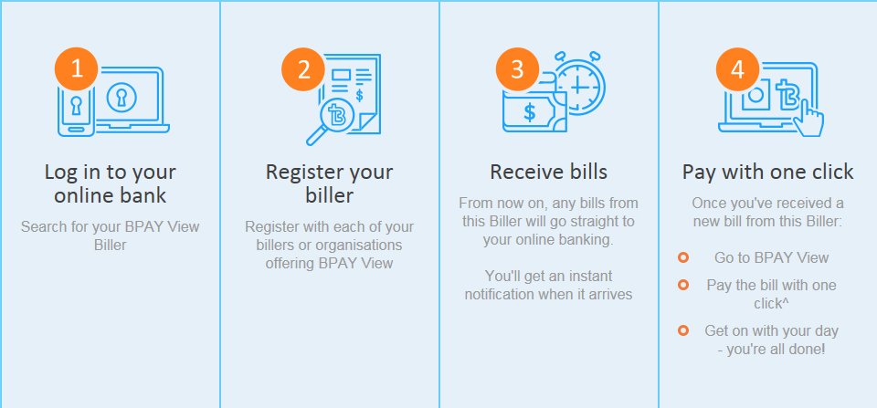

For instructions on how to locate BPay View through your online Bank
- Go to https://www.bpay.com.au/Personal/Receive-bills.aspx
- Scroll down to the How it works section
- Click on the Set up BPAY View button
- Enter the name of your bank in the search field
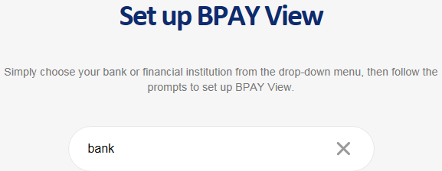
- Click on your bank in the menu
- Follow the instructions provided
examples
