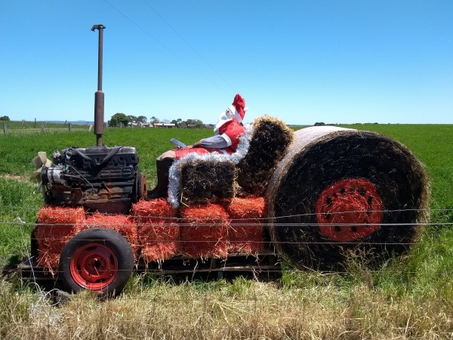  The Cororooke Hall committee invites our community to join in  Red Rock's Decorated Hay Bale Trail:  Alvie, Balintore, Beeac, Cororooke,  Coragulac, Cressy, Dreeite,  Nalangil, Ondit, Warrion & Wool Wool.  Entries close Monday 7th Dec  Judging Tuesday 8th Dec  Winners announced Friday 11th Dec. (Colac Herald)  Bales remain till 12th day of Christmas Wed 6th Jan  To be eligible for judging there is a height limit of two round bales or four small square bales.  There is no limit to your creativity!  Collect & return entry Forms to Cororooke General Store or email to helenebell825@gmail.com  Join Red Rock Community (Australia) Facebook for updates | Red Rock's Decorate a Hay Bale Trail Entry  Return entry form to Cororooke General Store by 7th Dec 2020  Name …............................................................  Phone ….........................  Email ..................................................  Address of the Hay Bale …....................................... …............................................................  Circle your theme  - Christmas Theme  - Animal  - Book or Nursery Rhyme  Title of the bale …........................  Inquiries Helene Bell 0438765214  Return your entries to  Cororooke General Store or email to helenebell825@gmail.com

