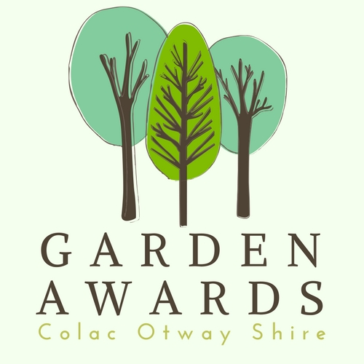

APPLICATION
FORM

SECTION 1: APPLICANT DETAILS
Please read the Colac Otway Shire 2017 Garden Awards Terms and Conditions to assess if your application meets the criteria for the Garden Awards
Name:
Address:
Phone Number:
Email:

SECTION 2: GARDEN DETAILS
Name of Garden:
Address of Garden:
Brief description of the Garden: | Max 300 words
Please attach at least 1 and up to 3 digital photos of your garden

SECTION 3: Please nominate which category you wish to enter:
Best Heritage Garden
Best Coastal Garden
Best Native Garden
Best Sustainable Garden
Best Edible Garden

SECTION 4: CONFIRMATION
I being the person listed above confirm and agree that:
I have read the Colac Otway Shire 2017 Garden Awards Terms and Conditions.
The information given in this application, including any attachments, is true and correct in every particular.
The owner of the nominated garden has agreed to be entered into the competition and photographed by a designated person from the Colac Otway Shire. I/They understand all photographs may be reproduced in promotional materials to be used by Council at its discretion.

Applications can be sent to:
2017 Garden Awards
Att: Events Department
Colac Otway Shire
Po Box 283
Colac VIC 3250

Or

emailed to inq@colacotway.vic.gov.au

