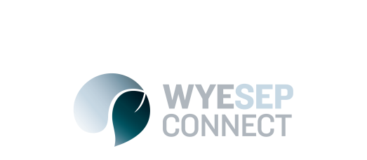

News
Please take our one-question survey on traffic options for Stanway Drive
25 September 2017

Following the 2016 flood event the Great Ocean Road was closed due to a major landslip.

During the time the landslip was being repaired by VicRoads, Grocon transported people between Wye River and Separation Creek by 4WD along Illuka Ave, Illuka Extension and Stanway Drive.

This was necessary because the most northern section of Stanway Drive was effectively a 4WD fire access track on private land.

Once this landslip repair work was completed the State Government investigated the issue of access. As a result of that investigation the State Government provided all funds necessary to upgrade this road to a sealed 2-wheel drive road, so that it could be used in the future for access between the towns if the Great Ocean Road was ever closed again.

Gates were installed on Stanway Drive to give Council the ability to close the road during normal times so that it did not become a through route in a way that was different to the pre-flood condition.

The roads along the alternative route are less than ideal with respect to steep grades, narrow road widths and significant drop-offs and it is not safe to encourage vehicles to use this route as a two-way road whilst the Great Ocean Road is open. The decision was made to allow only emergency access through this route.

It is being considered to allow one-way access temporarily whilst the townships are experiencing heavy construction activity to enable one way traffic movement for contractors and builders entering and exiting their work sites. Council would monitor and review this arrangement every 6 months. There is no intention to create permanent ongoing access along this route.

Given this background detail, Council is now seeking community feedback on traffic management options for Stanway Drive.

Please take our one-question survey: https://www.surveymonkey.com/r/9F3MHMS to let us know which of the two options you prefer or to provide comments/suggestions.

Thank you to everyone who did our initial survey, but please feel free to answer this updated survey also. Community members asked for a box to provide feedback, so we have updated the survey to allow for comments.

The survey is open from Monday 25 September until Monday 9 October 2017.

Thank you in advance for your feedback

Colac Otway Shire

