|  |
| --- |
| Wye River Public Land Projects Community Update- September 2017 |
| Plans have been prepared for a new lookout at Paddy’s Path and a riverbank platform in the foreshore caravan park. |

# Paddy’s Path rehabilitation

## Lookout reconstruction

A new lookout will be constructed along Paddy’s Path to provide views across the beautiful Wye River foreshore. It will replace an existing lookout recently undermined by landslide activity and includes the re-siting of Paddy’s plaque, currently in safe keeping with the community.

## Removal of ramped steps

Following community feedback on ramped steps installed through the recovery program last year, a section of track in the middle of Paddy’s Path will be diverted. The ramped steps at the Separation Creek end will also be removed and steps that meet Australian walking track standards installed. Works will begin once all approvals have been acquired.

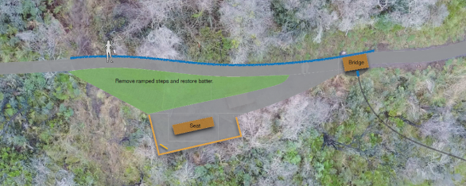

Figure (above) and Figure 2 (below): Paddy’s Path realignment and new lookout



# Riverbank platform

## Funding application success

The Otway Coast Committee secured funding through the Better Infrastructure for National Parks and Reserves Fund to improve the pedestrian access to the river, and provide a small boardwalk on the riverbank. The fund helps Crown land managers improve infrastructure for communities.

[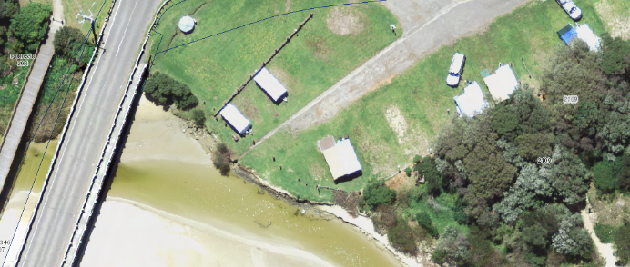](http://maps1.land.vic.gov.au/gvh270isd/index.html?viewer=msg3_site.gvh270viewer&locale=en-au)

Site of the new platform in the foreshore caravan park

The final plan improves access by defining the public open space within the caravan park with bollards, and enhances enjoyment of the estuary with tables and seating on the timber platform. Visual barriers and signs will be installed to highlight shallow water depths in this location.

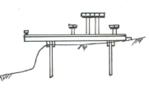

Figure 4: Side view

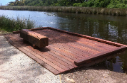

Figure 3: River bank platform with tables and seating seating

Figure 5: Example of riverbank platform