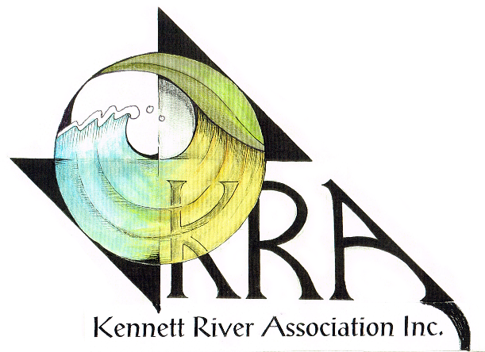

THE KENNETT RIVER ASSOCIATION
would like to invite residents from the communities of
KENNETT RIVER- WYE RIVER-SEPARATION CREEK-GREY RIVER
for a social barbecue
“connecting with communities along the great ocean road”
WHEN: SATURDAY NOVEMBER 4TH
^{TIME: 4.30pm}
WHERE: PICNIC AREA AT KENNETT RIVER (NEXT TO THE RIVER)
^{$10 a Family or $5 a head}
^{Meat and salad supplied}
BYO: Drinks, seats, plates and cutlery.
RSVP: September 30th ( for catering purposes) to
Andrew Taylor email: andrewmgdesign@bigpond.com

With thanks to our sponsor, the Apollo Bay & District Community Bank

