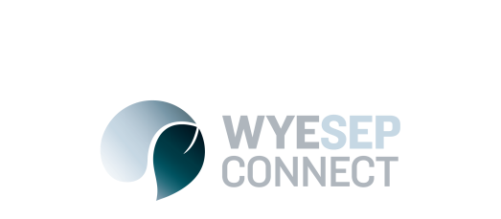

News
Wye Sep Communications Update
27 April
WyeSep Connect has transitioned to Council’s website, at: colacotway.vic.gov.au/wyesep
The http://wyesepconnect.info/ will redirect to the URL above on Council’s website. Council will be responsible for maintaining the wyesep pages rather than EMV from now on. Articles will be posted within a few days of receiving them.
Community members can send meeting minutes, updates and news articles to Yvette Hill, Bushfire Community Development Officer, on: yvette.hill@colacotway.vic.gov.au
New communications processes
As outlined in last month’s newsletter, as we move into the renewal phase, Colac Otway Shire has committed to provide project-specific communications and engagement opportunities wherever possible, and keep the community informed through:
The bushfire recovery email: Bushfire.recovery@colacotway.vic.gov.au
Periodic newsletters distributed around key infrastructure milestones, approximately monthly
Community drop-in sessions in Wye River for feedback on specific projects
A page on Council’s website, which will replace WyeSep Connect: www.colacotway.vic.gov.au/wyesep
Facebook: facebook.com/WyeSepConnect

WyeSep Connect Facebook Page
Council will also maintain the WyeSep Connect Facebook page. Articles will be posted within a few days of receiving them. Community members can send updates and news posts to Yvette Hill, Bushfire Community Development Officer, on: yvette.hill@colacotway.vic.gov.au or 5232 9400

Community Resilience Newsletter
Council will continue to produce the periodic newsletter, monthly or more often as needed. Community members can send meeting key dates, photos, information, updates and news articles to Yvette Hill, Bushfire Community Development Officer, on: yvette.hill@colacotway.vic.gov.au or 5232 9400. The next newsletter dates are scheduled approximately as follows: 27 April, 27 May, 27 June, 27 July.

