News
Wye River pedestrian works
19 July 2017

Work on the Wye River township improvements was completed this week.
The four-week VicRoads project included new kerb and channel, a pedestrian refuge on the Great Ocean Road, new bus stop platform, paths, landscaping and line marking for car parking spaces.
The pedestrian refuge will help pedestrians cross between foreshore car parking and the surf beach to the town’s facilities at this popular holiday destination.
The islands have been located between the general store and the main access point to the beach across the road.
A mountable traffic island was built at the nearby Wongara Drive intersection and gravel-parking bays in Morley Avenue have been sealed.
The $130,000 project delivers on a community request to create a safer beach and township pedestrian link across the Great Ocean Road.
About 100 indigenous grasses have been planted in the garden beds. A selection of more decorative plants will follow shortly.
The surrounding Great Ocean Road intersection has been repaired, asphalted and line marked.
A further 135m of kerb, channel and stormwater drainage is also being installed along the Great Ocean Road behind the foreshore reserve caravan park.
Traffic management was in place during the works. The Great Ocean Road remained open during the project.
VicRoads regional director Mark Koliba said VicRoads had focused heavily on stabilisation works at Wye River to make the Great Ocean Road safer and was now delighted to be able to give the Wye River community a safe point to cross between the surf beach and shops.
“Additional designated parking bays, a pedestrian refuge, sealed paths and kerb and channelling will give this busy pedestrian hub a more organised structure that helps guide people and traffic safely around the cafe, hotel, playground, camping and beach precinct.
”The community asked for these facilities and VicRoads is very pleased to have now delivered significant safety improvements to one of the Great Ocean Road’s most popular tourist destinations.”

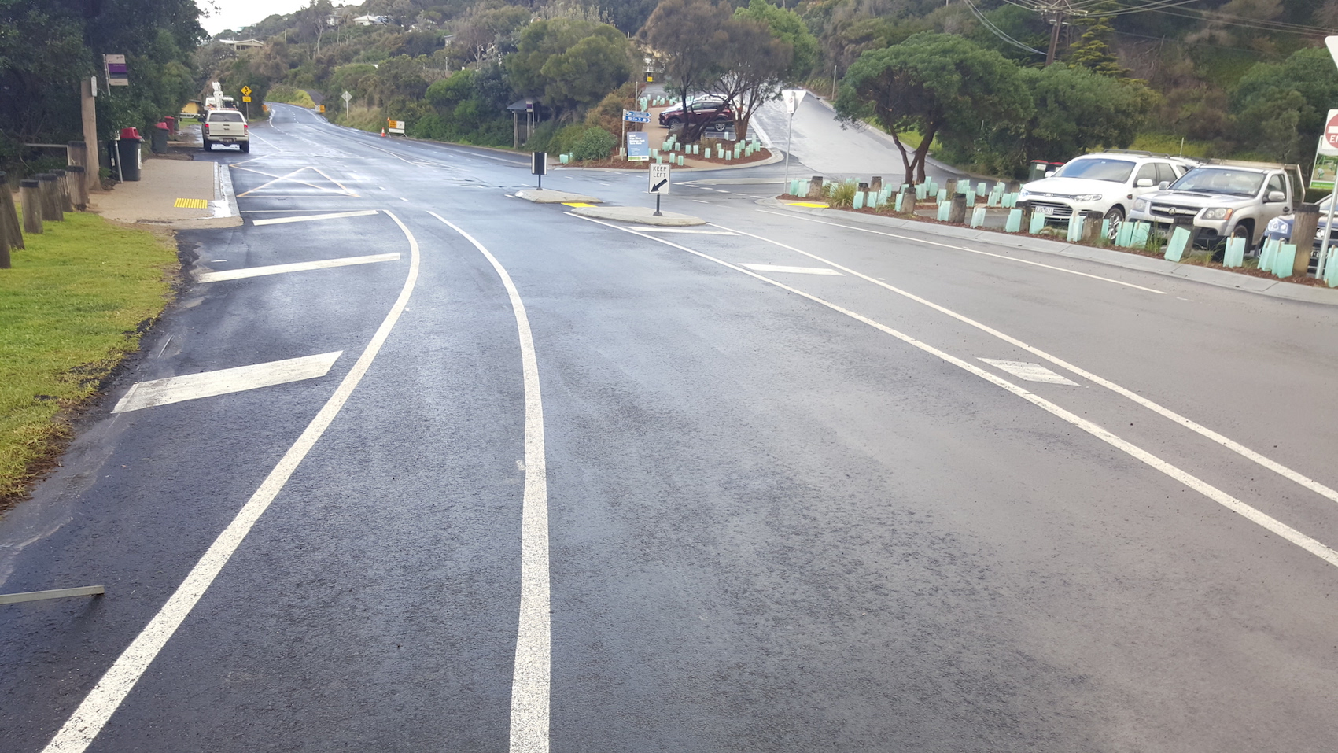
The township improvements at Wye River

