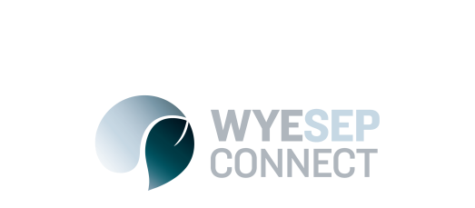

News
Onsite drainage survey
20 July 2017

Colac Otway Shire officers will be conducting an onsite drainage survey in Wye River and Separation Creek between the 25 July and 11 August.
As part of this survey we may need to enter private properties. Our officers will attempt to notify all property owners before conducting any inspections on private land. This work falls under Section 224 of the Local Government Act.
Survey work will only take place between 9 and 5pm, Monday to Friday. Thank you for your patience and understanding.
