Grant Application for Fire Resilient Demonstration Garden in Wye River Successful
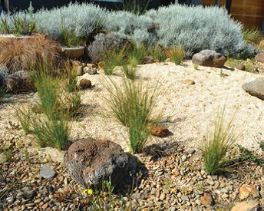
25 July 2017

We are pleased to announce that the Corangamite Catchment Management Authority has awarded a Coastal Small Grant to assist with the development of a garden to demonstrate fire-resistant landscaping and planting practices in Wye River.

The community response to the proposed garden has been extremely positive, and the Southern Otway Landcare Network is excited to be managing the project, with the support of the Flora, Fauna and Beachscape Work Group and Colac Otway Shire Council.

An open consultation process will commence in late spring this year to ensure that the whole community can contribute design ideas and suggest aspects they would like to see included. For inspiration and to ensure you understand fire resilience in garden landscaping, please refer to the Landscaping Your Coastal Garden for Bushfire booklet, available at: http://bit.ly/2u09z67

More information about how you can share your ideas will be available in the coming months. Ongoing workshops and information sessions on weed control and vegetation management
will also be held over the coming year to assist community efforts to build resilience for the future.

