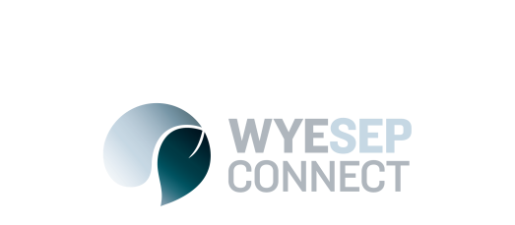

News
Accommodation for Fire Affected Community Members
4 July 2017

The following offers of accommodation are available to members of the Wye Sep communities who lost houses or who suffered damage during the 2015 Bushfire.
Scully Mill Separation Creek
Free accommodation at Scully Mill for owners of destroyed homes is still available following generous action of a private benefactor in funding 100 nights accommodation.
The offer includes a suite accommodating two people, although arrangement can be made to accommodate more. Available for short stays on weekdays or weekends, but not on long weekends or high season. No pets, and cannot be used by builders or contractors, only people who lost properties.
To book the accommodation, please contact Peter Jacobs on 5289 0462 or email peterjacobs@iprimus.com.au
Apollo Bay Recreation Reserve
The Otway Coast Committee are offering the following rates which have been discounted to assist and support community members through the rebuilding process.
Please contact the OCC bookings team on 5237 6577 and quote (WyeSep) when making your booking. Proof of address at the building site or a rates notice will be required to obtain the below pricing.
The below offer is only available through the Off Peak season which concludes at the end of November 2017 and excludes any Public Holiday’s, Grand Final Weekend and School Holidays.
Accommodation Type | Number of People | Rate | Extras
Cabins: | 2 Adults | $50.00 | Extra Adult $12.00 ea.  Extra Children $8.00 ea
Powered Site: | 2 Adults | $30.00 | Extra Adult $12.00 ea.  Extra Children $8.00 ea.
Unpowered Site | 2 Adults | $15.00 | Extra Adult $12.00 ea.  Extra Children $8.00 ea

