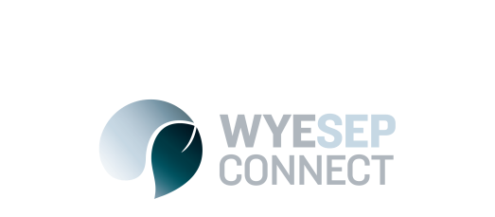

News
Discounted accommodation for fire-affected residents
23 May 2017

On behalf of the Otway Coast Committee (OCC), we are pleased to advise that discounted accommodation at the Apollo Bay Recreation Reserve is available for those members of the Wye River and Separation Creek communities who lost houses or who suffered damaged in the fires.
The OCC understand that this is a difficult and trying period for you and your families and we offer for those who need to meet with consultants and contractors during the planning and rebuild of your homes a discounted accommodation rate in Apollo Bay.
The OCC is able to offer the following rates in which have been discounted to assist and support you through your rebuilding process.
The below offer is only available through the Off Peak season in which is effective of today’s date and concludes at the end of November 2017 and excludes any Public Holiday’s, Grand Final Weekend or School Holidays.
If you are looking to book some form of accommodation please keep in mind that throughout the Colac and District Football / Netball season, home games are played at the Apollo Bay Recreation Reserve and to ensure a booking is secured for a cabin or site, we ask if you can please provide two (2) weeks’ notice to avoid any disappointment.
In order for the Wye River and Separation Creek Communities to obtain this offer we would like you to quote the following code work (WyeSep) and proof of address at the building site or a rates notice will be required to obtain the below pricing.
The Parks terms and conditions can be found on our website and Long term bookings will be considered at the discretion of management upon time of inquiry.
Fees:
Accommodation Type | Number of People | Rate | Extras
Cabins: | 2 Adults | $50.00 | Extra Adult $12.00 ea.  Extra Children $8.00 ea
Powered Site: | 2 Adults | $30.00 | Extra Adult $12.00 ea.  Extra Children $8.00 ea.
Unpowered Site | 2 Adults | $15.00 | Extra Adult $12.00 ea.  Extra Children $8.00 ea
If you have any queries regarding any of the above or wish to discuss your accommodation requirements, please do hesitate in contacting our Bookings team members on 5237 6577

