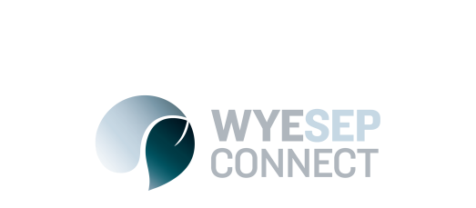

News
Stormwater reticulation design community drop-in sessions – all welcome!
10 August 2017

The concept design for the stormwater reticulation system is close to completion, and we are keen to hear your feedback on it. We are holding two community drop-in sessions for public comment on these designs in Wye River and in Melbourne, before detailed designs are produced in September. All property owners and residents welcome.

The concept designs will be put on the Wyesep Facebook page: www.facebook.com/wyesepconnect and the website www.colacotway.vic.gov.au/wyesep at least a week before the first drop in session.

No need to RSVP, please just come along.

Community drop-in sessions:
- Tuesday 29 August Wye River Surf Lifesaving Club
4pm to 6.30pm with presentation of plans at 4.15pm and 5.30pm
- Thursday 31 August Cardno Office – Level 4,
501 Swanston Street, Melbourne
5pm til 7pm with presentation of plans at 5.15pm and 6pm

