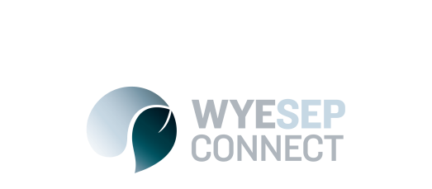

News
September Community Meetings – Wye River and Melbourne
28 August 2017
Wye River Saturday Sept 2, 10.30 – 12.30, Wye River Surf Club
Melbourne Thurs Sept 7, 5.30 – 7.30, 8 Nicholson St, East Melbourne
Topics for both meetings include: Reticulated Drainage Plan - discussion and feedback; Emergency access between Wye River and Separation Creek; Parks Victoria support for Wye River area projects; Community Fire Prevention Plan; Wye River Fire Recovery Evaluation. Senior Colac Otway Shire, Parks Vic, DELWP and Emergency Management Victoria staff will be in attendance.
Melbourne venue details: Buller Room, Emergency Management Victoria State Control Centre, Level 4, 8 Nicholson St, East Melbourne. Please sign in at security on the ground floor. Proceed to Level Four, turn right out of the lifts and proceed to the end of the hallway to the Buller Room.
If possible, please email your name to the CRC by 24 hours prior on crcwyesepcommunityreps@gmail.com so that security can be streamlined – however this is not essential
Convened by the Wye River, Separation Creek and Kennett River Community Resilience Committee. Queries to crcwyesepcommunityreps@gmail.com

